Title: Malting barley grain quality and yield response to nitrogen fertilization in the Arsi highlands of Ethiopia

Meharie Kassie ^{1*}, Kindie Tesfaye ²

¹ Arsi University, College of Agriculture and Environmental Sciences, P O Box 193, Asella, Ethiopia
² International Wheat and Maize improvement Center (CIMMYT), Addis Aababa, Ethiopia

Keywords: Grain protein content; Grain yield, Malting barley, Nitrogen fertilization, Marginal rate of return
I. Abstract Body
The malting industry in Ethiopia is often challenged by the availability of barley that meets the quality and quantity requirements set by the industry. Field experiments were conducted to evaluate (i)the effects of nitrogen (N) fertilization rate, variety and growing season on grain yield and grain characteristics of malting barley and (ii) to determine the N rate that optimize grain yield and quality of malting barley. The treatments studied were five N levels (0, 23, 46, 69 and 92 kg ha⁻¹) and two malting barley varieties (Holker and Miscal-21) over three growing seasons (2012, 2013 and 2014). The results showed that as N rates increased, malting barley grain yield, grain and straw N concentration, grain protein content, thousand kernel weight and kernel plumpness increased, but N rates had no effect on hectoliter weight. Grain yield, grain N concentration, grain protein content, kernel plumpness and thousand kernel weight were greater in Miscal-21, whilst straw N concentration and hectoliter weight was greater in Holker. Grain yield and hectoliter weight were affected by seasonal conditions, but grain and straw N concentration, grain protein content, kernel plumpness and 1000-kernel weight were not affected. Although both grain yield and protein content increased with increased N rates, based on the regression equation, application of 48 kg N ha⁻¹ gave the highest net benefit and marginal rate of return with acceptable grain quality (protein content < 11.5% and kernel plumpness > 85 g kg⁻¹). Application of N beyond 48 kg ha⁻¹ did not increase net benefit, but instead increased cost of production. In conclusion, to improve the likelihood that barley will be acceptable for malting, growers should limit N application and select varieties with low protein content.

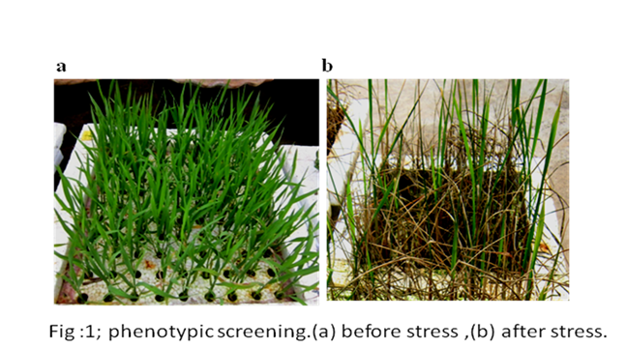
- Image:

III. Reference:
- Baethgen, W.E., C.B. Christianson, and A.G. Lamothe. 1995. Nitrogen fertilizer effects on growth, grain yield and yield components of malting barley. Field Crops Res. 43፡ 87–99.
- Halvorson, A.D., and C.A. Reule. 2007. Irrigated, no-till corn and barley response to nitrogen in northern Colorado. Agron. J. 99: 1521–1529.
- O’Donovan JT, Turkington TK, Edney MJ, Clayton GW, McKenzie RH et al. 2011. Seeding rate, nitrogen rate and cultivar effects on malting barley production. Agron. J. 103: 709-716
IV. Biography:
Meharie Kassie has completed his MSc at the age of 27 years from Haramaya University, Ethiopia. He is lecturer and researcher in Arsi University, College of Agriculture and Environmental Sciences. He has published 3 papers in reputed journals.
V. Presenting author details


Full Name: Meharie Kassie
Contact number: +251911749072
Twitter account:
Linked In account:
Session name/ number: Agronomy and Crop Science
Category: Oral presentation
Passport Number: EP4315286

