Title: Phenolic biopolyether from medicinal plants of Boraginaceae family – prospective anticancer agent

Barbakadze V,
Department of Plant Biopolymers and Chemical Modification of Natural Compounds, Tbilisi State Medical University Kutateladze Institute of Pharmacochemistry

Keywords: Boraginaceae, Phenolic biopolyether, Anticancer, Medicinal plants

- Abstract Body
According to data of ¹³C, ¹H NMR, 2D heteronuclear ¹H/¹³C HSQC, 1D NOE and 2D DOSY experiments the main chemical constituent of high molecular (>1000 kDa) water-soluble preparations from different species of two genera Symphytum and Anchusa (Boraginaceae family) was found to be poly[oxy-1-carboxy-2-(3,4-dihydroxyphenyl)ethylene] or poly[3-(3,4-dihydroxyphenyl)glyceric acid] (PDPGA). The polyoxyethylene chain is the backbone of this polymer molecule and 3,4-dihydroxyphenyl and carboxyl groups are regular substituents at two carbon atoms in the chain. The repeating unit of this regular polymer is 3-(3,4-dihydroxyphenyl)glyceric acid residue. This compound is a first representative of a new class of natural polyethers. Then the racemic monomer was synthesized for the first time via Sharpless asymmetric dihydroxylation of trans-caffeic acid derivative using an potassium osmiate catalyst. Methylated derivative of PDPGA was synthesized via ring opening polymerization of 2-methoxycarbonyl-3-(3,4-dimethoxyphenyl)oxirane using a cationic initiator. PDPGA is endowed with intriguing pharmacological activities as anticomplementary, antioxidant, anti-inflammatory, burn and wound healing and anticancer properties. PDPGA and its synthetic monomer exerted anticancer activity in vitro and in vivo against androgen-dependent and androgen-independent human prostate cancer (PCa) cells via targeting androgen receptor, cell cycle arrest and apoptosis without any toxicity, together with a strong decrease in prostate specific antigen level in plasma. However anticancer efficacy of PDPGA against human PCA cells is more compared to its synthetic monomer. Methylated synthetic analogue of PDPGA did not show any activity against PCa. Overall, this study identifies PDPGA as a potent agent against PCa without any toxicity, and supports its clinical application.

- Image:

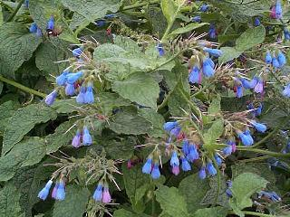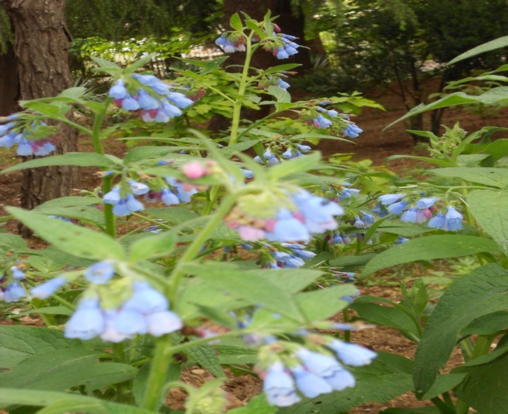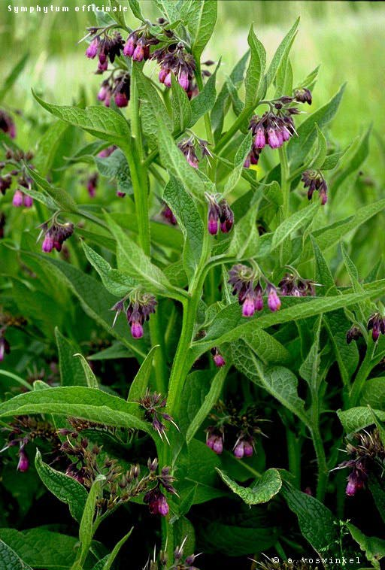
Symphytum asperum S.caucasicum S..officinale
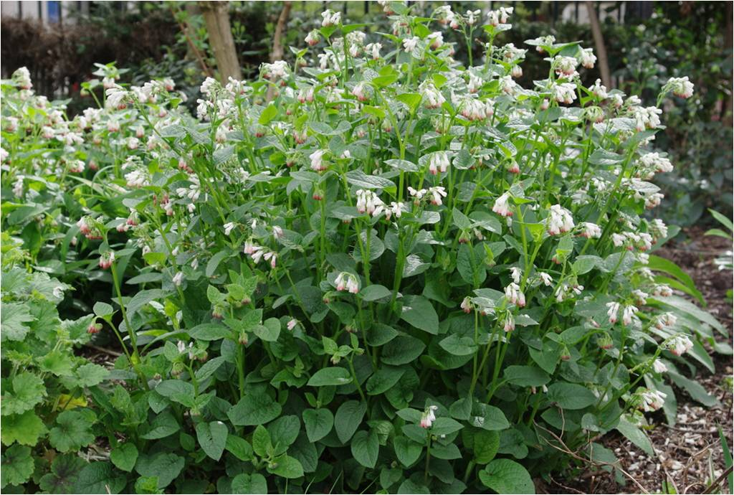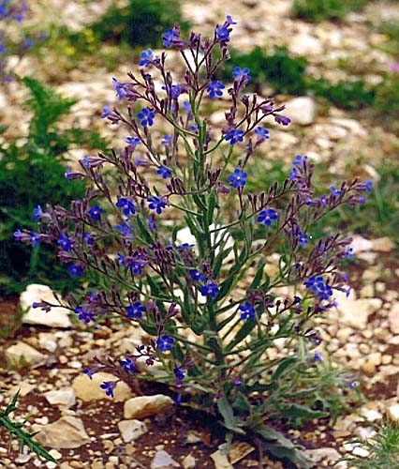
S.grandiflorum Ancchusa italica

- Reference:
- Barbakadze V., E. Kemertelidze, I. Targamadze, K. Mulkijanyan, A.S. Shashko and A.I. Usov, 2005. Poly[3-(3,4-dihydroxyphenyl)glyceric acid], a new biologically active polymer from Symphytum asperum Lepech. and S.caucasicum Bieb. (Boraginaceae). Molecules, 10:1135-1144.

- Shrotriya S., G. Deep, K. Ramasamy, K. Raina, V. Barbakadze, M. Merlani, L. Gogilashvili, L. Amiranashvili, K. Mulkijanyan, K. Papadopoulos, C. Agarwal and R. Agarwal, 2012. Poly[3-(3, 4-dihydroxyphenyl) glyceric] acid from comfrey exerts anti-cancer efficacy against human prostate cancer via targeting androgen receptor, cell cycle arrest and apoptosis. Carcinogenesis 33, 8:1572-1580.

- Merlani M., Y. Koyama, H. Sato, L. Geng, V. Barbakadze, B. Chankvetadze and T. Nakano, 2015. Ring-opening polymerization of a 2,3-disubstituted oxirane leading to a polyether having a carbonyl–aromatic π-stacked structure. Polymer Chemistry 6, 11:1932-1936.
- Biography:
Vakhtang Barbakadze has his expertise in isolation and structure elucidation of a new series of plant polyethers, which are endowed with pharmacological properties as anticancer agents. He has completed his Ph.D and D.Sci. in 1978 and 1999. He is the head of Department of plant biopolymers and chemical modification of natural compounds at the Tbilisi State Medical University Institute of Pharmacochemistry. 1996 and 2002 he has been a visiting scientist at Utrecht University, The Netherlands, by University Scholarship and The Netherlands organization for scientific research (NWO) Scholarship Scientific Program, respectively. He has published more than 100 papers in reputed journals.

- Presenting author details

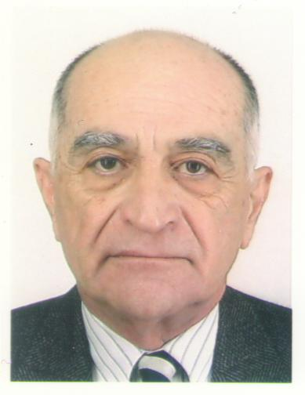
Full Name: Vakhtang Barbakadze
Contact number: +995595531509
Twitter account: https://twitter.com/vvbarbakadze
Linked In account: http://lnkd.in/pQQgMB
Session name/ number: Medicinal Plant Sciences/Session 8
Category: (Oral presentation/ Poster presentation) Oral presentation
Passport Number: 10AB18234

„The presentation was supported by Shota Rustaveli National Science Foundation of Georgia (SRNSFG) [grant number .....?]“

