The molecular mechanism behind the primed seed of cotton (Gossypium hirsutum L.)
Ghulam Abbas Narejo*, MPhil, PMNH, Pakistan
Amir Hussain, MPhil, PMNH, Pakistan
Zil-e-Haleefah, MPhil, PMNH, Pakistan

Abstract (300-word limit)
The molecular mechanisms behind the seed priming are still a mystery. However, advanced molecular tools such as genomics, transcriptomics, and proteomics have added significant information. Seed priming is a seed pre-soaking technique that is used to initiate pre-germination processes inside by activating the expression of certain genes. This study was designed to reveal important molecular mechanisms behind cotton seed priming. Seed priming completes into three phases: I. Imbibition phase, II. Lag phase, and III. Radicle emergence phase. Proteomic analysis revealed that GhAKT1 (K⁺ channel gene) was activated and expressed during phase I of primed seeds and facilitated the transport of K⁺ and elongation of embryonic cells in primed seeds. The repair and synthesis of new mitochondria were also observed in primed seeds by the resumption of respiratory activities. However, expression of ACT7 (Actin-gene) was also observed in primed seeds. In Phase II, more RNA transcripts were found than unprimed seeds. Several events were revealed, including the mitochondrial repair, synthesis of new mitochondria, and proteins. The embryonic expansion also began due to the expression of the GhAKT1 gene. The proteomic analysis also revealed the synthesis of α-amylase, β-amylase, protease, and isocitrate lyase in primed seeds which are required for degradation and translocation of reserve food. The end of Phase II and the start of Phase III marked by radicle protrusion through the testa/seed coat. During the third phase, there was a significant increase of actin proteins found in primed seeds which characterized cell division. Radicle cells elongation was also noted by following the activity of ACT7, and GhAKT1 genes.

Image
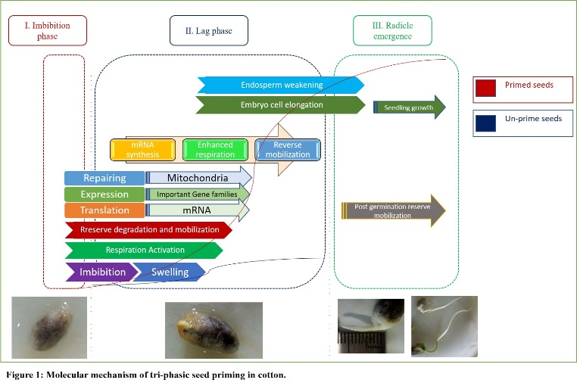
Recent Publications (minimum 5)
- Gallardo K, Job C, Groot S, Puype PC, Demol M, Vandekerekhove H, Job D (2004) Proteomics of Arabidopsis seed
germination and priming. The Biol of Seeds: Recent Advances (eds Nicholas G et al.), CABI, Cambridge pp. 199-209.
- Rosental L, H Nonogaki, Fait A (2014) Activation and regulation of primary metabolism during seed germination.
Seed Sci. Res. 24, 1-15.
- Sun Z, Li H, Zhang Y, Li Z, Ke H, Wu L, Zhang G, Wang X, Ma Z (2018) Identification of SNPs and candidate genes
associated with salt tolerance at the seedling stage in cotton (Gossypium hirsutum L.). Front Plant Sci 9:1011
doi:10.3389/fpls.2018.01011.
- Xu J, Xiaoli T, Egrinya E, Zhaohu L (2014) Functional characterization of GhAKT1, a novel Shaker-like K+ channel
gene involved in K+ uptake from cotton (Gossypium hirsutum L.). Gene 545: 61-71.
- Yanchao Y, Huixian X, Wenguan Z, Jialing X, Lili M, Liyuan W, Wei F, Jincai T, Haoran W, Haijun Z, Qingkang
W, Guihua Z, Xianliang S, Xue-Zhen S (2019) Genome-wide association and differential expression analysis of salt
tolerance in Gossypium hirsutum L at the germination stage. BMC Plant Biol. 19:394.

 Biography (150-word limit)
Ghulam Abbas has his expertise in seed priming, soil salinity (Plant Stress Physiology), and passion for improving the health of saline soil. He is working on different methods to find out suitable techniques to grow crops in saline soil. He is also working on molecular tools to find out and improve genes responsive to salt tolerance, particularly in cotton. He is also currently working usefulness of Algal extract (bio-priming) against the environmental stress of different crop plants. He did work on physical, physiological, and molecular aspects of seed priming under salinity stress during his Masters’ project. His work to develop a sustainable approach that will offer a new area of farming for farmers and the economy.

Contact Details:
Email: Ghulam.abbas@pmnh.gov.pk
Contact Number: 00 92 303 3235749
Linked In/twitter Account Id: https://www.linkedin.com/in/ghulam-abbas-narejo-4627a7117/
Facebook profile: https://www.facebook.com/ganarejo1
Session:
Presentation Category: E-Poster
Notes/Comments: The above work is purely from my Masters’ thesis.

