Biochemical Responses of some commercial Grapevine cultivars Grafted on Ch1 (Vitis vinifera L.) Rootstock under Drought Stress Condition

Valiollah Rasoli^{1,}*, Hamed Rahmani², Vahid Abdossi³

(1) Assistant Professor (Ph.D.), Temperate Fruit Research Center, Horticultural Sciences Research Institute, Agricultural Research, Education and Extension Organization (AREEO), Karaj, Iran. Email: spiiqv@gmail.com
(2) Ph.D. candidate, Department of Horticulture science and agronomy, science and research branch, Islamic Azad University, Tehran, Iran. Email: hamedrahmanij@gmail.com
(3) Assistant Professor (Ph.D.), Department of Horticulture science and agronomy, science and research branch, Islamic Azad University, Tehran, Iran. Email:abdossi@yahoo.com

ABSTRACT
Drought stress is the most important environmental limiting factor of the growth, development, and yield of crop plants and horticulture. In this study, the induction of drought resistance of commercial cultivars (as scion) by Ch1 rootstock was evaluated based on biochemical responses. Factorial experiment was performed in a completely randomized design (CRD) with three replications in the greenhouse. Plant materials consisted of five commercial grapevine cultivars (own-rooted plants of Black seedless, Flame seedless, Turkman seedless, Soltana, and Shahani and the scion these cultivars grafted on Ch1 rootstock). Drought stress treatment was irrigation stopping for 30 days from July to August and without irrigation stopping was as and control. Ch1 rootstock significantly increased the amount of proline, total protein, and enzyme activity of guaiacol peroxidase and catalase of cultivars in drought stress environment. The amount of hydrogen peroxide decreased in all grafted cultivars on Ch1 in both stress and non-drought stress environments by 14.3% and 18.9%, respectively. Soltana cultivar grafted on Ch1 rootstock showed the highest drought resistance. Therefore, it can be concluded that Ch1 rootstock is recommended as a rootstock for inducing drought resistance in grapevine cultivars scion.
Key words: Own rooted grapevine, grafting, drought tolerance, catalase, proline. Membrane Stability Index

Introduction
Iran is one of the major producers of grapes with 3.02 million tons of production and is ranked 10th in the world after China, Italy, the United States of America, Spain, France, Turkey, India, Argentina, and Chile (FAO, 2020). In most parts of Iran, as in other parts of the world, drought is the most important environmental limiting factor of the growth, development, and yield of crop plants and horticulture (Chaves, 2000; Rasoli, et al., 2015).
Iran has a high genetic diversity as one of the centers of origin of grapevine in the world. Iranian grapevine cultivars and genotypes are very diverse in tolerating all kinds of biotic and abiotic stresses. Studies conducted to evaluate the drought resistance of commercial Iranian grapevine cultivars show their moderate resistance (Rasoli, et al., 2015). Therefore, the use of drought-resistant rootstocks to reduce the effects of drought stress is more important (Rasoli, et al., 2015). Identifying or establishing biotic and abiotic stress-resistant rootstocks is one of the important strategies of fruit tree breeding programs (Rasoli, et al., 2015). Furthermore; the rootstocks directly affect the resistance, adaptability, tolerance, and quality of the grape production and indirectly affect the control of growth, ripening time, and berry size (Shaffer et al., 2004).
Although grapevines are relatively drought-tolerant, lack of rainfall in the spring and summer causes the growth cycle of grapevines to be negatively affected by high temperatures, increasing evapotranspiration, and finally drought stress. Since the response to drought stress varies according to the genetic background of the plant, using drought-resistant genotypes and rootstocks is the one of appropriate strategies to improve fruit trees in drought conditions (Cattivelli et al., 2008; Lovisolo et al., 2010; Liu et al., 2012).
In the study of the effect of drought resistance rootstocks on Cabernet Savingon cultivar, it was reported that 110R, 140Rug, 1103P, and 44-53M rootstocks had the highest inducible effect on leaf water potential and photosynthesis rate of scion in the drought stress conditions (Nikolaou et al. 2003).
Grapevine rootstocks of 110R and SO4 had increased drought stress tolerance in Cardinal and Superior seedless scions; which Cardinal with SO4 and Superior seedless with 110R were the best grafting combination. In addition, drought tolerance was positive significantly associated with the accumulation of soluble sugars and proline as well as the balance of K⁺ and Na⁺ in the leaves (Toumi et al., 2007). In addition, Tramontini et al. (2013) reported that there was an effective rootstock- scion interaction to water absorption from the soil and the stomatal control susceptibility in drought conditions.
The use of 5BB and 99R rootstocks increased drought stress tolerance in Italian grape cultivar compared to own root seedlings (Sabir, 2016). The rootstock effect on yield, vegetative growth rate, yield, pruning weight, and berry weight had been demonstrated in Chardonnay and Cabernet Sauvignon cultivars (Migicovsky et al., 2021). Rootstocks also play an essential role in metabolites in the scion. It has been reported that grapevine scion grafted on 101.14 and M4 rootstocks had different responses in oxidative stress, protein, secondary metabolism, energy metabolism, hormone, modulation of C metabolism, osmotic responses, levels of ABA, stomatal control, and mitochondrial function in the drought stress environment (Prinsi et al., 2018; Prinsi et al., 2021).
From a physiological point of view, stomata closure, in response to water status declines, is one of the first responses to water stress to prevent the hydraulic failure (Charrier et al., 2018; Cardone et al., 2019). Many scientists described variation in stomata control and proposed a physiological classification of plants as isohydric or anisohydric. Isohydric species can maintain a constant midday leaf water potential (Ψ leaf), by closing their stomata, regardless of soil water availability; whereas anisohydric species maintain higher stomatal aperture to optimize photosynthetic activity, but their Ψ leaf significantly declines as soil water deficit increases (Charrier et al., 2018; Cardone et al., 2019). However, this framework is still debated considering that grapevine cultivars can exhibit, for instance, both near iso- or anisohydric behaviors depending on the environmental conditions (Chaves et al., 2010; Dal Santo et al., 2016). In particular, a key role in the determination of the degree of iso/anysohydricity is played by the hydraulic properties of the soil (Cardone et al., 2019; Tramontini et al., 2014; Domec and Johnson, 2012) and by the rootstock (Cardone et al., 2019; Merli et al., 2016).
Ch1 is one of the Iranian rootstocks of grapevine that is resistant to drought stress, salinity, and lime of soil (Rasoli and Golmohammadi, 2010). In this study, the inducible effects of Ch1 were evaluated on the physiological and biochemical behaviors of some grapevine cultivars under drought stress.

Materials and Methods
Plant materials
Plant materials included Ch1 (as drought-tolerant rootstock) and five commercial grapevine cultivars (Black seedless, Flame seedless, Turkman seedless, Soltana, and Shahani). Ch1 was used as a rootstock and the scions of five cultivars were grafted on it. As well as, own-rooted plants of commercial cultivars were prepared.
Experimental conditions
Experimental treatments included three factors: a) five cultivars, b) own-rooted plant and grafted on Ch1rootstock, and c) drought stress (with &without drought stress). All grafted and own-rooted cultivars were planted in 20-liter pots. Each pot was filled with cocopeat and perlite (3:1). A factorial experiment was conducted in a completely randomized design (CRD) with three replications (three pots and two plant in each pot for each treatment). Therefore, there were 60 pots as fallow:
5 (cultivars) ×2 (own-rooted & grafted plant) ×2 (with &without drought stress) ×3 (rep.) =60
All pots were divided into two groups. The first group was drought treated and the second group was without drought stress. Drought stress treatment was performed by stopping irrigation for 30 days from 15th July to 15th August. The whole experiment lasted from February to the end of September for eight months. Each pot was irrigated with 2 liters of water every five days. All experiments were carried out in a greenhouse (with a temperature of 32±32°C, humidity of 60%, and natural light).
The studied traits
Samples were taken from the leaves of each treatment separately in 15th August and physiological and biochemical studies were performed.
Bradford (1976) method was used to determine the protein concentration. Bates et al. (1973) method was used to measure the proline concentration using hydrate solution of 3% sulfosalicylic acid. L-proline was used to draw the standard curve of proline at concentrations of 100, 50, 25, 12.5, and 0 µM and toluene was used as a control (0 level). To measure the amount of hydrogen peroxide, the Alexiva (2001) 0.1% trichloroacetic acid (TCA) method was used. To measure the quantitative concentration of guaiacol peroxidase enzyme, Chance and Mahli method (1995) was used. Nakano and Asada (1981) methods was used to measure the ascorbic peroxidase activity. Dehyndza (1981) method was used to measure the quantitative concentration of catalase activity. Leaf sodium and potassium were measured by Hamada and Elena method (1994) based on leaf ash using flame photometer (JENWEY Co., LTD, England).
Statistical analysis
Analysis of variance (ANOVA) was performed Factorial CRD. An error level of 5% was used for the accuracy of the test. The means were compared using Duncan's multiple range test (DMRT). Statistical analysis was performed by Gen-Stat Ver.12 statistical software. The graphs were drawn using Microsoft Excel software Ver. 2013.
Results and Discussion
The independent effect means comparing drought stress were shown in Table 1. Drought stress significantly increased catalase, hydrogen peroxide, proline, ascorbic acid, guaiacol peroxidase, and protein (P <0.05).
Table 1: The means comparison of drought stress effect on the physiological and biochemical traits.
Variables | Drought stress | No Stress | Difference | P. Value
Catalase (mM/min) | 2.33±.154 | 2.17±0.15 | 0.16 | 0.01
Peroxide hydrogen (µM) | 0.81±.19 | 0.66±.17 | 0.14 | 0.01
Proline (µM /g leaf) | 0.31±0.15 | 0.21±0.13 | 0.09 | 0.02
Ascorbic peroxidase (mM/min) | 1.86±0.38 | 1.4±0.33 | 0.42 | 0.008
Guaiacol peroxidase (mM/min) | 0.75±0.395 | 0.38±0.25 | 0.36 | 0.01
Protein (µM /ml) | 1.23±0.12 | 1.1±0.15 | 0.1 | 0.01

In the independent effect means comparing of rootstock type on the studied traits, the mean of Ascorbic acid in grafted and own-root treatments was not significantly different (P> 0.05); while there were significantly different (P <0.05) in the means of catalase, hydrogen peroxide, guaiacol peroxidase, and proline. Ch1 rootstock significantly decreased hydrogen peroxide, and proline and significantly increased catalase, and protein compared to own root treatment (P <0.05, Table 2).
Table 2: The mean comparing of effect of rootstock type on the studied traits.
Variables | Own root | Grafted on Ch1 | Difference | P. Value
Catalase (mM/min) | 2.23±0.17 | 2.91±0.18 | 0.05 | 0.044
Peroxide hydrogen (µM) | 0.79±0.18 | 0.66±0.20 | 0.1 | 0.023
Proline (µM /g leaf) | 0.27±0.17 | 0.35±0.11 | 0.11 | 0.001
Ascorbic peroxidase (mM/min) | 1.68±0.48 | 1.67±0.35 | 0.01 | 0.88
Guaiacol peroxidase (mM/min) | 0.51±0.30 | 0.65±0.43 | 0.14 | 0.04
Protein (µM /ml) | 1.04±0.13 | 1.29±0.13 | 0.08 | 0.006

The comparison of the mean of the triple interaction (cultivar × rootstock × drought stress) in biochemical traits was shown in Figure 1. Ch1 rootstock significantly increased leaf Catalase of cultivars in both environments; so that this increase in stress and the non-stress environment was 30.4% and 22.3%, respectively. The highest and lowest leaf catalase levels were observed in all grafted cultivars on Ch1 and Own-rooted Shahani, respectively (Figure 2a). The amount of ascorbic peroxidase was significantly different in cultivars, but the rootstock type had no significant effect on the amount of ascorbic peroxidase in with and without drought stress (Figure 2d).
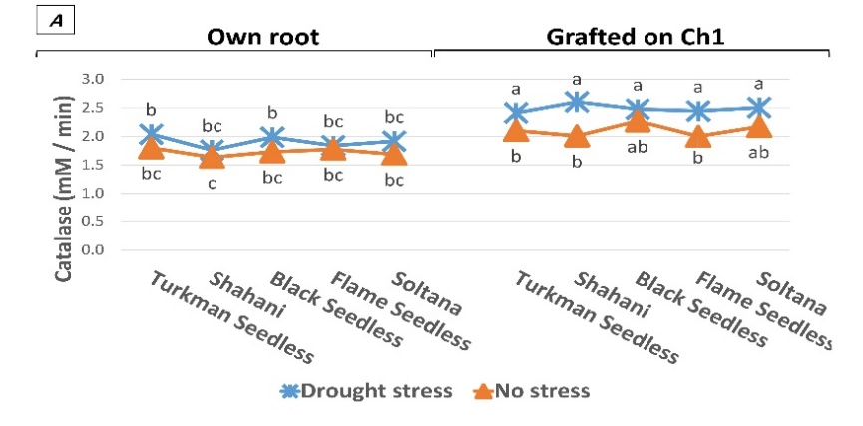 | 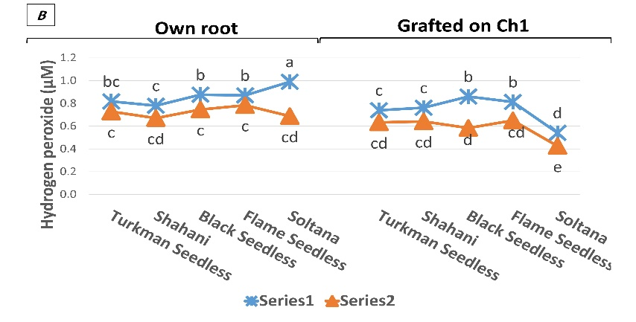
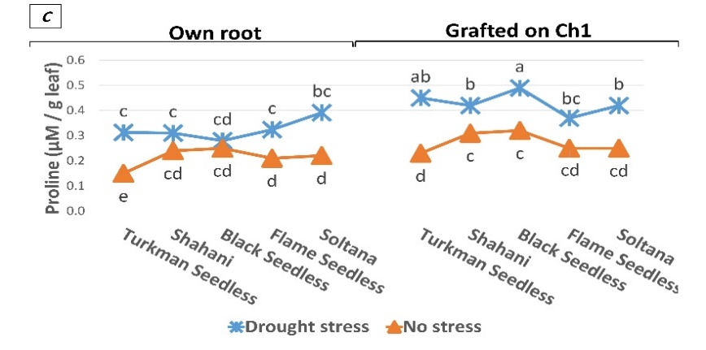 | 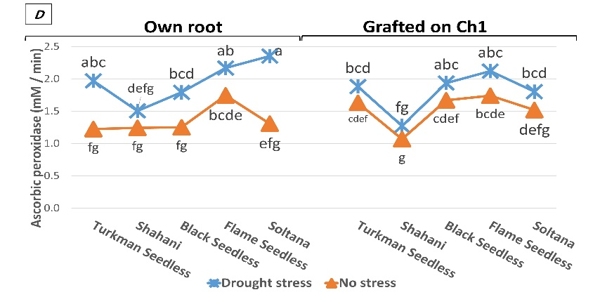
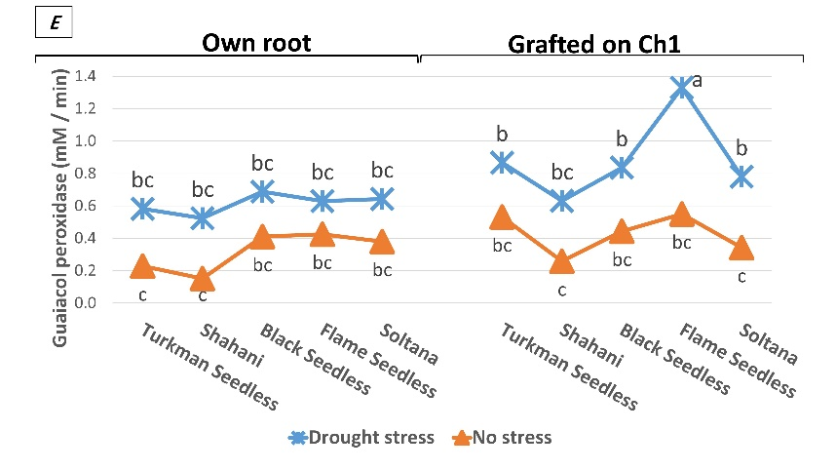 | 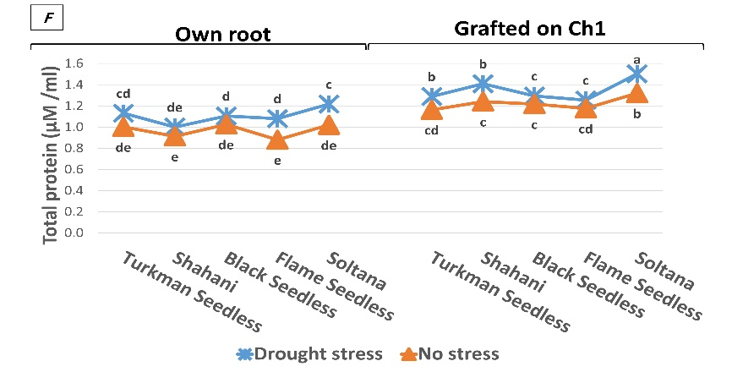
Figure 1: The means comparison of the triple interaction (cultivar × rootstock × drought stress) in biochemical traits by DMRT method.
The amount of guaiacol peroxidase in grafted cultivars on Ch1 was significantly higher than own-rooted cultivars in drought stress environment so that the amount of guaiacol peroxidase was 44.8 and 33.3% in grafted cultivars on Ch1 in stress and non-drought environments, respectively (Figure 2e). Increased activity of antioxidants during drought stress indicates plant tolerance to drought stress (Noctor et al., 2014). Induction of antioxidant enzyme activity is a general adaptation strategy that plants use to overcome damage caused by oxidative stress (Noctor et al., 2014). Catalase, Ascorbic peroxidase, and guaiacol peroxidase are antioxidant enzymes that increase their activity under stress (Sharma and Dubey, 2005; Wang et al, 2005; Chakraborty and Pradhan, 2011). The coordinated activity of these enzymes may act as an effective antioxidant defense against the effects of reactive oxygen species in drought stress conditions. A number of plants’ enzymes regulate the intracellular level of hydrogen peroxide, that Catalase, guaiacol peroxidase, and ascorbic peroxidase are more important (Noctor and Foyer, 1998). In the present study, the higher activity of antioxidant enzymes in grafted cultivars on Ch1 could help protect cell membranes and photosynthetic apparatus against oxidative damage and more tolerance of these cultivars in drought stress. Lower values of oxidative stress indexes such as EL and hydrogen peroxide in grafted Flame seedless on Ch1 can also be attributed to higher activity and better efficiency of the antioxidant enzymes. Higher activity of antioxidant enzymes in drought-resistant cultivars had been reported in other types of environmental stresses such as cold and salinity (Wang et al, 2009).
In the present study, the amount of hydrogen peroxide was reduced in all Grafted grapevine cultivars on Ch1 in both environments, so that these reductions in stress and non-stress environment were 14.3% and 18.9%, respectively. The highest and lowest levels of hydrogen peroxide were obtained in own-rooted and grafted Soltana on Ch1, respectively (Figure 2b). Normal activity of cellular metabolism undergrowth periods leads to the regular production of reactive oxygen radicals. Biotic and abiotic stresses cause an imbalance between the production and purification of oxygen free radicals and thus increase their concentration in the cell (Kar, 2011). Increased drought hydrogen peroxide content, especially in more sensitive cultivars and genotypes, had been confirmed in many studies (Wang et al., 2012; Chakraborty and Pradhan, 2011). The low amount of hydrogen peroxide can be due to the better performance of the antioxidant defense system (CAT and POD enzymes) in resistant cultivars (Wang et al., 2012; Chakraborty and Pradhan, 2011).
Drought stress increased the proline content by 29.6% compared to the non-stress environment. The amount of proline in all grafted grapevine cultivars on Ch1 increased compared to own-rooted cultivars so that this increase was 32.8% in the environment with drought stress and 27.1% in the environment without drought stress. The highest and lowest proline levels in drought stress conditions were observed in grafted on Ch1 and own-rooted Black seedless cultivar, respectively. In a stress-free environment, the highest and lowest proline levels were observed in grafted Black seedless on Ch1 and own-rooted Turkmen Seedless cultivars, respectively (Figure 2c). The amount of proline in the grapevine increases with increasing drought stress. Compatible solvents such as proline do not interfere with normal cell biochemical reactions and act as osmotic protectors during osmotic stress. Physiological action of proline, sugars, and other osmotic compounds that maintain the stability of cell membranes, due to their inhibitory effect on bonding between adjacent membranes during periods of stress and storage of lipids and stability of proteins through the formation of hydrogen bonds with linear proteins, gene regulation, and osmotic regulation (Shariat and Assareh, 2006). An increase in proline content with the intensification of drought stress, in addition to the present study in other studies on various plants, was also observed such as cherries (Sivritep et al., 2008), corn (Helal and Abdolaziz, 2008), and rice (wang et al., 2009).
Total protein increased significantly in grafted cultivars on Ch1. Ch1 rootstock increased total protein by 22.1% and 26.4% in with and without drought stress environment, respectively. The highest total protein content was observed in grafted Soltana on Ch1 cultivar in drought stress and the lowest was found in own-rooted Flame seedless cultivar in without drought stress (Figure 2f). The amount of soluble protein content is one of the traits in plants affected by stress that decreases with increasing drought stress (Gill & Tuteia, 2010). The reason for this decrease is the increase in the activity of protein-degrading enzymes such as protease and the accumulation of amino acids such as proline. However, in the present study, the use of Ch1 rootstock prevented the reduction of total protein and subsequently reduced the effect of drought stress on grafted cultivars. In grafted on Ch1 cultivars, protein reduction was less than own-rooted, which may be due to the reduction of complex variability of protein materials in drought stress (Bertamini et al., 2006), which indicates that grafted cultivars on Ch1 were less sensitive than own-rooted cultivars in drought stress condition.
Conclusion
The results of this study showed that the increase of the level of antioxidant activity and proline content by Ch1 rootstock increased the tolerance of grafted cultivars in drought stress environment, which in turn reduced hydrogen peroxide content and thus reduced cell damage in drought stress. In other words, there is a negative relationship between the increase of antioxidant activity and proline with the decrease of hydrogen peroxide. On the other hand, unlike other studies, the use of Ch1 rootstock prevented the reduction of total protein and subsequently reduced the effect of drought stress on grafted cultivars. Therefore, Ch1 rootstock should be recommended as a rootstock for inducing drought resistance in grapevine cultivars. Among grapevine cultivars, Soltana cultivar with Ch1 rootstock showed the highest resistance to drought stress.
Literature Cited
Alexieva, V., Sergiev I., Mapelli S. & Karanov, E., 2001. The effect of drought and ultraviolet radiation on growth and stress markers in pea and wheat. Plant Cell Environ. 24, 1337-1344.
Arve, L.E., Torre, S., Olsen, J.E. & Tanino, K.K., 2011 Stomata responses to drought stress and air humidity. In: Shanker, A. & Venkateswarlu, B., (Eds) Abiotic Stress in Plants- Mechanisms and Adaptations. InTech Open Access Publisher, Vienna, Austria.
Bajji, M. & Kinet, J.M.S., 2002. The use of the electrolyte leakage method for assessing cell membrane stability as a water stress tolerance in durum wheat. Plant Growth Regul. 36, 61-70.
Bates, L.S., Waldern, R.P. & Teave, I.D., 1973. Rapid determination of free proline for water stress standies. Plant and Soil 39, 205-107.
Bertamini, M., Zulini, L., Muthuchelian, K. & Nedunchezhian, N., 2006. Effect of water deficit on photosynthetic and other physiological responses in grapevine (Vitis vinifera L. cv. Riesling) plants. Photosynthetica 44, 151-154.
Bradford, M.M., 1976. A rapid and sensitive method for the quantitation of microgram quantites of protein utilizing the principles of protein dyebinding. Anal. Biochem. 72, 248-254.
Cattivelli, L., Rizza, F., Badeck, F. W., Mazzucotelli, E., Mastrangelo, A. M., & Francia, E., 2008. Drought tolerance improvement in crop plants: an integrated view from breeding to genomics. Field Crops Res. 105, 1-14.
Chakraborty, U. & Pradhan, B., 2011. Drought stress-induced oxidative stress and antioxidative responses in four wheat (Triticum aestivum L.) varieties. Arch. Acker Pflanzenbau Bodenkd. 58, 617-630.
Chance, B. & Maehly, A.C., 1995. Assay of catalase and peroxidase. In: Culowic, S.P. & Kaplan, N. O. (eds). Methods in enzymology Vol. 2. Academic Press. Inc. New York. PP 764-765
Chaves, M.M., Pereira, J.O.S., Maroco, J.O., Rodrigues, M.L., Ricardo, C.N.P.P. & Osorio, M. L., 2002. How plants cope with water stress in the field? Photosynthesis and growth. Ann. Bot. 89, 907-916.
Choi, Y.J., Hur, Y.Y., Jung, S.M., Kim, S.H., Noh, J.H., Park, S.J. & Yun, H.K., 2013. Transcriptional analysis of Dehydrin1 genes responsive to dehydrating stress in grapevines. Hortic. Environ. Biotechnol. 54, 272-279.
Dhanda, S.S. & Sethi, G.S., 1998. Inheritance of excised- leaf water loss and relative water content in bread wheat (Triticum aestivum). Euphytica 104, 39–47.
Dhindsa, R.S., Plumb-Dhindsa P. & Thorpe, T.A., 1981. Leaf senescence: correlated with increased levels of membrane permeability and lipid peroxidation, and decreased levels of superoxide dismutase and catalase. J. Exp. Bot. 32, 93-101.
FAO. 2020. Food and agriculture organization of the United Nations. Rome, Italy.
Flexas, J. & Medrano, H., 2002. Drought-inhibition of photosynthesis in C3 plants: stomatal and non-stomatal limitation revisited. Annu. Bot. 89,183-189.
Gärtel, W., 1996. Grapes. In: “Nutrient Deficiencies and Toxicities in Crop Plants”, (Ed.): Bennett, W. F. APS, St. Paul, MN, PP.177–183.
Gill, S.S. & Tuteja, N., 2010. Reactive oxygen species and antioxidant machinery in abiotic stress tolerance in crop plants. Plant Physiol. Biochem. 48, 909-930.
Hamada, A.M., & EL-enany, A.E., 1994. Effect of NaCl salinity on growth, pigment and mineral element contents, and gas exchange of broad bean and pea plants. Biologia. Plantarum. 36, 75- 81.
Helal, R.M. & Abdolaziz, S.M., 2008. Comparative response of drought tolerant and drought sensitive maize genotypes to water stress. Aust. J. Crop Sci. 1, 31-36.
Hugalde, I.P., & Vila, H.F., 2014. Isohydric or anisohydric behavior on vines an endless controversy? Rev. de Investig. 40, 75-82.
Kafi, M., Buarzouei, A., Salehi, M., Kamandi, A., Masoumi, A. & Nabati, J., 2009. Physiology of environmental stresses in plants. First Edition. Mashhad University Jihad Press. Mashhad, Iran, pp. 451-455.
Kar, R.K., 2011. Plant responses to water stress: role of reactive oxygen species. Plant Signal. Behav. 6, 1741-1745.
Karimi, S., Yadollahi, A., Arzani, K., Imani, A. & Aghaalikhani, M., 2015. Gas- exchange response of almond genotypes to water stress. Photosynthetica 53,29-34.
Kuster, T.M., Matthias, A., GünthardtGoerg, M.S. & Schulin, R., 2013. Root growth of different oak provenances in two soils under drought stress and air warming conditions. Plant Soil. 369, 61–71.
Liu, B.H., Cheng, L., Liang, D., Zou, Y.J. & Ma, F.W., 2012. Growth, gas exchange, water-use efficiency, and carbon isotope composition of ‘Gale Gala’ apple trees grafted onto 9 wild Chinese rootstocks in response to drought stress. Photosynthetica 50, 401-410.
Lovisolo, C., Perrone, I., Carra, A., Ferrandino, A., Flexas, J., & Medrano, H., 2010. Drought-induced changes in development and function of grapevine (Vitis spp.) organs and in their hydraulic and non-hydraulic interactions at the whole-plant level: a physiological and molecular update. Funct. Plant Biol. 37, 98-116.
Migicovsky, Z., Cousins, P., Lindsay, M.J., Myles, S., Striegler, R.K., Verdegaal, P. & Chitwood D.H., 2021. Grapevine rootstocks affect growth-related scion phenotypes. Bio. Rxiv, 10: 1-10.
Nakano, Y. & Asada, K., 1981. Hydrogen peroxide is scavenged by ascorbate-specific peroxidase in spinach chloroplasts. Plant Cell Physiol. 22, 867–880.
Nikolaou, N., Angelopoulos, K. & Karagiannidis, N., 2003. Effects of drought stress on mycorrhizal and non-mycorrhizal Cabernet Sauvignon grapevine, grafted onto various rootstocks. Exp. Agric., https://doi.org /10.1017/ S0014479703 001 25X.
Noctor, G. & Foyer, C.H., 1998. Ascorbate and glutathione: keeping active oxygen under control. Annu. Rev. Plant Biol., 49, 249-279.
Noctor, G., Mhamdi, A. & Foyer, C.H., 2014. The roles of reactive oxygen metabolism in drought: not so cut and dried. Plant Physiol. 164, 1636-1648.
Prinsi, B., Simone, N.A., Failla, O., Scienza, A. & Espen, L., 2018. Root proteomic and metabolic analyses reveal specific responses to drought stress in differently tolerant grapevine rootstocks. BMC Plant Biol. 18, 126-134.
Prinsi, B., Simeoni, F., Galbiati, M., Meggio, F., Tonelli, C., Scienza, A. &Espen, L., 2021. Grapevine rootstocks differently affect physiological and molecular responses of the scion under water deficit condition. Agronomy 11, 289-298.
Rasoli, V. & Golmohammadi, M., 2010. Evaluation of drought tolerance of grape cultivars in Qazvin province. Seed Plant Improv. 1, 359-349.
Rasoli, V., Farshadfar, E. & Ahmadi, J., 2015. Evaluation of genotype × environment interaction of grapevine genotypes (Vitis vinifera L.) By Non Parametric Method. J. Agr. Sci. Tech. 17, 1279-1289.
Sabir, A., 2016. Vegetative and reproductive growth responses of grapevine cv. 'Italia' (Vitis vinifera L.) grafted on different rootstocks to contrasting soil water status. J. Agr. Sci. Tech. 18, 1681-1692.
Sairam, R.K., 1994. Effect of moisture stress on physiological activities of two contrasting wheat genotypes. Indian. J. Exp. Biol. 32, 584-593.
Shaffer. R., Sampaio, T.L., Pinkertorn, J. & Vasconcelos, M.C. 2004. Grapevine root stocks for Oregan vineyards. Extension Service Oregan State University. pp. 201-209
Shariat, A. & Assareh, M.h., 2006. Effect of drought stress on pigments, soluble sugars and growth characteristics of four eucalyptus species. J. constr. res. 78, 149-139.
Sharma, P. & Dubey, R.S., 2005. Drought induces oxidative stress and enhances the activities of antioxidant enzymes in growing rice seedlings. Plant Growth Regul. 46, 209-221.
Sivritepe, N., Sivritepe, N., Erturk, U., Yerlikaya, C., Turkan, I., Bor M. & Ozdemir, F., 2008. Response of the cherry rootstock to water stress induced in vitro. Biol. Plant. 52, 573–576.
Toumi, I., M'sehli, W., Bourgou, S., Jallouli, N., Bensalem-Fnayou, A., Ghorbel, A. & Mliki, A., 2007. Response of undrafted and grafted grapevine cultivars and rootstocks (Vitis sp.) to water stress. J. Int. Sci. Vigne Vin. 41, 85-94.
Tramontini, S., Vitali, M., Centioni, L. & Schubert, A., 2013. Claudio Lovisolo Rootstock control of scion response to water stress in grapevine. Environ. Exp. Bot. 93, 20-26.
Wang, F.Z., Wang, Q.B., Kwon, S.Y., Kwak, S.S. & Su, W.A., 2005. Enhanced drought tolerance of transgenic rice plants expressing a pea manganese superoxide dismutase. J. Plant Physiol. 162, 465-472.
Wang, F., zeng, B., Sun, Z. & Zhu, C. 2009. Relationship between proline and Hg+2 induced oxidative stress in tolerant rice mutant. Arch. Environ. Contam. Toxicol. 56, 723-731.
Wang, S., Liang, D., Li, C., Hao, Y., Ma, F. & Shu, H., 2012. Influence of drought stress on the cellular ultrastructure and antioxidant system in leaves of drought-tolerant and drought-sensitive apple rootstocks. Plant Physiol. Biochem. 51, 81-89.
Wang, W.B., Kim, Y.H., Lee, H.S., Kim, K.Y., Deng, X.P. & Kwak, S.S., 2009. Analysis of antioxidant enzyme activity during germination of alfalfa under salt and drought stresses. Plant Physiol. Biochem. 47, 570-577.
Charrier, G., Delzon, S., Domec, J.C., Zhang, L., Delmas C.E.L. & Merlin, I. 2018. Drought will not leave your glass empty: Low risk of hydraulic failure revealed by long-term drought observations in world's top wine regions. Sci. Adv. 4, 1-10.
Chaves, M.M., Zarrouk, O., Francisco, R., Costa, J.M., Santos, T. & Regalado, A.P. 2010. Grapevine under deficit irrigation: hints from physiological and molecular data. Ann Bot. 105(5), 661-76.
Dal Santo, S., Palliotti, A., Zenoni, S., Tornielli, G.B., Fasoli, M. & Paci, P. 2016. Distinct transcriptome responses to water limitation in isohydric and anisohydric grapevine cultivars. BMC Genomics, 17, 815-820.
Tramontini, S., Döring, J., Vitali, M., Ferrandino, A., Stoll, M. & Lovisolo, C. 2014. Soil water-holding capacity mediates hydraulic and hormonal signals of near-isohydric and near-anisohydric Vitis cultivars in potted grapevines Funct. Plant Biol. 41, 1119-1128.
Domec, J.C. & Johnson, D.M. 2012. Does homeostasis or disturbance of homeostasis in minimum leaf water potential explain the isohydric versus anisohydric behavior of Vitis vinifera L. cultivars?. Tree Physiol. 32, 245-252.
Merli, M.C., Magnanini, E., Gatti, M., Pirez, F.J., Pueyo, I.B. & Intrigliolo, D.S. 2016. Water stress improves whole-canopy water use efficiency and berry composition of cv. Sangiovese (Vitis vinifera L.) grapevines grafted on the new drought-tolerant rootstock M4. Agric. Water Manage. 169, 106-111.
M.F. Cardone, R. Perniola, C.R. Catacchio, F. Alagna, S. Rotunno, P. Crupi, D. Antonacci, R. Velasco, M. Ventura, and C. Bergamini. Grapevine adaptation to drought: New candidate genes for the genotype-dependent response. BIO Web of Conferences 15, 01016 (2019)

