When agriculture meets nanotechnology: a recipe for success

Vasileios Fotopoulos
Department of Agricultural Sciences, Biotechnology & Food Science, Cyprus University of Technology, 3603 Lemesos, Cyprus

Keywords: nanomaterials; plant priming; abiotic stress; nanoparticles; polymer coatings

- Abstract Body
Global agricultural production is suffering substantial losses due to climate change-related weather events such as drought and salinity, leading to tissue damage and, ultimately, major yield losses. The development of sustainable, ‘green’ technologies is therefore becoming of utmost important, also due to the need for reduced agrochemical use. Nanotechnology provides invaluable tools to a variety of industrial sectors. Increasing attention is being given to the development and optimization of nanomaterials for application in the agricultural industry towards protection against stress and improved growth, based on their small size, high surface to volume ratio and unique optical properties. The current presentation gives an up-to-date description of main research activities carried out at the Cyprus University of Technology with the employment of advanced nanoparticles and polymers applied at plant and seed level. This technology offers an attractive alternative to established approaches such as conventional breeding and genetic modification with key advantages, representing a characteristic example of integrative plant physiology where multiple disciplines such as materials science, agriculture and analytical chemistry join forces to develop exciting new tools in modern agriculture.

- Image:

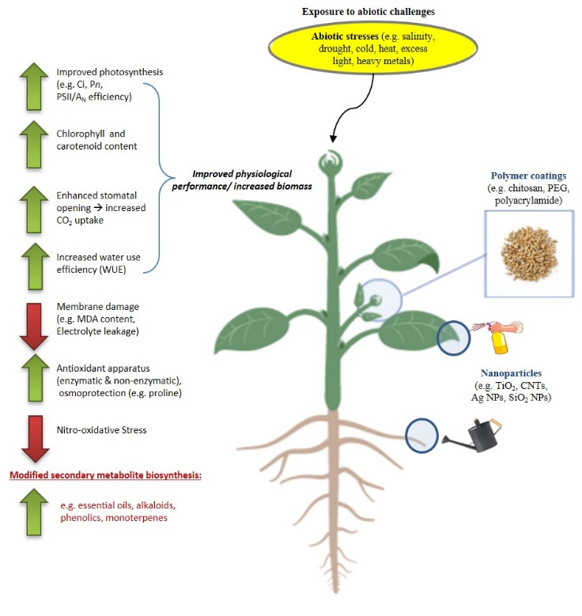
- Reference:
- Gohari G, Zareei E, Rostami H, Panahirad S, Kulak M, Farhadi H, Amini M, Martinez-Ballesta MdC, Fotopoulos V (2021). Protective effects of cerium oxide nanoparticles in grapevine (Vitis vinifera L.) cv. Flame Seedless under salt stress conditions. Ecotoxicology and Environmental Safety 220, 112402.
- Gohari G, Panahirad S, Sadeghi M, Akbari A, Zareei E, Zahedi SM, Bahrami MK, Fotopoulos V (2021). Putrescine-functionalized carbon quantum dot (Put-CQD) nanoparticles effectively prime grapevine (Vitis vinifera cv. ‘Sultana’) against salt stress. BMC Plant Biology 21, 120
- Ioannou A, Gohari G, Papaphilippou P, Panahirad S, Akbari A, Dadpour MR, Krasia-Christoforou T, Fotopoulos V (2020). Advanced nanomaterials in agriculture under a changing climate: the way to the future? Environmental and Experimental Botany 176, 104048.
- Biography:
Vasileios Fotopoulos is Associate Professor in Structural and Functional Plant Biology at the Cyprus University of Technology. His main scientific research focuses on the study of nitro-oxidative signaling cascades involved in plant responses to stress factors, while emphasis is being given in the development of priming technologies towards the amelioration of abiotic stress factors and promotion of plant growth. To date, Dr. Fotopoulos is the author of 87 scientific articles published in peer-reviewed journals (h-index=38), while he serves as Editor-in-Chief in Plant Stress and Associate Editor in Plant Molecular Biology.

- Presenting author details


Full Name: Vasileios Fotopoulos
Contact number: (+357)-25002418
Linked In account: https://www.linkedin.com/in/vassilis-fotopoulos-4ab10428/
ORCID: 0000-0003-1205-2070
Lab website: http://plant-stress.weebly.com

