Adaptation mechanism of mango fruit (Mangifera indica Linn cv. Chaunsa White) to heat suggest modulation in several metabolic pathways

Zainab Khanum^{1,3}, Martín E. Tiznado-Hernández², Arslan Ali¹, Syed Ghulam Musharraf ^{1,3}, Muhammad Shakeel¹ and Ishtiaq Ahmad Khan*¹
¹ Jamil-ur-Rahman Center for Genome Research, Dr. Panjwani Center for Molecular Medicine and Drug Research, International Center for Chemical and Biological Sciences, University of Karachi, Karachi- 75270, Pakistan
² Coordinación de Tecnología de Alimentos de Origen Vegetal, Centro de Investigación en Alimentación y Desarrollo, A. C. Hermosillo, Sonora, México
³ H.E.J. Research Institute of Chemistry, International Center for Chemical and Biological Sciences, University of Karachi, Karachi- 75270, Pakistan
* Correspondence:
Ishtiaq Ahmad Khan
ishtiaqchemist@gmail.com

Abstract

Climate change is becoming a global problem because of its harmful effects on crop productivity. In this regard, it is crucial to carry out studies to determine crops' response to heatwave stress. Response molecular mechanisms during the development and ripening of mango fruit (Mangifera indica L. cv. Chaunsa White) under extreme heatwaves were studied. Mango flowers were tagged and fruits 18, 34, 62, 79, 92 days after flowering (DAF) as well as fruits on 10 and 15 days of postharvest shelf life were studied through RNA-Seq and metabolome of the fruit mesocarp. The environmental temperature was recorded during the experiment. Roughly, 2,000,000 clean reads were generated and assembled into 12,876 redundant transcripts and 2,674 non-redundant transcripts. The expression of genes playing a role in oxidative stress, circadian rhythm, senescence, glycolysis, secondary metabolite biosynthesis, flavonoid biosynthesis and monoterpenoid biosynthesis was quantified as well as reactive oxygen species. Higher expressions of six abiotic stress genes and a senescent associated gene was found at 79 DAF (recorded temperature 44 ℃). Higher expressions of nucleoredoxin and glutathione S-transferase 1 family protein were also recorded. Activation of the GABA-shunt pathway was detected by the glutamate decarboxylase transcript expression at 79 DAF. Larger energy demands at the beginning of fruit ripening were indicated by an increase in fructose-bisphosphate aldolase gene expression. Finally, the radical scavenging effect of mango fruit inflorescence and fruit pulp extracts showed decline upon heatwave exposure. We recorded a broad genetic response of mango fruit suggesting the activation of several metabolic pathways which indicated the occurrence of genetic and metabolic crosstalks in response to intense heatwaves. Collectively, this study presents experimental evidence to help in the elucidation of the molecular mechanism of crops response to heat stress which in turn will help in the designing of protocols to increase crop productivity in the face of climate change.

Image

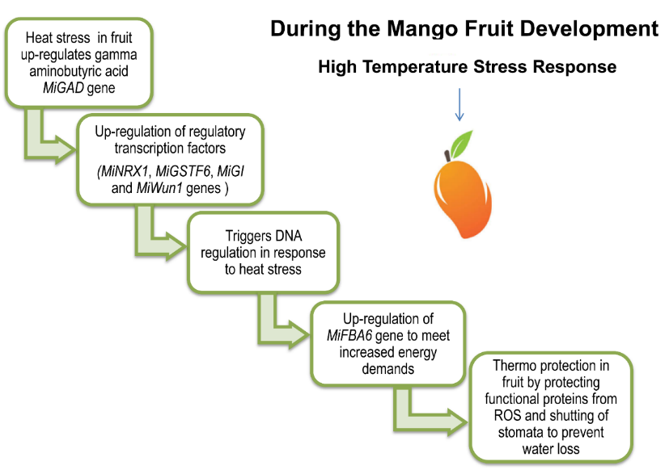

Recent Publications

Khanum, Z., Tiznado-Hernandez, M. E., Ali, A., Musharraf, S. G., Irshad, R., Nizamani, Z. A., & Khan, I. A. (2020). Cytotoxic Evaluation of Antioxidant and Gamma-Amino Butyric Acid (GABA) Enriched Mango (Mangifera indica cv. Chaunsa) Mesocarp Extract on HER2-Positive Breast Cancer Cells. Journal of the Chemical Society of Pakistan, 42(6), 909-918.
Khanum, Z., Tiznado-Hernández, M. E., Ali, A., Musharraf, S. G., Shakeel, M., & Khan, I. A. (2020). Adaptation mechanism of mango fruit (Mangifera indica L. cv. Chaunsa White) to heat suggest modulation in several metabolic pathways. RSC Advances, 10 (58), 35531-35544.

Biography



Zainab Khanum has her expertise in molecular biology and bioinformatics. She has studied the stress response mechanism in mango (Mangifera indica Linn cv. Chaunsa White) fruit during its development and has characterized modulation in several metabolic pathways. Her research work will help scientists and public to understand implications of climate change on food crops in general. Her research work ensures the development of sustainable methods and constructive strategies to tackle food insecurity in the face of climate change.

Contact Details:

Email: zainab12khanum@gmail.com
Contact Number: 0308-0234750
Presentation Category: E-Poster

