Medicinal and Aromatic Plant Science

Ruby Bhullar Garcha, Dr. Anjana Bhatia, INDIA
Ruby Bhullar Garcha, Dr. Anjana Bhatia, INDIA
Abstract
Statement of the problem: The Coronavirus (COVID-19) epidemic has impacted people’s health and health-related importance of life. In addition to non- pharmaceutical interventions, nutrition, and other lifestyle measures influence immune strength and susceptibility to infectious disease. Since the outbreak, there has been no vaccine or specific antiviral medication or clinically approved drug so based on the contribution of past traditional medicine (ethnomedicine) and immune-based therapy as a treatment in critical pathogen outbreaks, we aim the potential use of medicinal and aromatic plants in enhancing immunity as a preventive solution. Methodology & Theoretical Orientation: This paper focuses on the antiviral potential of medicinal plants against coronavirus disease as they are enhanced with diverse phytochemicals through highly active secondary metabolites that can interrupt the replication of several highly pathogenic viruses. The main focus of researchers around the world is designing and identifying inhibitors against all possible viral key protein targets with one of the drug target guanine-N7 methyltransferase which plays a key role in capping the 5ʹ-ends of viral genomic RNA and sub-genomic RNAs to escape host innate immunity. The various computational approach used are homology modeling, protein and ligand preparation, Substrate docking, Molecular docking, High throughput virtual screening, and Molecular dynamics simulation. Findings: A combination of all these computational approaches provides the screened compounds that readily interact with the G3A binding site of the homology modeled N7-MTase domain and will have strong potency towards inhibiting the substrate binding and efficiently hinder the capping mechanism thus making the final compounds COVID-19 therapeutics. Conclusion & Significance: The anti-viral phytochemicals target N7-MTase inhibiting SARS-CoV-2 with the ability of RNA capping mechanism and the failure of which leads to viral RNA degradation, eventually hindering the replication cycle thereby curing COVID-19.

Image:
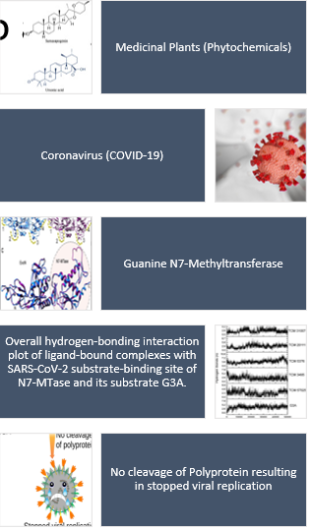
Recent Publications:
- Bhullar, G.R., Bhatia, A. Site Selection criteria and process in a clinical trial. International Journal of Pharmacology and Therapeutics 2020; 10(1): 12-16
- Kaur, R., Mahajan A., and Bhatia A. (2018). Comparison of different methods of lipid extraction for microalgae Chlorella pyrenoidosa. Journal of Emerging Technologies and Innovative Research. 5(6), 115-120.
- Bhatia, A., Arora, S., Singh, B., and Nagpal, A. (2020). Screening of rhizomes of Rheum emodi Wall. Ex. Meissen for antimutagenic potential employing Ames assay. The Nucleus, 63(2), 167-177
- Dr. Anjana Bhatia (Ed.).Proceeding of Recent Developments in Science and Technology ISBN: 978-93-837-3071-1
- Dr. Anjana Bhatia (2018). Increasing the Participation of Women in World of Computing In Edited Book “ Wireless and Mobile Computing -2018” Page No.84 ISBN: 978-81-932-6024-1
 BIography:
Ruby Bhullar Garcha has her experience in research on Biofuels, with skill in CRISPR basics, Medical Coding, passion in research and writing. Her research-oriented, re-skill, up-skill approach, led her to take initiative to learn more on COVID-19 by participating in E-conference on Socio-economic and Health Implications due to current COVID-19 pandemic and Mitigation strategies which broadened her view with Botany background to learn more with the Role of aromatic plants in immunity building during COVID times for natural metabolites in medicinal and aromatic plants have the potential inhibitors that could serve in regulating protein function and controlling viral replication by various computational approaches.

