Medicinal and Aromatic Plant Science

Ruby Bhullar Garcha, Dr. Anjana Bhatia, INDIA
Ruby Bhullar Garcha, Dr. Anjana Bhatia, INDIA
Abstract
Statement of the problem: The Coronavirus (COVID-19) epidemic has impacted people’s health and health-related importance of life. In addition to non- pharmaceutical interventions, nutrition, and other lifestyle measures influence immune strength and susceptibility to infectious disease. Since the outbreak, there has been no vaccine or specific antiviral medication or clinically approved drug so based on the contribution of past traditional medicine (ethnomedicine) and immune-based therapy as a treatment in critical pathogen outbreaks, we aim the potential use of medicinal and aromatic plants in enhancing immunity as a preventive solution. Methodology & Theoretical Orientation: This paper focuses on the antiviral potential of medicinal plants against coronavirus disease as they are enhanced with diverse phytochemicals through highly active secondary metabolites that can interrupt the replication of several highly pathogenic viruses. The main focus of researchers around the world is designing and identifying inhibitors against all possible viral key protein targets with one of the drug target guanine-N7 methyltransferase which plays a key role in capping the 5ʹ-ends of viral genomic RNA and sub-genomic RNAs to escape host innate immunity. The various computational approach used are homology modeling, protein and ligand preparation, Substrate docking, Molecular docking, High throughput virtual screening, and Molecular dynamics simulation. Findings: A combination of all these computational approaches provides the screened compounds that readily interact with the G3A binding site of the homology modeled N7-MTase domain and will have strong potency towards inhibiting the substrate binding and efficiently hinder the capping mechanism thus making the final compounds COVID-19 therapeutics. Conclusion & Significance: The anti-viral phytochemicals target N7-MTase inhibiting SARS-CoV-2 with the ability of RNA capping mechanism and the failure of which leads to viral RNA degradation, eventually hindering the replication cycle thereby curing COVID-19.

Image:
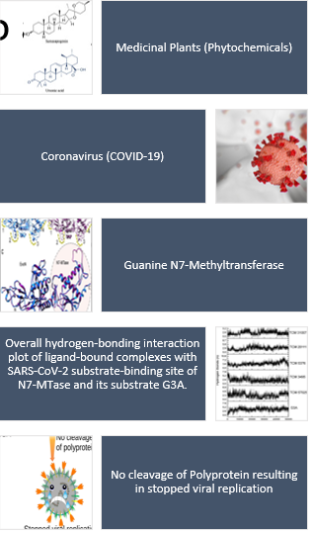
Recent Publications:
- Kaur, R., Mahajan A., and Bhatia A. (2018). A study to augment biofuel potential of Chlorella pyrenoidosa using different culture conditions. International journal of basic and applied research.8(10), 440-454.
- Kaur, R., Mahajan A., and Bhatia A. (2018). Comparison of different methods of lipid extraction for microalgae Chlorella pyrenoidosa. Journal of Emerging Technologies and Innovative Research. 5(6), 115-120.
- Bhatia, A., Arora, S., Singh, B., and Nagpal, A. (2020). Screening of rhizomes of Rheum emodi Wall. Ex. Meissen for antimutagenic potential employing Ames assay. The Nucleus, 63(2), 167-177
- Dr. Anjana Bhatia (Ed.).Proceeding of Recent Developments in Science and Technology ISBN: 978-93-837-3071-1
- Dr. Anjana Bhatia (2018). Increasing the Participation of Women in World of Computing In Edited Book “ Wireless and Mobile Computing -2018” Page No.84 ISBN: 978-81-932-6024-1
BIography:
Anjana Bhatia has her expertise in Antimutagenics, Biofuels, Women and Children studies with years of experience in research, evaluation, teaching and administration with projects like Evaluation of an ayurvedic herb Tinospora cordifolia for antimutagenic potential in Ames assay and also major projects like Potential Biofuel crops. In view to pandemic COVID-19 commended the Medicinal and Aromatic plant sciences for use of their natural metabolites as the potential inhibitors by using various computational approaches that could serve in regulating protein function and controlling viral replication.

