New Directions in Sunflower Breeding

YALCIN KAYA

Trakya University, Engineering Faculty, Genetic and Bioengineering Department, Edirne, Turkey

Keywords: Sunflower, Hybrid Breeding, Resistance Breeding, Molecular Breeding
As a summer crop, sunflower (Helianthus annuus L.) influences from climatic conditions more such as drought, hot temperatures, etc during the vegetation period because of mostly growing in drylands in the world. Mostly hybrids exist in the sunflower seed market almost all growing countries for many years and new genes have been adding to genetic background year by year based on current needs and by growing areas and these are mostly resistant to some diseases, weeds and broomrape parasite which are main limiting factors of sunflower yield as well as in few amount as tolerant to abiotic stress too. Until today, mostly classical breeding methods have been used to obtain and develop these new sunflower hybrids containing these desired characteristics but the use molecular breeding methods have also increased recently in both public and private sunflower breeding programs almost all part of the world. However, due to global warming, sunflower breeders should include many different traits especially in abiotic stress tolerance mostly to drought into new developed hybrids which have higher seed yielding potential and adaptation capability in addition to tolerance to biotic stresses (weeds, diseases and broomrape). Wild sunflower (Helianthus family has 51 species) present huge opportunities to sunflower breeders both finding useful genes and also creating genetic variations in desired traits in their breeding gene pool in their nurseries. However, new molecular breeding methods help enormously to breeders for screening of their genetic materials in huge amounts and accelerating their breeding program as well as transferring these desired genes into cultivated one from wild types and interspecific crosses and constituting gene pyramiding for longer resistance in developing new hybrids and inbred lines in sunflower. Nowadays, most of sunflower hybrids which especially in Blacksea region which has over 60% of planted areas in the world and in Europe have at least three dimensions’ resistance as herbicide tolerance (IMI or SU herbicides) and new races of broomrape resistant and also new races of downy mildew resistance in sunflower market. However, utilizing from molecular markers as well as using genotyping-by-sequencing and association mapping methods will help to breeders to add new traits in their lines and hybrids quickly and practically both for biotic stresses such as disease tolerance and also abiotic stress tolerance in the future.

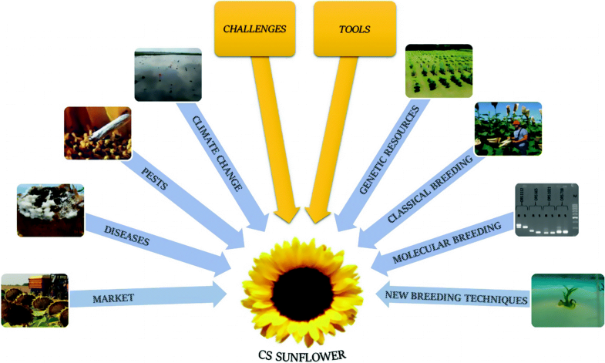
References:
- Miladinović D., Hladni N., Radanović A., Jocić S., Cvejić S. (2019) Sunflower and Climate Change: Possibilities of Adaptation Through Breeding and Genomic Selection. In: Kole C. (eds) Genomic Designing of Climate-Smart Oilseed Crops. Springer, Cham. https://doi.org/10.1007/978-3-319-93536-2_4
- Dimitrijevic A and Horn R (2018) Sunflower Hybrid Breeding: From Markers to Genomic Selection. Front. Plant Sci. 8:2238.
- Kaya Y (2016) Sunflower. In: Gupta SK (ed) Breeding oilseed crops for sustainable production, 1st edition opportunities and constraints, 1st ed. Academic Press, San Diego, CA, pp 55–88
Biography:
Prof Dr Yalcin Kaya, Trakya University, Edirne, Turkey has longer carrier and experience on plant breeding and genetics and developed many sunflower hybrids and lines. He has worked in research institute as National Sunflower Coordinator and as Project leader for over 20 years and deputy director. He had M Sc in University of Nebraska, Lincoln, US, and Post Doc on sunflower breeding in USDA Sunflower Lab at Fargo, ND, US. Now he is Plant Breeding Research Center director and Genetic Engineering Dept. Head at university. He is also former President of Turkish Plant Breeders Union and International Sunflower Association. He published more than 200 papers.
Presenting author details

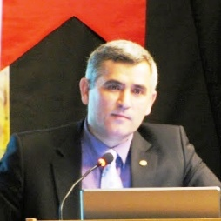
Full Name: YALCIN KAYA
Contact number: +90 542 2828184
Twitter account: @yalcinkaya22
Linked In account: yalcinkaya22
Facebook profile: https://www.facebook.com/yalcinkaya22
Session name/number: Molecular Plant Breeding /
Category : Oral presentation

