Utilization of wild germplasm for imparting leaf rust resistance in bread wheat (Triticum aestivum L.)
Niranjana M, Sekhon NK, Niharika Mallick, Jha SK, Tomar SMS, Vinod, Division of Genetics, ICAR- Indian Agricultural Research Institute, New Delhi

Abstract
Statement of the Problem: Wheat is one of the three major cereal crops. Biotic stresses are major limiting factors affecting wheat crop from realizing its yield potential. One of the major biotic stresses affecting wheat cultivation globally is brown/leaf rust caused by Puccinia triticina Eriks. Utilization of genetic resistance is the best way to mitigate leaf rust infection.
Methodology & Theoretical Orientation: Introgression lines of wheat derived from wild species were tested for leaf rust at seedling stage against most predominant race 77-5 (121R63-1=THTTS). Multi-pathotype testing using 22 leaf rust races was undertaken in selected resistant lines. Ten-day-old seedlings were inoculated by spraying a solution of uredospores and incubated for 48 hrs in a humid chamber which were shifted to greenhouse benches under ambient temperature, light and relative humidity conditions. Individual seedlings were scored for leaf rust reaction at 12 days after inoculation using the scale as described by Stakman (1962). Molecular marker analysis was undertaken in the resistant lines to confirm the uniqueness and novelty of the resistance genes. Molecular markers linked to Lr19, Lr28, Lr24, and Lr34 were utilized for confirming the uniqueness of resistance in these lines. Genomic dot-blot hybridization and genomic in situ hybridization (GISH) were utilized for detection of alien genomes.
Findings: Highly resistant 176 introgression lines derived from species like Ae. variabilis (132), Ae. speltoides (15), T. spelta (10), T. monococcum (13), T. turgidum (3), Secale cereale (3) were identified. Three of them were found resistant to all the races. While one showed resistance to all races except 77-8 (253R31=TGTTQ). Another line showed resistance to all races except 77-10 (377R60-1= MHTTS). Molecular markers helped in identifying the novel Lr genes.
Conclusion & Significance: Novel leaf rust resistance genes were identified in Ae. variabilis and Ae. speltoides derivatives. These genes will be an asset in wheat resistance breeding. Wild relatives of wheat are a wonderful source of rust resistance genes. Utilization of these germplasm resources will help broaden the genetic variability available in wheat and prevent genetic erosion.

Image 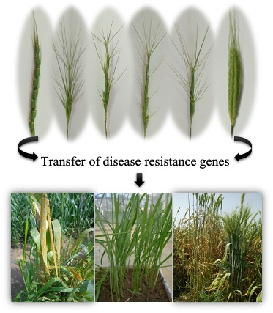
Recent Publications (minimum 5)
- Niranjana M, Vinod, Sharma JB, Mallick N, Tomar SMS, Jha SK. 2017. Cytogenetic analysis and mapping of leaf rust resistance in Aegilops speltoides Tausch derived bread wheat line “Selection 2427” carrying putative gametocidal gene(s). Genome. 60 (12): 1076-1085 (doi.org/10.1139/gen-2017-0107)
- Niranjana M. 2017. Gametocidal genes of Aegilops: Segregation distorters in wheat – Aegilops wide hybridization. Genome. 60 (8): 639-647 (doi.org/10.1139/gen-2017-0023)
- Niranjana M, Jha SK, Niharika Mallick, Aakriti Verma, Bhanwar Singh, Arvind Ahlawat, Tomar SMS, Vinod. 2018. Distribution of genes producing phenol colour reaction in grains of wheat and its related species, mode of inheritance and breeding for low polyphenol activity. Indian J. Genet., 78(4): 433-442 (DOI: 10.31742/IJGPB.78.4.5)
- Rani K, Raghu BR, Jha SK, Priyanka Agarwal, Niharika Mallick, Niranjana M, Sharma JB, Singh AK, Sharma NK, Rajkumar S, Tomar SMS, Vinod. 2020. A novel leaf rust resistance gene introgressed from Aegilops markgrafii maps on chromosome arm 2AS of wheat. Theoretical and Applied Genetics: 1-10 (doi.org/10.1007/s00122-020-03625-w)
- Omkar M. Limbalkar, J. B. Sharma, S. K. Jha, N. Mallick, M. Niranjana and Vinod. 2019. Mapping of genes for leaf and stem rust resistance in bread wheat genotype Selection 212. Indian J. Genet., 79(1): 1-8 (DOI: https://doi.org/10.31742/IJGPB.79.1

 Biography
Dr. Niranjana M has her expertise in wheat genetics, cytogenetics and plant breeding. She is currently working as a Scientist in ICAR-Indian Agricultural Research Institute, New Delhi, India. She has been working in wheat pre-breeding for 7 years starting from her doctoral research. Her research focuses on identifying, cytogenetic and molecular mapping of disease especially rust resistance genes from under-utilized wild germplasm of wheat.
Email: mniranjana2010@gmail.com; niranjana@iari.res.in
Notes/Comments:

