Elucidation of Genotypic variability, Character Association and Genetic Diversity for Stem Anatomy of Twelve Tossa Jute (Corchorus olitorius L.) Genotypes
Md. Mia Mukul
Breeding Division, Bangladesh Jute Research Institute, Ministry of Agriculture, Manik Mia Avenue, Dhaka, Bangladesh.

Abstract: Anatomy of twelve tossa jute genotypes were performed for the variability, heritability, and genetic advance based on yield attributing six anatomical traits. The experiments were carried out in in field and laboratory including 12 tossa jute genotypes followed by RCB design in JAES-Manikganj and Bangladesh Jute Research Institute, Dhaka, Bangladesh during 2019-20. The tested genotypes were expected to perform better than controls in respect of anatomical characters contributing to fiber yield in tossa jute plants. Five genotypes i.e. Acc. 1318, Acc. 1306, (JRO S₁), O-412-9-4, O-0512-6-2 providing good results for the total fiber bundle area, trapezoid number, bark diameter, area of trapezoid and bark thickness per transverse section in anatomy of jute plants depicting the more variability (P>0.01) as well as possibility of tossa jute varietal development. These morphological and anatomical traits showing highly significant association (**) with one another, and coupled with high genetic and phenotypic variance components; high heritability; high & moderate genetic advance and higher divergence in clustering (D²) and PCA would be used as criteria for selection and improvement for fiber yield of tossa jute. The high variation and divergence for anatomical characters may be considered as an effective selection method of genotypes for higher fiber yield comparing with controls. The genotypes i.e. Acc. 1318, Acc. 1306, JRO (Segregate), O-412-9-4, O-0512-6-2 with good anatomical traits related to fiber yield could be used as parents in breeding program as well as direct variety development.
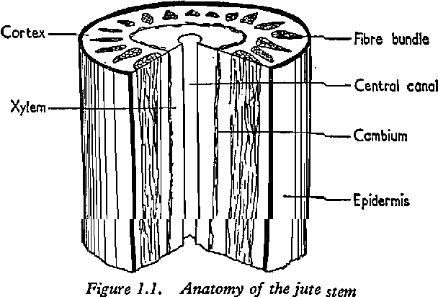
Figure: Anatomy of the jute stem
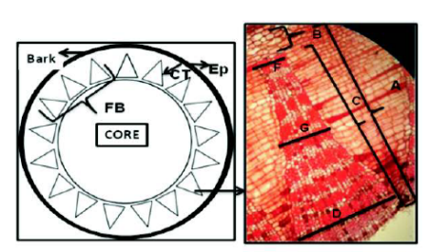
Figure: Pattern of fiber cell distribution in cross section of jute plant
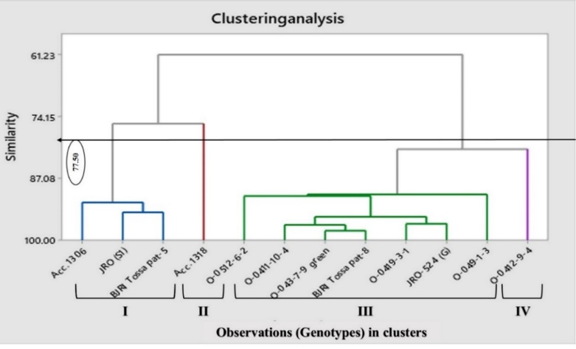
Figure: Dendrogram showing the relationships among 12 tossa jute genotypes for six anatomical characters contributing to fiber yield
Recent Publications
- Jatothu JL, Kumar AA, Choudhary SB, Sharma HK, Maruthi RT, Kar CS, Mitra J. 2018. Genetic diversity analysis in tossa jute (Corchorus olitorius L.) germplasm lines. Journal of Applied and Natural Science 10 (1): 1-3 (2018). DOI: 10.31018/jans.v10i1.1566
- Gärtner H, Schweingruber FH. 2013. Microscopic Preparation Techniques for Plant Stem Analysis. Swiss Federal Research Institute WSL, 8903 Birmensdorf, Switzerland. https://www.dora.lib4ri.ch/wsl/islandora/ object/wsl: 9994
- Jolliffe IT, Cadima J. 2016. Principal component analysis: a review and recent developments. Philos. Trans. A Math. Phys. Eng. Sci. 13; 374(2065): 20150202. doi: 10.1098/rsta.2015.0202
- Kumar V, Singh PK, Dudhane AS, De DK, Satya P. 2014. Anatomical and morphological characteristics of nine jute genotypes. Journal of Crop and Weed, 10(2):334-339. http://www.cropandweed.com/vol10issue2/ pdf2005/54.pdf
- Maiti RK, Satya P. 2009. Fiber bundle anatomy determines the yield potentials, and fiber quality of bast fiber (Long Fiber): A hypothesis. Int. J. Agril. Env. Biotech. 2(4): 41-46.
- Maity S, Chowdhury S, Datta AK. 2012. Jute Biology, Diversity, Cultivation, Pest Control, Fiber Production and Genetics. In: Lichtfouse E. (eds) Organic Fertilisation, Soil Quality and Human Health. Sustainable Agriculture Reviews, vol 9. Springer, Dordrecht. https://doi.org/10.1007/978-94-007-4113-3_9

Pervin N, Haque GKMN. 2012. Variability in anatomical characters in relation to fiber content and quality in white jute (Corchorus capsularis L.). International Research Journal of Applied Life Sciences. V-1, Issue-4, Article-6. Doi:10.1.1.448.1564&rep= rep1&type=pdf

Biography

Md. M. Mia (B/D: 19-05-1991; Gaibandha; 25°30'32.1"N 89°28'38.7"E), Scientific Officer, Breeding Division, Bangladesh Jute Research Institute (www.bau.edu.bd), Ministry of Agriculture, Manik Mia Avenue, Dhaka, Bangladesh working on Jute (Corchorus spp. L.) breeding to develop biotic-abiotic stress tolerant climate smart high yielding varieties since 19 January, 2017. He is expert on breeding of Jute, Rice and other crops to develop high yielding varieties. He has completed MS (2014) on Genetics and Plant Breeding with CGPA 3.84 (4.00) and B. Sc. Agril. Honours (2012) with CGPA 3.76 (4.00) from Bangladesh Agricultural University (www.bau.edu.bd), Mymensingh-2202, Bangladesh. He has awarded National Science and Technology Fellowship (2013-14), Govt. of Bangladesh for his valuable Research on Food & Agriculture: ‘Characterization of Rice Genotypes for Nutrient Content’. He also worked as Scientific Officer (Transformed Rice Breeding), Breeding Division, Bangladesh Rice Research Institute (www.brri.gov.bd), Joydebpur, Gazipur, Bangladesh, collaborated by IRRI, Philippines during April-Nov, 2016.
Name: Md. Mukul Mia
Cell: +8801520083088
Email: mukulbjribreeding@gmail.com
ORCID ID: https://orcid.org/0000-0003-1668-4702
https://www.researchgate.net/profile/Md_Mia5
Notes/Comments: This article is prepared on my original research work. The investigation was done and some tossa jute genotypes were identified as superior which will be used as breeding parents or materials for new high yielding variety development. The newly developed high yielding variety will be commercially cultivated in farmers’ field for golden fiber production and contribute to the national economy.

