MODELLING WITH ROOT, THE CENTRE OF LIFE

Debabrata Das
ICAR-Central Inland Fisheries Research Institute, Kolkata Centre, CGO Complex, 2nd Floor, C Wing, DF Block, Sector-1, Salt Lake, Kolkata-700064 (India)

Abstract (300 word limit)

Most genomic expressions in plants and animals are due to the environmental interactions, these all we are knowing. Whether, a further prolong survival or non-survival of living-beings for both plants and animals may solely depend mere on environmental variables. In plant-science. author has presumed and proved that in all situations. a centre of life in any plants is situated on their roots, or tip of their root. Found that a plant cannot grow or live-long without their roots when growth is concerned. Given an experiment here, this communication made on an perpetual aquatic plant and in search of creations of life or the centre of life in plant is mere, the roots. The aquatic plant species experimented Ipomoea reptans, easy growing a hydrophyte has rooting system which habited usually in aquatic-medium and the shoots prevailing as aerial parts. In such aquatic medium where the roots prevail, if no oxygen supplied or given in the aquatic medium whole the plant get dies, even though the plants have their aerial shoots. Under a condition of given zero (0 ppm) oxygen when dissolved oxygen gets replaced by other natural gasses or gaseous bio-molecules synthesized owing to environmental pollution namely namely Methane, Sulphur di-oxide or even with Carbon di-oxide in aquatic mediums. Thus this may be the hidden-reason why we do discard roots of a plant to consider as food-values. Keys here are as following Aquatic plants, rooting medium, No dissolved oxygen, computer and electronics, Root the centre of life in plants

Image

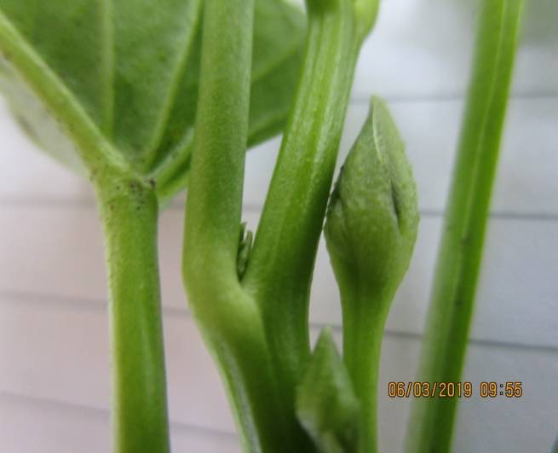

Fig 1 Root the Centre of Life in Plant, stem biomass flowers proportionately.
REFERENCES
Ajith Harish; Charles Kurland (2019) Reply to Caetano-AnollÉS et al. Comment on “Empirical Genome Evolution Models Root the Tree of Life” Biochimie; Vol (149): PP-137-138
Clément Saint Cast; Céline Meredieu; Pauline Défossez; Loïc Pagès; Frédéric Danjon .(2019). Modelling Root System Development for Anchorage of Forest Trees up to the Mature Stage, Including Acclimation to Soil Constraints: The Case of Pinus Pinaster. Plant and Soil; Vol (439): 1-2,
Debabrata Das (2020) Computer & Electronics Can Prove Root the Centre of Life, Stem Dynamics May Flower Proportionately in any Geography. International Journal of Innovations in Agriculture, Vol (2): 37-44
Shivang Shekhar; Jayadipta Ghosh (2020) A Metamodeling Based Seismic Life-Cycle Cost Assessment Framework for Highway Bridge Structures. Reliability Engineering and System Safety; Vol.(195): 1
Debabrata Das, 2018. Ecology Based Fisheries Modelling with Biotechnology. Educational Press of Write and Print Publication H-13, Bali Nagar, New Delhi-110 015. 2.

MitraGuha and Chaudhuri. 1985. Studies in Botany, revised edition, Volume-II. Moulik Library, Kolkata. pp.653


Dr Debabrata Das, ARS
Author, a Scientist posted at Central Inland Fisheries Research Institute (CIFRI), of Kolkata Centre, under Indian Council of Agricultural Research (ICAR), since the year 2018, posted at Kolkata Centre.
Born in the year 1969 in a very remote village Ghugia of Nadia District (of West Bengal), this district literaly means plenty of rivers. Undergone through local Schools and Academic Qualifications obtained from Bidhan Chandra Krisshi Viswavidyalaya, West Bengal and Indian Agricultural Research Institue of IASRI at New Delhi (India).
Working on the ancient Ayurvedic sciences applied to Agriculture and Fisheries with the modern perspective pertaining to computational modelling and digital applications.

Notes/Comments: Nil

