Abstract Template

Title: Identification of low pH induced differentially expressed genes in rice: An experimental and computational approach

Ekta Choudhary¹, Pushprenu¹, Anil Kumar Singh², Dev Mani Pandey^{1,}*

¹Birla Institute of Technology, Mesra, Ranchi-835215, Jharkhand, India
²Indian Institute of Agriculture Biotechnology, Ranchi, Jharkhand, India

Keywords: Soil Acidity, Acidic Stress, Low pH Stress, Rice, Real Time PCR, FESEM, OCT

- Abstract Body (up to 250 words)
Rice (Oryza sativa) is a very important crop used in various forms for consumption by majority of the population. Its growth and productivity are affected by variety of biotic and abiotic stresses. Soil acidity is among the various factors depressing the rice crop growth and productivity. Majority of soil in Jharkhand, India is acidic having a pH < 5.5 and one of the major limiting factors for rice production. Considering above challenge investigating such genes which are induced under low pH conditions in the traditional variety of rice making them to be tolerant for acidic stress is a great of interest. For this study surface sterilized seeds of some verities were sown in soil containing pots at varying low pH and kept in growth chamber under controlled conditions. Low pH treated varieties were studied for measuring the changes in morphological, biochemical, molecular and micro-structural parameters. Low pH induced changes in growth and biochemical parameters were observed. RT-PCR based differential gene expression pattern of various genes under acidic stress was overserved. Field emission scanning electron microscope (FESEM) based changes in characteristics of stomata while optical coherence tomography (OCT) based micro-structural changes in different layers of low pH treated leaves were observed. Online available microarray data of A. thaliana grown under low pH were used for finding novel candidate (hub) genes. Rice homolog of these hub genes were identified and studied for Real-Time PCR based gene expression under low pH stress and obtained findings will be presented.

- Image:

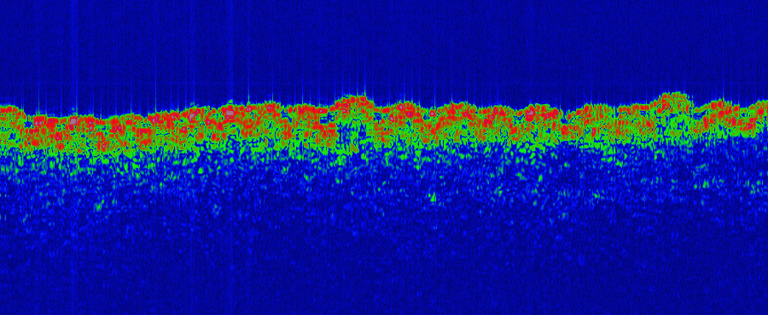

- Reference:
- Singh, B.N. 2011. Status of rice in Jharkhand – Rice Knowledge Management Portal (www.rkmp.co.in)
- Kochian, L. V., Hoekenga, O. A., Pineros, M. A. 2004. How do crop plants tolerate acid soils? Mechanisms of aluminum tolerance and phosphorous efficiency. Annu. Rev. Plant Biol., 55, 459-493.
- Kim, H., Du, X., Kim, S., Kim, P., Wijesinghe, R. E., Yun, B. J., & Kim, J. 2019. Non-Invasive Morphological Characterization of Rice Leaf Bulliform and Aerenchyma Cellular Regions Using Low Coherence Interferometry. Applied Sciences, 9(10), 2104.
- Biography:
Dev Mani Pandey has completed his Ph. D. (Plant Physiology) from Chaudhary Charan Singh, Haryana Agricultural University, Hisar, India. He was Post-Doctoral Fellow and served as Consultant to Plant Breeding, Genetics and Biotechnology, IRRI, Los Banos, Philippines. He is a recipient of Young Scientist Award and presented his research findings and Chaired the Session at National and International meetings in India and abroad. He has organized International Symposium successfully and served as Organizing Committee Member of various International Conference/Congress and has been serving as an editorial board member of repute. Currently he is working as Associate Professor at the Department of Bio-Engineering, Birla Institute of Technology, Mesra, Ranchi, Jharkhand, India.

- Presenting author details


Full Name: DEV MANI PANDEY
Contact number: 9431900315
E-mail: dmpandey@bitmesra.ac.in
Twitter account: -
Session name/ number: -
Category: Oral presentation
Passport Number: NA

