Abstract Template

Title: Ozone stimulates the production of anthocyanins as a secondary antioxidant defense in Arabidopsis thaliana.

Nimble Giri, and Dr. Thomas Sasek
Department of Biology, University of Louisiana at Monroe, Louisiana, USA

Keywords: Anthocyanins, Antioxidant defenses, Ozone, Arabidopsis thaliana, Pap-1, TT-3, Vtc-1, Blh-1, Col-1, GPA-1, and Des1
- Abstract
Ozone is the major air pollutant damaging crops and other vegetation. It causes oxidative stress, resulting in increased synthesis of secondary metabolites. Anthocyanins are naturally occurring secondary metabolites that increase in concentration to fight free radicals and lower damage in leaves. Arabidopsis thaliana, a small flowering plant with short lifecycle is an ideal model organism. Three seed lines varying in anthocyanin production (TT-3, Blh-1, Pap-1) were compared to wild type Col-1. Three other lines were selected with mutations in other antioxidant defenses (Vtc-1, GPA-1, Des-1). Three- to four-week-old seedlings were exposed to 0ppb, 150ppb, 300ppb, 450ppb ozone for eight hours on three consecutive days. Anthocyanin concentrations were determined before exposure and one week after exposure. Lines with more anthocyanins were found to be more resistant as evidenced by less leaf damage. One week after exposures, the anthocyanin lines had increased anthocyanin concentrations up to 5X at 300ppb compared to 0ppb, but not as much at 450ppb. Pap-1, a transformed line that over produces anthocyanins, had the highest anthocyanin production. TT-3, a mutant with no anthocyanins, was severely damaged under 450ppb. In the lines with mutations in other antioxidant defenses, Des-1 and GPA-1 were less sensitive to ozone due to enhanced antioxidant defenses and did not increase anthocyanin concentrations much when exposed to ozone. Vtc-1, deficient in the primary antioxidant defense ascorbate, increased its anthocyanin concentrations 8X even at 150ppb, perhaps in compensation for its lack of primary defense. Results suggest that genetic engineering to enhance anthocyanins could increase crop resistance.

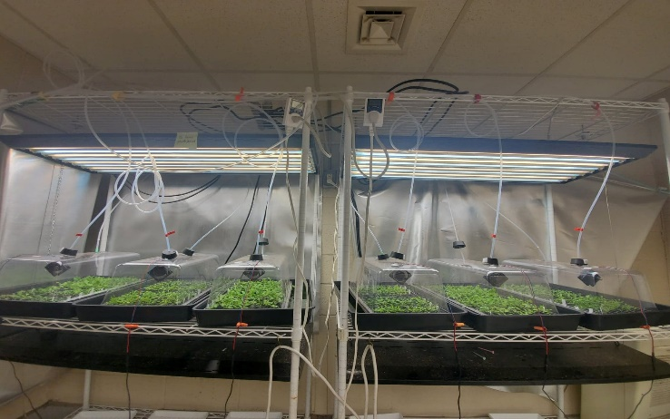
II. Image:

- Reference:
- Weigel, D., et. al. 2000. Activation tagging in Arabidopsis. Plant Physiol. 122, 1003-1014.
- Borevitz, J., et. al. 2000. Activation tagging identifies a conserved MYB regulator of phenylpropanoid biosynthesis. The Plant Cell. Vol. 12, 2383-2393.
- Conklin, L. et al. 1996. Environmental stress sensitivity of an ascorbic acid-deficient Arabidopsis mutant. Plant Biology. Vol. 93, pp. 9970- 9974.
- Joo, JH. et al. 2005. Different signaling and cell death roles of Heterotrimeric G protein (alpha) and (beta) subunits in the Arabidopsis oxidative stress response to ozone. The Plant Cell. Vol. 17, 957-970.
- Alvarez, C. et al. 2010. An 0-Acetylserine (thiol)lyase homolog with L-cysteine desulfhydrase activity regulates cysteine homeostasis in Arabidopsis. Plant Physiology. Vol. 152, pp. 656-669.
- Biography:
I completed my undergraduate in 2016 from Tribhuvan University, Nepal. I studied botany as a BS student and did my undergraduate thesis on ethnobotany. I came to USA in 2018 as a graduate student at the University of Louisiana at Monroe. I am currently working on Arabidopsis thaliana under the guidance of Dr. Thomas Sasek. He completed is PhD and postdoctoral at Duke University in plant physiological ecology considered the effects of climate change on invasive plants. The objective of our work is to study anthocyanins and their responses to different ozone concentrations as one mechanism of increased ozone resistance.
- Presenting author details


Full Name: Nimble Giri
Contact number: 318-267-5073
Twitter account: Imbl.g
Linked In account: Nimble Giri
Session name/ number: 05: Stress Signalling in Plants
Category: e-Poster presentation

