Abstract

Title: The importance of standards for essential and seed oils crops of indigenous plants used in Southern Africa.

SWANEPOEL KM¹,
¹Southern African Essential Oil Producers Association, Pretoria, South Africa

Keywords: Essential oil, Vegetable oil, Natural products, Standards, Sustainable crop development, Feasibility studies, Rural development, Alternative crops, Entrepreneurship, Poverty alleviation.

- Abstract
The essential oil industry is a fast growing and changing industry and African plants are now fashionable to be included in new products containing natural products. Essential oils e.g. Pelargonium var Rose, Lippia javanica, Eriocephalus punctulatus, Helichrysum splendidum and cold pressed or vegetable oils of indigenous plants amongst others are the focus areas. Adansonia digitata (Baobab) and Schlerocarya birrea (Marula) oil, pulp and powder of both are under supplied in a growing market of currently developed products that have already been accepted by most international companies. Ximenia africana and X. americana, Citrullus lanatus (Kalahari Melon) oils are now researched for developing market demand and for the requirements in natural products industry. There are almost no existing standards for the products of Africa and if the demand is increasing, the most needed standards should be developed at the same time to avoid exploitation. Advantages and challenges have been identified with potential of sustainable crop development. Climate change and pressure on natural resources can be managed if careful sustainable measures are taken in time. This study could assist role players of community projects, agricultural and rural development schemes in decisions of choosing alternative crops and for skills and entrepreneurship development and poverty alleviation. The information can also be applied by government departments, small scale and emerging farmers in the feasibility studies of utilization of natural products as new enterprises to the advantage of the producers of South Africa and the consumer ultimately.

- Image:

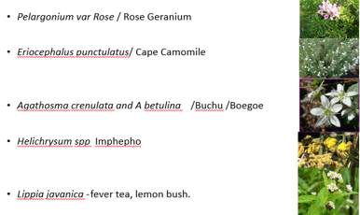

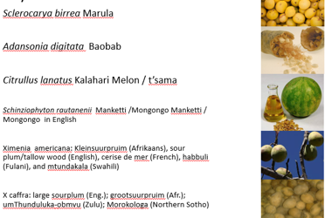

- Reference:
- Van Wyk, B.E Medicinal Plants of Southern Africa, transport in higher plants. 1997, BRIZA
- Hutchings, A. Zulu Medicinal Plants, 1996.
- Diederichs, N, Commercialising Medicinal Plants A Southern African Guide, 2006, SUNPRESS
- Lost crops of Africa; Volume III Fruits, 2008, National Research Council
- Lis-Balchin, M., Geranium and Pelargonium: History of Nomenclature, Usage and Cultivation 2002, Taylor & Francis Ltd
- Biography:
Executive Director of SAEOPA (Southern African Essential Oil Producer Association), involved in many industry studies in the field of essential oils since 2000. Lectured Botany, Bio -entrepreneurship, Biotechnology and Environmental Science. Papers at IPUF (indigenous Plant use Forum) and on international level at WOCMAP (World Congress on Medicinal and Aromatic Plants), ISEO (international Society of Essential Oils) , ASNAPP (Agribusiness in Sustainable Natural African Plant Product), Green Gold, SAAB (South African Association of Botanists) , African Corp Science, Agricultural and Training World Conference, CHEMRAWN (Committee on Chemical Research Applied to World Needs), Industrial crops and Rural Enterprises. Publications for the department of trade and industry, Agriculture and Forestry and Acta Horticulturae. Currently a consultant for UNIDO in the GQSP-SA (Global Quality and Standards in South Africa) Project.

- Presenting author details


Full Name: Karen Swanepoel
Contact number: +27 820816077
Twitter account: saeopa
Linked In account: Southern African Essential Oil Producers Association
Session name/ number:
Category: (Oral presentation/ Poster presentation)
Passport Number: M00202823

