Title: Screening of soybean genotypes against drought stress using morpho-physiological, biochemical and gene based SSR markers
Akash Sharma¹, M.K. Tripathi ²
1. Department of Genetics & Plant Breeding, Rajmata Vijayaraje Scindia Krishi Vishwa Vidyalaya, Gwalior, Madhya Pradesh, India
2. Department of Plant Molecular Biology & Biotechnology Rajmata Vijayaraje Scindia Krishi Vishwa Vidyalaya, Gwalior, Madhya Pradesh, India
Key words: soybean, drought stress, SSR markers, biochemical and morphological characterizations
Abstract: Soybean (Glycine max (L.) Merrill.) contributes 57% of the total oilseed production worldwide. Sustainability of its production is severely challenged by drought, depressing up to 40% of the yield annually. Also Selection of drought-tolerant varieties based on morpho-physiological and biochemical attributes assisted with genomic approaches is one of the methods to be focused. To overcome this challenge, conventional and genomic approaches together with biochemical assays have been utilized for understanding drought tolerance mechanisms followed by utilization of this information for developing drought-tolerant soybean cultivars. In this experiment, material was monitored in randomized block design (RBD) with three replications. Sixty-day-old plants evaluated for various morpho-physiological parameters including biochemical parameters viz.: antioxidant enzyme activities and photosynthetic characteristics of soybean. Furthermore, the changes in photosynthetic and chlorophyll fluorescence characteristics, total soluble protein, total sugar and enzymatic activities of sixty soybean genotypes subjected to drought tolerance. The lipid peroxidation contents varied low and high (70.2 ± 1.15 to 120.8 ± 1.67 nmol/g). The highest catalase content and glutathione reductase were exhibited soybean genotypes equal to 0.98 U/mg proteinand 0.60 U/mg protein. Significant variation for guaiacol peroxidase (0.37 ± 1.1 to 1.24 ± 0.9 %) and ascorbate peroxidase (0.51 ± 0.46 to 1.48 ± 1.3 %) was detected. On the basis of anti oxidant enzymatic activity four genotypes namely JS 97-52, NRC-7, EC- 5338828, and EC-602288 may be considered as putative drought tolerant genotypes. These genotypes may be used in advance breeding and biotechnological works to develop drought tolerance/resistant varieties in upcoming days.

Image: 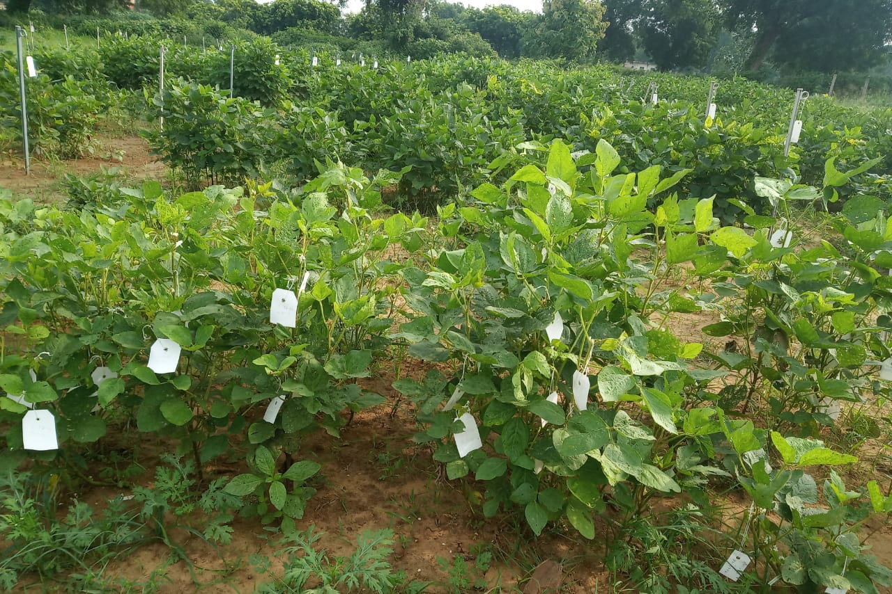

Reference:
1. Akitha-Devi MK and Giridhar P. 2015. Variations in physiological response, lipid peroxidation, antioxidant enzyme activities, proline and isoflavones content in soybean varieties subjected to drought stress. Proceedings of the National Academy of Sciences 85(1): 35-44.

2. Angra S, Kaur S, Singh K, Pathania D, Kaur N, Sharma S and Nayyar H 2010. Waterdeficit stress during seed filling in contrasting soybean genotypes association of stress sensitivity with profiles of osmolytes and antioxidants. International Journal of Agriculture Research 5: 328-345.

3. Dong D, Fu X,Yuan F,Chen P, Zhu S, Li B, Yang Q, Yu X and Zhu D. 2014. Genetic diversity and population structure of vegetable soybean (Glycine max (L.) Merrill.) in China as revealed by SSR markers. Genetic Resources Crop Evolution61:173-183.

4. Kachare, S. 2017. Studies on Morpho-physiological changes and gene expression under drought condition in soybean [Glycinemax (L.)Merrill]. A Ph. D Thesis, JNKVV, Jabalpur.

5. Masoumi H, Farrokh D, Jahanfar D, Ghorban N and Davood H. 2011. Chemical and biochemical responses of soybean (Glycine max L.) cultivars to water deficit stress. Australian Journal of Crop Science 5(5): 544-553.
Bibliography: Akash Sharma has completed B.Sc. (Ag) from College of Agriculture, Rajmata Vijayaraje Scindia Krishi Vishwa Vidyalaya, Gwalior, Madhya Pradesh, India. In 2018 with 79%. He is pursuing M.Sc. in Genetics &Plant Breeding, from RVSKVV, Gwalior, M.P. India and his research work on drought in Soybean (Glycine max (L.) Merrill.
Personal Details:

Full Name: Akash Sharma Contact number: +919074000523
E-mail id: sharmaskykitu1993@gmail.com Session name/ number: Molecular plant breeding/04
Category: Poster presentation Passport Number: U1552161

