Rhizophagus intraradices in biofortification with Fe and Zn of Vigna unguiculata

Ursula del Carmen López-Ferrer¹, Hortensia Brito-Vega^{2*}, Arturo Reyes-Ramírez¹, José María Tun-Suarez¹, Carlos Juan Alvarado-López³
¹Tecnológico Nacional de México, División de Estudios de Posgrado e Investigación, Instituto Tecnológico de Conkal
²División Académica de Ciencias Agropecuarias, Universidad Juárez Autónoma de Tabasco, Km 25.5 Carretera VHSA-Teapa, Rancheria 3er. Sección, Vhsa, Tabasco, Mexico. C.P. 86040.
³Catedrático CONACYT. Avenida Tecnológico S/N, Conkal, Yucatán, México. C.P 97345.
*Responsible to present at the event

Keywords: Bean pelón, arbuscular mycorrhizal fungus, nutritional, agronomic, quality.

- Abstract
The present study investigated effect of Rhizophagus intraradices on biofortification with Fe and Zn in Vigna unguiculata (bean pelón). The importance of the extraradical mycelium of arbuscular mycorrhizal fungus (AMF) in the processes of acquisition of Zn and Fe, inoculation with AMF could contribute to grain biofortification not only by increasing the absorption of micronutrients in the soil but also by overcoming the impact of the anti-nutritional factors. The treatments were: T1(Vigna), T2(Vg+Fe), T3(Vg+Zn), T4(Vg+Fe+Zn) inoculated and without inoculation. The experimental unit consisted of five plants giving a total of 24 experimental units. Between the treatments, as well as on the initial and final edges of each furrow, three plants were placed to avoid contamination between treatments. In the aerial part, biometric variables such as pod size and grain yield per plant were evaluated at 120 DDG. The results of the agronomic characteristics of the harvested pods of V. unguiculata showed significant difference to the application of Zn and inoculation with R. intraradices, showing a larger size and higher quality pods, the length of the sheath oscillated between 13.63 and 15.14 cm, values that are between 12.73 and 17.76 cm (Guillen-Molina et al., 2016). For the number of grains per pod, values between 10.98 and 12.38 were found, the highest values being biofortified with Zn and those inoculated R. intraradices have more than 11.5 grains per pod. The AMF plants showed better development and yield against those that were not inoculated and in turn, the bean fortified with Zn presented the highest averages.

- Germination, development and production bean pelón.

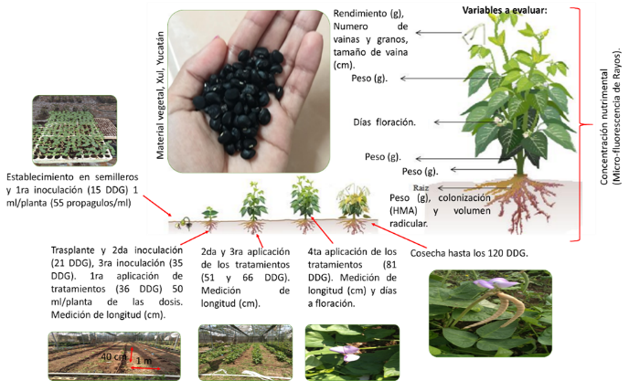

- Reference:
- Guillén-Molina, M. Márquez-Quiroz, C. de la Cruz-Lázaro, E. Velázquez-Martínez, J.R. Soto Parra, J. M. García Carrillo, M. Orozco Vidal, J.A.. 2016. Biofortificación de frijol caupí (Vigna unguiculata L. Walp) con hierro y zinc. Revista Mexicana de Ciencias Agrícolas, 17:3427-3438
- Tamayo, E. Gómez-Gallego T. Azcón-Aguilar C. Ferrol N. 2014. Genome-wide analysis of copper, iron and zinc transporters in the arbuscular mycorrhizal fungus Rhizophagus irregularis. Frontiers in Plant Science 5:547
- Biography:
2010 has completed his PhD at the age of 35 years from 1995 University and Postdoctoral Studies from 2015 CIIDIR-IPN GUASAVE UNIT, MEXICO, 1997 University Juarez Autonomous of Tabasco. She is the Professor-Researcher in Sustainable Tropical Agriculture. She has published more than 25 papers in reputed journals and has been serving as an editorial board member of repute Journal Madera y Bosque, Journal ERA.
- Presenting Co-author details


Full Name: Hortensia Brito-Vega
Contact number:+52 6871266592
Linked In account: hortensia.brito@ujat.mx
Session name/ number: 02 Agricultural Science
Category: (Oral presentation/ Poster presentation) Poster
Passport Number: G149583947

