A fast neutron mutant population in model rice variety KitaakeX and its use to facilitate forward and reverse genetics
Rashmi Jain^{a,b}, Guotian Li^{a,b}, Jerry Jenkins^{d}, Shengqiang Shu^{c}, Dario Copetti^{e,f,g}, David A. Kudrna^{f,g}, Mawsheng Chern^{a,b}, Joel Martin^{c}, Phat Q. Duongª, Wendy S. Schackwitz^{c}, Anna M. Lipzen^{c}, Kerrie W. Barry^{c}, Rod A. Wing^{e,f,g}, Jeremy Schmutz^{c,d}, and Pamela C. Ronald^{a,b}

aDepartment of Plant Pathology and the Genome Center, University of California, Davis, CA 95616, USA
bFeedstocks Division, Joint BioEnergy Institute, Lawrence Berkeley National Laboratory, Berkeley, CA 94720, USA
cU.S. Department of Energy Joint Genome Institute, Walnut Creek, CA 94598, USA
dHudsonAlpha Institute for Biotechnology, Huntsville, AL 35806, USA
eArizona Genomics Institute, School of Plant Sciences, University of Arizona, Tucson, AZ 85721;
fBIO5 Institute, School of Plant Sciences, University of Arizona, Tucson, AZ 85721;
gInternational Rice Research Institute, Genetic Resource Center, Los Baños, Laguna, Philippines
Abstract
The Kitaake variety (ssp. japonica), has emerged as a model for rice research. It is an extremely early flowering rice cultivar, easy to propagate, with good yield potential and eating quality. Here, we report the de novo genome sequencing and analysis of KitaakeX, a Kitaake variety carrying the XA21 immune receptor. Our KitaakeX sequence assembly contains 377.6 Mb, consisting of 33 scaffolds (476 contigs) with a contig N50 of 1.4 Mb. The assembly is complemented with detailed gene annotations of 35,594 protein coding genes. We identified 331,335 variations between KitaakeX and the reference genome Nipponbare (ssp. japonica), and 2,785,991 variations between KitaakeX and Zhenshan97 (ssp. indica). We also compared Kitaake resequencing reads to the KitaakeX assembly and identified 219 small variations. We have generated a Kitaake mutant database called KitBase (https://kitbase.ucdavis.edu/), which includes genomic data, phenotypic data, and seed information for the 1504 fast neutron-induced KiaakeX mutant lines. In-depth characterization of 1,504 of these mutagenized lines reveals an average of 61 mutations affecting 43 genes in each line. The 1,504 mutagenized lines are expected to yield a 68% probability of hitting a given rice gene. The availability of the high quality KitaakeX genome and annotation reported here will greatly facilitate analysis of the FN mutants which was previously compared to Nipponbare as the reference genome. We have finished an analysis of 2200 mutants and we plan to finish 4000 by the end of the year 2020 which will facilitate rice research.
Image:
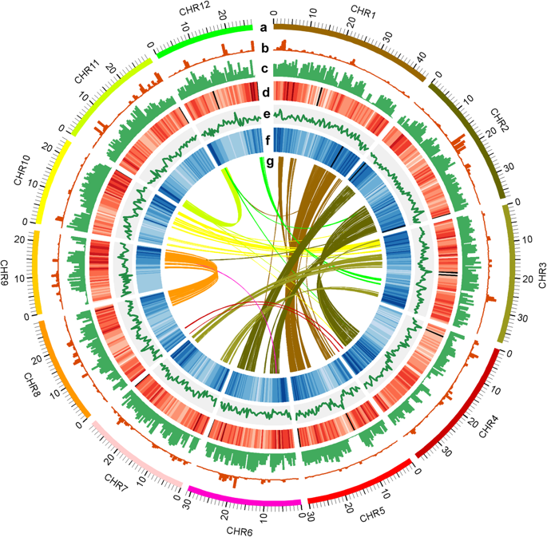

Figure: Genome wide analysis of KitaakeX genome and its comparison with other rice varieties; a Circles indicate the 12 KitaakeX chromosomes represented on a Mb scale; b, c SNPs and InDels between KitaakeX and Nipponbare (b) and KitaakeX and Zhenshan97 (c); d Repeat density; e GC content; f Gene density; g Homologous genes in the KitaakeX genome. Window size used in the circles is 500 kb
References:
Jain R., Jenkins J., Shu S., Chern M., Martin J.A., Copetti D., Duong P. Q., Pham N. T., Kudrna D. A., Talag J., Schackwitz W. S., Lipzen A. M., Dilworth D., Bauer D., Grimwood J., Nelson C. R., Xing F., Xie W., Barry K. W., Wing R. A., Schmutz J., Li G., Ronald P. C.(2019). Genome sequence of the model rice variety KitaakeX. BMC Genomics 20, 905 (2019) doi:10.1186/s12864-019-6262-4
Li G., Jain R., Chern M., Pham N.T., Martin J.A., Wei T., Schackwitz W.S., Lipzen A.M., Duong P.Q., Jones K.C., Jiang L., Ruan D., Bauer D., Peng Y., Barry K.W., Schmutz J., Ronald P.C. (2017). The Sequences of 1,504 Mutants in the Model Rice Variety Kitaake Facilitate Rapid Functional Genomic Studies. The Plant Cell tpc.00154.2017
Li G., Chern M., Jain R., Martin J.A., Schackwitz W.S., Jiang L., Vega-Sánchez M.E., Lipzen A.M., Barry K.W., Schmutz J., Ronald P.C.(2016). Genome-wide Sequencing of 41 Rice (Oryza sativa L.) Mutated Lines Reveals Diverse Mutations Induced by Fast-neutron Irradiation. Mol. Plant.doi:10.1016/j.molp.2016.03.009.

