Title: Deciphering Biosynthetic Machineries of Iridoid Glycosides in a Medicinal Herb, Picrorhiza kurroa Through NGS Transcriptomics and Comparative Co-Expression Networks

RS Chauhan, Ashish Sharma, Shilpa Sharma, Poornima Sharma, Roma Pandey, Anjali Kharb, Neeti Nirwal
Department of Biotechnology, Bennett University (Times of India Group); Greater Noida 201310, UP, India

Keywords: Picrorhiza kurroa, Picrosides, NGS transcriptomes, Pathway, Genes, Enzymes

- Abstract Body (up to 250 words)
Picrorhiza kurroa is a high altitude (3000–5000 m) medicinal herb distributed in the North-Western Himalayas of India. It has pharmacological properties like hepatoprotective, antiallergic, antiasthmatic, antioxidant, anticancerous, and immunomodulatory due to occurrence of iridoid glycosides, Picroside-I (P-I) and Picroside-II (P-II) as the major chemical constituents. However, only P-I is produced in shoot cultures whereas P-II in roots/rhizomes, thereby, limiting the development of a sustainable production platform for these two metabolites, which will not only to relieve pressure on natural populations of P. kurroa but also provide continuous supply of these Phytochemicals. In that direction we have deciphered biosynthetic machineries of P-I and P-II through a combination of approaches, including bio-retrosynthetic linking and characterization of pathway intermediates, mapping pathway genes/enzymes through comparative genomics, differential transcriptomics (NGS, qRT-PCR) and comparative co-expression networks to capture pathway genes, regulators and transporters of picrosides. Key genes regulating critical enzymatic steps, transcription factors, kinases and transporters contributing to picrosides biosynthesis and accumulation are being functionally validated through CRISPR/Cas9- based genome editing.

- Image:

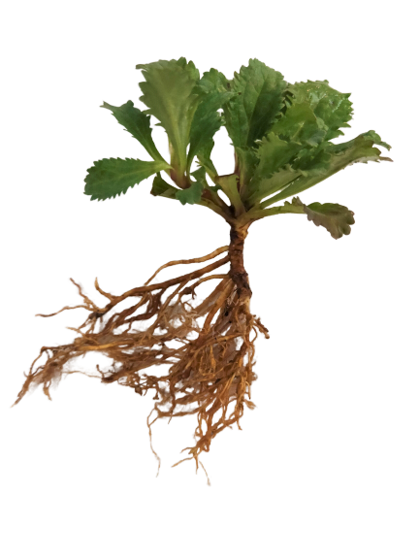

- References:
- Kumar V, Bansal A and Chauhan RS. 2017. Modular design of Picroside-II biosynthesis deciphered through NGS transcriptomes and metabolic intermediates analysis in naturally variant chemotypes of a medicinal herb, Picrorhiza kurroa. Front. Plant Sci. 8:564. doi: 10.3389/fpls.2017.00564
- Kumar V, N Sharma, H Sood, RS Chauhan (2016). Exogenous feeding of immediate precursors reveals synergistic effect on picroside-I biosynthesis in shoot cultures of Picrorhiza kurroa Royle ex Benth. Sci Rep 6:29750 10.1038/srep29750
- Biography:
Prof. Chauhan has completed his PhD at the age of 28 yrs from HP Agriculture University, Palampur, India and Postdoctoral Studies from University of Wisconsin, Madison, USA. He is the Dean (Research & Consultancy) and Head of Biotechnology at the Bennett University, Greater Noida, India. He has published more than 100 papers in reputed journals on deciphering biosynthetic machineries of natural products in plants through genomic approaches. He is recipient of National Awards and Overseas fellowships of the Govt of India.
- Presenting author details


Full Name: Rajinder Singh
Contact number: 9418405536
Twitter account: RajBTBI_Edu
Linked In account: Rajinder Chauhan
Session name/ number: Plant Genome Science/01
Category: (Oral presentation/ Poster presentation): Oral (Invited)
Passport Number:L8503895

