Abstract Template

Title: Improvement of salt tolerance in upland cotton through back crossing method

Mohammadreza Ramazani Moghaddam1* and Musarreza . Vafaeitabar²
- Horticultural Crops Science Research Department, Khorasan Razavi Agricultural and Natural Resources Research and Education Center AREEO, Mashhad, Iran.
- Cotton Research Department, Tehran Agricultural and Natural Resources Research and Education Center, AREEO, Varamin, Iran
* Corresponding Author: rezaramezani@yahoo.com

Keywords: Cotton, Salinity tolerance, Back cross

- Abstract Body (up to 250 words)
In this project in order to increase salt-tolerant of commercial cultivars, those lines were used that selected from saline lands of Saedoddin cotton farms in Kashmar region. These lines possessed high growth ability under saline stress with small boll growth size. In order to improve salt-tolerant lines with upstanding vegetative growth under salt stress conditions, crossing were done between commercial cultivars namely, Varamin, Sahel, Bakhtegan and Mehr and selected lines. This followed by several back crossing at central station (Varamin station) and screening of offspring under saline condition at Saedoddin farms at the next of each year. This operation repeated during 4 years and in the last year several elite plants were selected from both stress (kashmar region) and non-stress (Varamin station) of salinity. The results reveal that average value of measured traits of selected lines were superior than their commercial parents under both conditions of stress and non-stress of salinity. For example, average seed cotton plant yield of improved lines which derived from Mehr cultivar crosses was 109.9 gr, while under salt stress conditions the same in Mehr cultivar was 55.3 gr. Also under non-salt stress condition, average seed cotton of these lines was 145.9 gr but in their maternal parent (cv. Mehr) it was 108 gr. The main conclusions describe that resulted populations from crosses posses some economically significant traits, especially under salt stress conditions which made them superior than their parents and such a large generated diversity could be used for elite genotypes in our further breeding researches.

- Image:

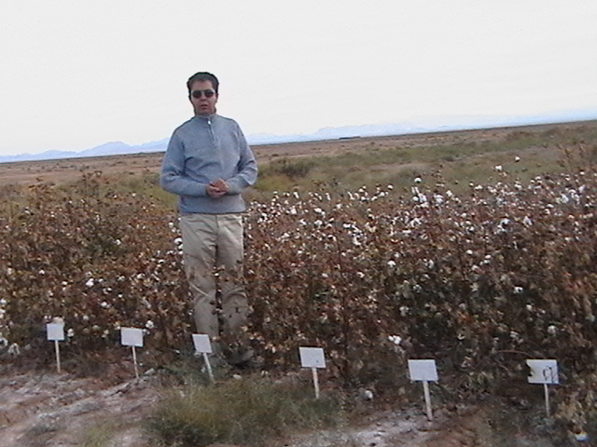
Figure 1 – BC5 lines(5th generation of back cross progenies) under salinity stress in Kashmar region of Khorasan-e-Razavi Province of Iran.

- Reference:

- Vafaeitabar, M. and Ramazani Moghaddam, M.R., .2012. Salt resistant lines improvement in upland cotton through back crossing approach.Final report of research project. KRANRREC Pub. 59 PP.
- Qadir, M. and M.Shams. 1997. Some agronomic and physiological aspect of salt tolerance on cotton (Gossypium hirsutum) .J.Agron. Crop Sci. 179: 101-106.
- Nawar, M. T., A. M. Zaher, K. El-Sahhar, and S. A. Abdel-Rahim. 1998. Effect of salinity on botanical characters and fiber maturity of three Egyptian cotton cultivars. Proc.World Cot. Conf.Athen, Greece, Sept. 6-12, 1998. pp: 272-277species production, Plant Cell Physiol. 55: 2060–2076.
- Biography:
Mohammadreza Ramazani Moghaddam has completed his PhD at the age of 33 years from Tehran science and research University. He is the head of cotton department of KRANRREC and senior scientist (cotton geneticist and breeder) of AREEO of Iran. He has published more than 35 papers in scientific journals and has been serving as an editorial board member of journal. He has introduced 3 new cultivars of cotton.(Up to 100 words)
- Presenting author details


Full Name: Mohammadreza Ramazani Moghaddam
Contact number: +989151100741
Twitter account:
Linked In account: rezaramezani@yahoo.com
Session name/ number:
Category: (Oral presentation/ Poster presentation):oral presentation
Passport Number:X47858394

