Abstract -_Dr.Harish - India

Title: The mysterious circle: molecular curiosities of RNA mediated gene regulation

Harish H¹, Kunal Seth KS¹
¹Plant Biotechnology Laboratory, Department of Botany, Mohanlal Sukhadia University, Udaipur – 313 001 (Rajasthan) India

Keywords: Back splicing, circular RNA, Gene regulation, non-canonical splicing, non-coding RNA

- Abstract Body (up to 250 words)
Circular RNA (circRNA) is emerging as a key player because of its role in gene regulation and potential application in RNA-based drugs. Regulated and/or competitive spatiotemporal biogenesis of circRNA occurs through non-canonical splicing mechanism that involves back-splicing. Many functional aspects have been attributed to this newly emerging group of non-coding RNA. Few functional roles identified are miRNA sponging, protein sponging, mRNA trapping and involvement of circRNA in development and diseases. The role of circRNA in plants is less explored and has been demonstrated that many circRNAs are involved in modulation of stress responsive genes. In this review, biogenesis and functional aspects of circRNA have been discussed with special focus on plants perspectives. Many unanswered questions which have not been raised before are discussed for future research endeavors.

- Image:

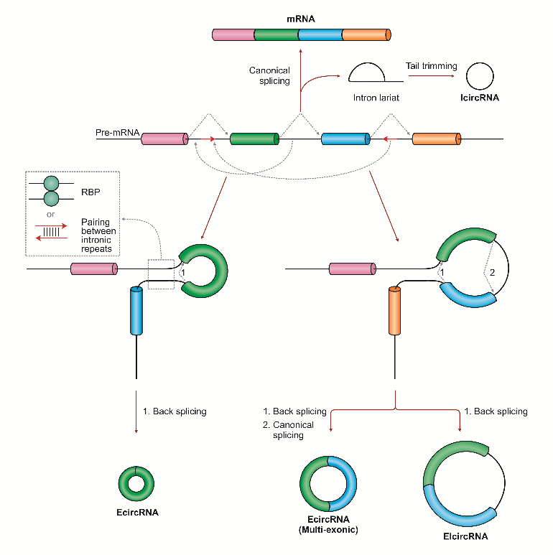

- Reference:
- Seth, K. and Harish, 2017. The mysterious circle: Molecular curiosities of RNA mediated gene regulation. Gene Rep., 9; 13-19
- Biography:
Harish has completed his PhD at the age of 28 years from Jai Narain Vyas University, Jodhpur and Postdoctoral Studies from Jai Narain Vyas University at Jodhpur. He is the Assistant Professor of Botany, at Mohanlal Sukhadia University, Udaipur (Rajasthan) India. He has published more than 25 papers in reputed journals and having more than 500 citation to his credit. Weblink: https://sites.google.com/view/dr-harish/home
- Presenting author details



Full Name: Dr. Harish
Contact number: +91-9414478466
Twitter account: @HarishMangesh
Linked In account:-
Session name/ number:
Category: Poster presentation
Passport Number: S2121573

