Abstract Template

Title: DNA fingerprinting based on SSR amplification profiles for Sicilian hazelnut (Corylus avellana L.) germplasm identification

FIORE MC¹, MARCHESE A², DIGANGI I³, SCIALABBA A²
¹ CREA Research Centre for Plant Protection and Certification, Bagheria (PA), Italy
² Department of Biological, Chemical and Pharmaceutical Sciences and Technologies (STEBICEF), Palermo, Italy
³ Living Plants Germplasm Bank of Nebrodi, Contrada Pirato, Ucria (ME), Italy

Keywords: Hazelnut accessions, Microsatellite (SSR) marker, Germplasm conservation, Genetic diversity

- Abstract Body (up to 250 words)
Hazelnut (Corylus avellana L.) is an important crop in the world and Italy is the second producer after Turkey. In Sicily hazelnut crop represents an essential element for a sustainable local development, for landscape protection of marginal mountain areas and for a defensive action against deterioration of the land and hydrogeological instability. The Sicilian hazelnut production is based on main cultivars and local selection identified by local name. Therefore there is an increasingly need to develop a method to detect cases of synonyms and to describe the germplasm diversity. Simple Sequence Repeats (SSR) have been used to true-to-type characterization of cultivars (Wünsch and Hormaza , Boccacci et al.). In this work, the genetic diversity of 53 hazelnut accessions was analysed by using a set of SSR loci (Boccacci and Botta). Most of SSR loci were polymorphic, enabled to detect a high level of molecular diversity and to identify several cases of homonyms, synonyms and somatic mutants. An UPGMA clustering analysis and PCoA were carried out to investigate the genetic relationships among accessions. This analysis provides new insight into the Sicilian hazelnut diversity useful to support morphological characterization and to identify unambiguously all genotypes. Genotyping is one of the most important step to recovery Sicilian hazelnut food chains and a useful starting point for the development of a conservation strategy and for the establishment of a core collection of Corylus avellana L. germplasm.

- Hazelnut ex situ collection preserved at “Living Plants Germplasm Bank” of Nebrodi ( 800 m.a.s.l.)

- Reference:
- Wünsch, A & Hormaza JI (2002) Cultivar identification and genetic fingerprinting of temperate fruit tree species using DNA markers. Euphytica 125: 59–67
- Boccacci P, Akkak A, Bassil NV, Mehlenbacher SA, Botta R (2005) Characterization and evaluation of microsatellite loci in European hazelnut (Corylus avellana L.) and their transferability to other Corylus species. Mol Ecol Notes 5:934–937
- Boccacci P, Botta R (2010) Microsatellite variability and genetic structure in hazelnut (Corylus avellana L.) cultivars from different growing regions. Sci Hortic 124:128–133
- Biography:
Maria Carola Fiore has completed her bachelor degree in Agricultural Science at Palermo University. She was a Research Fellow at Institute for Genetics of the University of Cologne. She got her PhD in Horticultural Science. She has currently a permanent position as researcher at CREA Research Centre for Plant Protection and Certification. Her research interests focussing on plant molecular genetics and biodiversity conservation. She has published more than 60 papers in reputed journals and international conferences.
- Presenting author details

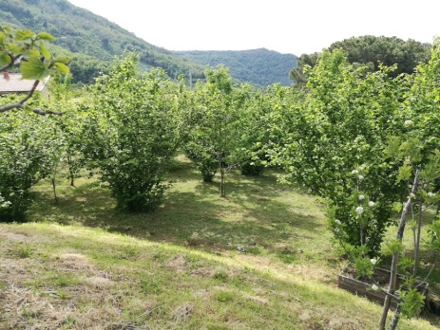

Full Name: Maria Carola Fiore
Contact number: +39 091909090
Session name/ number: Plant Genome Science/1
Category: e-Poster

