Abstract

Title: De Novo sequencing and hybrid assembly of biofuel crop Jatropha curcas L: Insights on gene annotation, comparative genomics and transcriptome analysis with identification of quantitative trait loci for geminivirus resistance

Nagesh Kancharla¹, Saakshi Jalali¹, J. V. Narasimham¹, Vijay Yepuri¹, Arockiasamy S^{1*}

¹Reliance Technology Group, Reliance Industries Limited, Navi Mumbai, Maharashtra, India;

Keywords: oil seed; biofuel; genome sequencing; transcriptomics; hybrid sequencing; simple sequence repeats; linkage map; geminivirus

- Abstract Body (up to 250 words)
Jatropha curcas is an important perennial, drought tolerant plant identified as a potential biodiesel crop. We report here the hybrid de novo genome assembly of Jatropha curcas generated using Illumina and PacBio sequencing technologies and identification of quantitative loci responsible for geminivirus resistance. In this study, we generated scaffolds of 265.7 Mbp in length which is corresponding to 84.8% of the gene space using BUSCO analysis. Additionally, 96.4% of predicted protein-coding genes were captured in corresponding tissues transcriptome data, which reconfirms the accuracy of the assembled genome. The genome was utilized to identify 12,103 dinucleotide repeat SSR markers, which were exploited in genetic diversity analysis to identify genetically distinct lines. A total of 250, polymorphic SSR markers were employed to construct a genetic linkage map for Jatropha Mosaic Virus (JMV) resistance using interspecific F₂ mapping population involving Jatropha curcas and Jatropha integerrima as parents. QTL analysis showed the identification of three minor quantitative
trait locus (QTL) for JMV resistance and validated in an alternate recipient genetic background F₂ mapping population. These validated QTLs were utilized in Marker Assisted Breeding (MAS) for developing Jatropha Mosaic Virus resistance hybrids in Jatropha. Comparative genomics of oil-producing genes across selected oil producing species revealed 27 conserved genes and 2,986 orthologous protein clusters in Jatropha. This reference genome assembly gives an insight into the understanding of the complex genetic structure of Jatropha and serves as source for the development of agronomically improved virus resistant and oil producing species.

- Image: 1

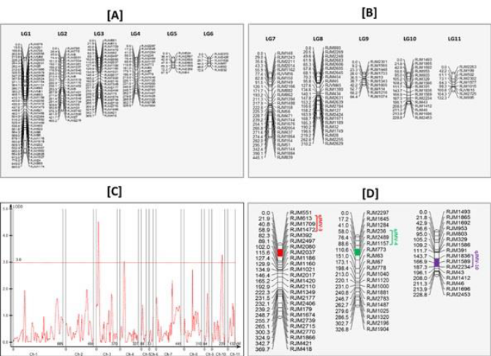
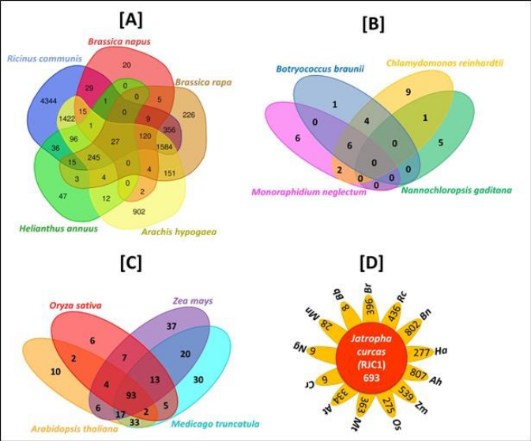
Image 1: An interspecific genetic linkage map of Jatropha depicting QTL Analysis for geminivirus resistance.
Image 2: Venn diagrams depicting comparative genomics of lipid metabolizing genes of Jatropha with 13 different plant species.
- Reference:
- Sato, S.; Hirakawa, H.; Isobe, S.; Fukai, E.;Watanabe, A.; Kato, M.; Kawashima, K.; Minami, C.; Muraki, A.;Nakazaki, N.; et al. Sequence analysis of the genome of an oil-bearing tree, Jatropha curcas L. DNA Res. 2011,18, 65–76.
- Wu, P.; Zhou, C.; Cheng, S.;Wu, Z.; Lu,W.; Han, J.; Chen, Y.; Ni, P.;Wang, Y.; Xu, X.; et al. Integrated genome sequence and linkage map of physic nut (Jatropha curcas L.), a biodiesel plant. Plant J. 2015, 81, 810–821.

- Biography:
I, Nagesh Kancharla has completed my PhD in Plant Genetics from Osmania University, Hyderabad. I am having more than 14 years of industrial plant molecular breeding experience in various food, cash, model and bio-fuel crops. I am presently working as Senior Research Scientist at Reliance Industries Ltd, Mumbai. My major work responsibilities include molecular breeding for plant-based bio-fuel crops to develop high yielding and disease resistant hybrids through latest cutting edge technologies. I have two publications in peer reviewed journals and presented my work in various international conferences.
- Presenting author details
Full Name: Nagesh Kancharla
Contact number: +917718829686
Twitter account: NA
Linked In account: Nagesh Kancharla
Session name/ number:
Category: (Oral presentation)
Passport Number:



