Title: Transformation and Expression of a Na⁺-dependent high affinity bicarbonate transporter, SbtA in Nicotiana chloroplasts

Vandana Tomar¹, Panchsheela Nogia¹, Namitha Nayak², Rajesh Mehrotra² and Sandhya Mehrotra²*

¹Department of Biological Sciences, Birla Institute of Technology and Science, Pilani, Rajasthan-333031, India
²Department of Biological Sciences, BITS, Pilani KK Birla Goa Campus, Zuarinagar, Goa-403726, India

Keywords: SbtA; Carbon concentrating mechanism; Agroinfiltration; Nicotiana benthamiana

- Abstract Body (up to 250 words)
Integration of cyanobacterial bicarbonate transporters into the inner envelope membrane of chloroplast of C₃ plants is assumed to enhance their photosynthetic performance. SbtA transporter has been looked upon as one of the most potential candidate for achieving this objective. In the present study, we attempted installing SbtA transporter protein from Synechococcus elongatus PCC 7942 to the inner chloroplast envelope of Nicotiana chloroplasts via nuclear transformation. The sbtA gene was fused with two transit peptide sequences viz., TNaXTP (transit peptide from AT3G56160.1) and TMDTP (transit peptide from AT2G02590.1) from inner envelope targeted proteins of Arabidopsis thaliana to generate fusion constructs in a GFP vector (pCAMBIA 1302). Transient as well as stable expression of the gene was studied by transforming N. benthamiana by agroinfiltration and N. tabacum by Agrobacterium mediated co-culture method. Expression of the transgene in N. benthamiana was confirmed by PCR and RT-PCR at DNA and mRNA level respectively and by western blotting at protein level by using anti-GFP primary antibody and horseradish peroxidase (HRP) conjugated anti-rabbit secondary antibody. Stable plants of N. tabacum carrying the gene of interest were generated on MS medium with selection agents and analysed by gene specific PCR analysis. Confocal images of the protoplasts reveal chloroplastic location of the protein in both the constructs. The work highlights the importance of signal sequence (cTP) in targeting large non-chloroplastic transmembrane proteins to the chloroplasts by transformation of nuclear genome. It provides a preliminary yet valuable basis for future manipulations of chloroplast function for improving plant photosynthesis.

- Image:

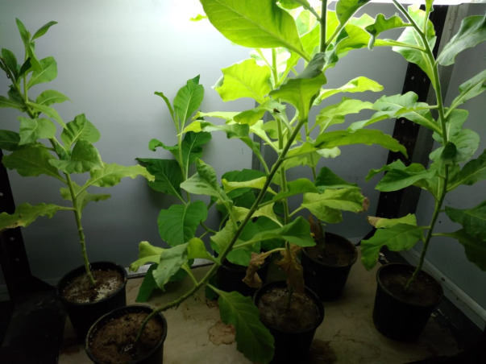

- Reference:
- Du, J., Förster, B., Rourke, L., Howitt, S. M. and Price G. D. (2014) Characterisation of cyanobacterial bicarbonate transporters in E. coli shows that SbtA homologs are functional in this heterologous expression system. PLoS ONE, 9(12), e115905.
- Rolland, V., Badger, M.R. and Price, G.D. (2016) Redirecting the cyanobacterial bicarbonate transporters BicA and SbtA to the chloroplast envelope: soluble and membrane cargos need different chloroplast targeting signals in plants. Frontiers in Plant Science, 7, 185.

- Uehara, S., Adachi, F., Ito-Inaba, Y. and Inaba, T. (2016) Specific and efficient targeting of cyanobacterial bicarbonate transporters to the inner envelope membrane of chloroplasts in Arabidopsis. Frontiers in Plant Science, 7, 16.

- Biography:
Sandhya Mehrotra completed her Ph.D in the year 2003 from National Botanical Research Institute, Lucknow, India. Thereafter she did a post doctoral fellowship at Nara Institute of Science and Technology, Nara, Japan. Currently, she is Associate Professor of Biology at Birla Institute of Technology and Science, (BITS, Pilani), Goa Campus. She has over 30 publications with an H-index of 8 and has served as reviewer of several journals.

- Presenting author details


Full Name: Sandhya Mehrotra
Contact number: +91-9772975612; +91-0832-2580372
Twitter account:
Linked In account:
Session name/ number: Plant Biotechnology
Category: Oral presentation
Passport Number: N0735559

