Title: REF6, an Arabidopsis H3K27me3 demethylase, functions in high temperature response

Kaixuan He^{1,2}, Hailiang Mei¹, Xian Deng¹, Qi Qiu¹, Xiaofeng Cao^{1,2}

¹Institute of Genetics and Developmental Biology, Chinese Academy of Sciences, Beijing, China
²College of Life Sciences, University of Chinese Academy of Sciences, Beijing, China

Keywords: REF6, H3K27me3, thermo-morphogenesis

- Abstract Body
As the sessile organisms, plants have developed a series of mechanisms to cope with the changeable environment, such as ambient temperature. Epigenetic regulation plays fundamental roles in modulating chromatin-based processes and shaping the epigenome in multicellular eukaryotes. Arabidopsis RELATIVE OF EARLY FLOWERING 6 (REF6), a Jumonji C domain-containing histone demethylase¹, directly recognizes the CTCTGYTY motif by its zinc-finger domains to demethylate H3K27me3 at specific loci in Arabidopsis genome². Phenotypic analysis shows that ref6 mutant displays insensitivity to high ambient temperature, showing shorter hypocotyl length than that of Col at 28℃, indicating that REF6 may function in plant thermo-morphogenesis. Using ChIP-seq and RNA-seq analysis, we identified several REF6 targets involved in thermo-morphogenesis process. Further study will help us to uncover the essential role for H3K27me3 dynamics in diverse abiotic stresses.

- Image:

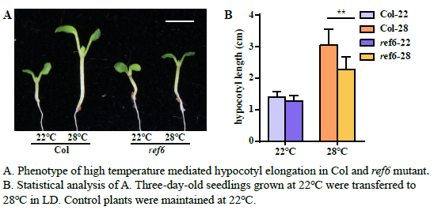

- Reference:
- Lu, F., Cui, X., Zhang, S., Jenuwein, T. & Cao, X, 2011. Arabidopsis REF6 is a histone H3 lysine 27 demethylase. Nat. Genet. 43, 715–719
- Cui, X., Lu, F. et al., 2016. REF6 recognizes a specific DNA sequence to demethylate H3K27me3 and regulate organ boundary formation in Arabidopsis. Nat. Genet. 48, 694–699

- Biography:
Kaixuan He has been studying the graduate program for PhD Degree on Genetic Biology in Institute of Genetics and Developmental Biology, Chinese Academy of Sciences, from Sept. 2015 to now.

- Presenting author details


Full Name: Kaixuan He
Contact number: 8617733274250
Linked In account:
Session name/ number:
Category: Poster presentation
Passport Number: EC9644172

