Abstract

Title: Targeting mechanism of H3K27me3 demethylase REF6 and its role in transgenerational thermomemory in Arabidopsis

Xian Deng¹, Junzhong Liu², Qi Qiu¹, Hailiang Mei¹, Kaixuan He¹, Qingqing Yao³, Baixing Wu³, Jixiang Zhang⁴, Falong Lu⁴, Jinbiao Ma³, Zuhua He², Xiaofeng Cao¹.
¹ State Key Laboratory of Plant Genomics and National Center for Plant Gene Research, Institute of Genetics and Developmental Biology, Chinese Academy of Sciences, Beijing, China.
²National Key Laboratory of Plant Molecular Genetics, CAS Center for Excellence in Molecular Plant Sciences, Shanghai Institute of Plant Physiology & Ecology, Shanghai Institutes for Biological Sciences, Chinese Academy of Sciences, Shanghai, China.
³State Key Laboratory of Genetic Engineering, Collaborative Innovation Centre of Genetics and Development, Department of Biochemistry, Institute of Plant Biology, School of Life Sciences, Fudan University, Shanghai, China.
⁴State Key Laboratory of Molecular Developmental Biology, Institute of Genetics and Developmental Biology, Chinese Academy of Sciences, Beijing, China.

Keywords: Arabidopsis, H3K27me3, Histone demethylase, DNA methylation, transgenerational thermomemory.
- Abstract Body (up to 250 words)
RELATIVE OF EARLY FLOWERING 6 (REF6/JMJ12), a Jumonji C (JmjC)-domain-containing H3K27me3 histone demethylase, finds its target loci in Arabidopsis genome by directly recognizing the CTCTGYTY motif via its zinc-finger (ZnF) domains (1, 2). REF6 tends to bind motifs located in active chromatin states and depleted for heterochromatic modifications. However, the underlying mechanism remains unknown. Here, using biochemistry, structural biology, and high-throughput sequencing, we showed that REF6 binding affinity to specific regions is repelled by DNA methylation within CTCTGYTY motif. In addition, we also found that heat-induced HEAT SHOCK TRANSCRIPTION FACTOR A2 (HSFA2) directly activates REF6, which in turn derepresses HSFA2. REF6 and HSFA2 establish a heritable feedback loop which is involved in transgenerational thermomemory and stress adaptation.

- Image:

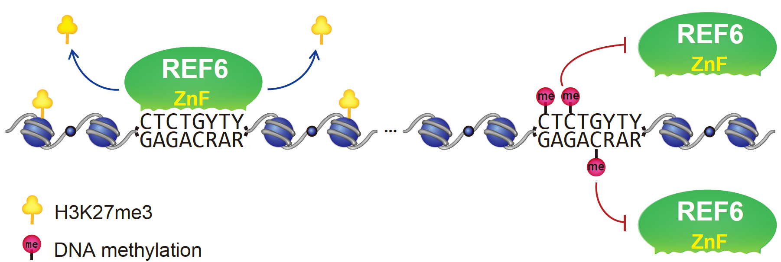

- Reference:
- Lu, F., Cui, X., Zhang, S., Jenuwein, T. & Cao, X. 2011. Arabidopsis REF6 is a histone H3 lysine 27 demethylase. Nat Genet, 43: 715-719.
- Cui, X. et al. 2016. REF6 recognizes a specific DNA sequence to demethylate H3K27me3 and regulate organ boundary formation in Arabidopsis. Nat Genet, 48: 694-699.
- Biography:
Xian Deng has completed her PhD and Postdoctoral Studies at the age of 30 years from Institute of Genetics and Developmental Biology, Chinese Academy of Sciences. She is the Associated Professor of Institute of Genetics and Developmental Biology, Chinese Academy of Sciences. She has published more than 15 papers in reputed journals, such as PNAS, Cell Res, Curr Opin Plant Biol, Nat Sci Rev, Plant Physiol, Bio-protocol, etc.
- Presenting author details


Full Name: Xian Deng
Contact number:
Twitter account:
Linked In account:
Session name/ number:
Category: Oral presentation
Passport Number: PE1560983

