Abstract Template

TO TASTE OR NOT TO TASTE: THAT IS THE QUESTION! Innovative approaches and instruments for tomato breeding

GREGOIRE O¹, SANTUCCI S², NEGRI S¹, LAZZARIN R¹, POLUZZI G¹, BERETTA M¹, BRUNAZZI A¹

¹ISI Sementi SpA, Frazione Ponte Ghiara, 43036 Fidenza (Italy)
²University of Perugia, Dipartimento Scienze Agrarie Alimentari ed Ambientali, Borgo XX Giugno 74, 06121 Perugia (Italy)

Keywords: Tomato, taste, NIR, traits, fruit quality

- Abstract Body (up to 250 words)
Tomato (Solanum lycopersicum L.) is an important crop worldwide and the most important vegetable in Europe. During the last decade of selection breeders successfully focused on traits as plant yield, long-shelf-life and disease resistances, nonetheless final consumers are frequently not satisfied regarding the fruit quality and taste. Furthermore, from the breeders’ point of view, the lack of phenotyping platforms and clear key traits that can efficiently identify individuals exhibiting rare, optimal genotypes from large populations is currently on of the major bottlenecks. To face this constraint, we promoted two different projects: I) APPreciation of simplification project with the aim to accelerate the development of new improved varieties thanks to the use of FieldBook App and II) Taste it ISI with the objective to create a tool for the detection of the flavor components in tomato directly into the field/greenhouse. In this study, 25 ISI Sementi commercial varieties including 5 testers, were phenotypically characterized with all the DUS test traits in order to assess the genetic stability of the hybrids. Then, organoleptic properties of each varieties were settled by a sensory analysis and MS: from mature fruits, 19 flavor traits (including L-glutammic acids that is demonstrated to be the main responsible of the peculiar umami taste in tomato) were determined and used to build specific calibrations with a micro-NIR spectrometer. These calibrations and the complete phenotypic characterization done are now successful instruments that are helping the breeders for making the right decision regarding the advancement of tasty tomato breeding lines or varieties.

- Image:

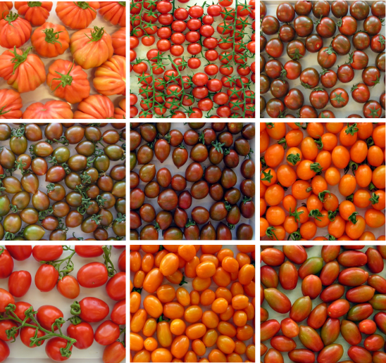

- Reference:
- Rife, T. W., & Poland, J. (2014) Field Book: An open-source application for field data collection on Android. Crop Science 54, 1624-1627
- Biography:
Dr. Brunazzi has completed her PhD in Agrobiosciences, genomics and crop sciences from Sant’Anna University (Pisa, Italy) after several years working as a researcher and Junior Breeder around Europe. She currently is the fresh market tomato breeder of ISI Sementi in Italy, a premier Italian seed company. She has published several papers regarding phenotypic characterization both in cereals and different horticultural species.
- Presenting author details


Full Name: Alice Brunazzi
Contact number: +393396705429
Twitter account: AliceBrunazzi
Linked In account: www.linkedin.com/in/alice-brunazzi-phd
Session name/ number: nutrigenomics
Category: Oral presentation
Passport Number:YA8238642

