Abstract Template

Title: Phenotyping of segregating generations derived from sunflower interspecific crosses
(Helianthus annuus× Helianthus argophyllus)

Muhammad Mubashar Hussain¹, Saeed Rauf¹
¹Department of Plant Breeding & Genetics, College of Agriculture, University of Sargodha, Sargodha

Keywords: yield losses, root to shoot ratio, introgression, crop wild relatives
- Abstract
Drought is a major production constrained in crop species and crop wild relatives are important source of resistant for biotic and abiotic stresses. A breeding program was initiated to introgress drought tolerance in sunflower through hybridization between the argophyllus and annuus species. Selection was carried out in segregating generation for high cuticular waxes, smaller leaf area, single haeding and high oil contents. The developed F₅ breeding lines were compared with non-adapted elite sunflower germplasm under controlled condition. Contrasting water regimes was developed by irrigating 100% of the field capacity, or 75%, 50% and 25% of the total water applied in the control under randomized complete block design. The comparison between the two types of germplasm showed that drought resistant breeding lines showed superior traits such as leaf area, shoot weight and root shoot ratio. Several drought resistant promising lines such as UCA-2, UCA-B-5, UCA-B-27 were identified which showed superior traits such leaf area, root length and root to shoot ratio under high intensity water stress treatment (T3).

- Image:

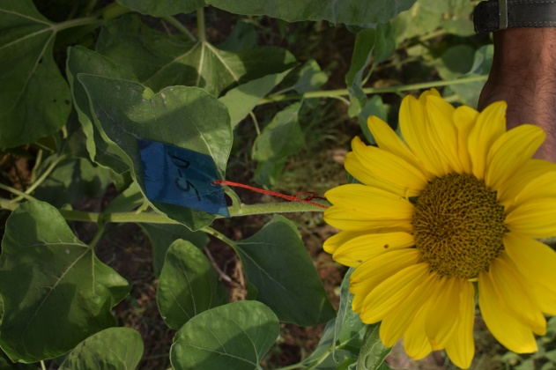

- Reference:
- Acquaah, G. (2007) Principles of plant genetics and breeding. 2nd Edition, Wiley-Blackwell, Hoboken.
- Hussain M.M., Kausar M., Rauf S., Khan M.F.Z., Paderweski J., Khan M., Haq I.K and Raza A.B.M. (2018). “Selection for Some Functional Markers for Adaptability of Helianthus argophyllus× Helianthus annuus Derived Population under Abiotic Stress Conditions
- Khan M., Rauf S., Munir H., Kausar M., Hussin M.M., Ashraf,E. (2016). Evaluation of sunflower ( Helianthus annuus L.) single cross hybrids under heat stress conditions. Archives of Agronomy and Soil Science.
- Biography:
XXXX has completed his PhD at the age of 25 years from XXXX University and Postdoctoral Studies from School of Medicine, XXXX University, Singapore. He is the Director of XXXX, a premier Bio-Soft service organization. He has published more than 25 papers in reputed journals and has been serving as an editorial board member of repute. (Up to 100 words)
- Presenting author details

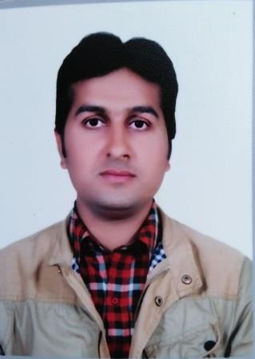
Full Name: Muhammad Mubashar Hussain
Contact number:00923317675595
Linked In account: https://www.linkedin.com/in/mubashar-hussain-2a2076b5/
Category: (Oral presentation)

