Recent Achievements in Sunflower Molecular Breeding

YALCIN KAYA

Trakya University, Engineering Faculty, Genetic and Bioengineering Department, Edirne, Turkey

Keywords: Sunflower, Hybrid Breeding, Molecular Plant Breeding, Genome Analysis
Sunflower (Helianthus annuus L.) is one of the main oil crops and grows commonly non irrigated lands in the world, therefore it influences from environmental conditions especially during grain filling period. Some diseases, weeds and broomrape parasite are main limiting factors of sunflower yield in addition to abiotic stresses. Hybrids have been using largely in sunflower production since 1980s almost in all of the world. However, plant breeders have to combine many different traits to new cultivars biotic and abiotic resistance in addition to higher seed and oil yielding and higher adaptation capability. Therefore, we need seriously new molecular tools both developing new hybrids and inbred lines and accelerating breeding program in sunflower, and also gene pyramiding in such as drought tolerance, higher oleic, etc. Helianthus family has 51 species so it has huge genetic resources keeping very useful genes for plant breeders both developing new plant designs to increase leaf area then new hybrids could catch higher heterosis on seed yield etc. New developments on molecular breeding will help to breeders both screening enormous genetic materials and then determining and transferring to cultivated ones shortly utilizing from molecular markers. Genotyping-by-sequencing and association mapping based on next-generation sequencing technologies enabled these identification of new markers from huge wild species and interspecific hybrids in sunflower. On the other hand, new image analysis methods and drone technology will facilitate to work for phenotyping on huge genetic materials giving the opportunities to look different angles to breeders while analyzing to plants. As results, the future targets will be more complex both combining classical and molecular tools together in sunflower breeding programs and also help to develop new hybrids associated multi useful genes together.

Reference:
- Zhang K, Raboanatahiry N, Zhu B and Li M (2017) Progress in Genome Editing Technology and Its Application in Plants. Front. Plant Sci. 8:177.
- Dimitrijevic A and Horn R (2018) Sunflower Hybrid Breeding: From Markers to Genomic Selection. Front. Plant Sci. 8:2238.
- Mangin B, Bonnafous F, Blanchet N, Boniface M-C, Bret-Mestries E, Carrère S, Cottret L, Legrand L, Marage G, Pegot-Espagnet P, Munos S, Pouilly N, Vear F, Vincourt P and Langlade NB (2017) Genomic Prediction of Sunflower Hybrids Oil Content. Front. Plant Sci. 8:1633.
Biography:
Prof Dr YALCIN KAYA, TRAKYA UNIVERSITY, Edirne, Turkey has longer carrier and experience on plant breeding and genetics and developed many sunflower hybrids and lines. He has worked in research institute as National Sunflower Coordinator and as Project leader for over 20 years and deputy director. He had M Sc in UNIVERSITY OF NEBRASKA, Lincoln, US, and Post Doc on sunflower breeding in USDA Sunflower Lab at Fargo, ND, US. Now he is PLANT BREEDING RESEARCH CENTER director and GENETIC ENGINEERING Dept. Head at university. He is also former President of TURKISH PLANT BREEDERS UNION and INTERNATIONAL SUNFLOWER ASSOCIATION. He published more than 200 papers.
Presenting author details
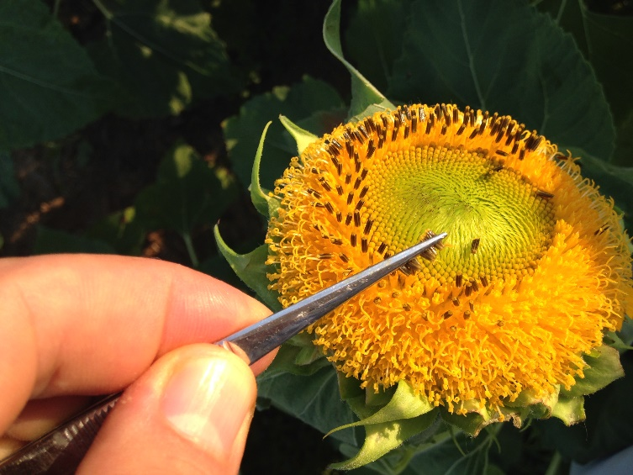

Full Name: YALCIN KAYA
Contact number: +90 542 2828184
Twitter account: @yalcinkaya22
Linked In account: yalcinkaya22
Session name/number: Molecular Plant Breeding / 4
Category: Oral presentation
Passport Number: S 02753318

