Computational Genomics: AP2/ERF family in plants

Shouhartha Choudhury¹, Preetom Regon² and, Sanjib Kumar Panda^{3*}

¹Department of Life Science and Bioinformatics, Assam University, Silchar-788011
²School of Life Sciences, Assam University, Silchar-788011

Keywords: AP2 Family, ERF Family, RAV Family and, Abiotic stress
Abstract
The present study investigated AP2/ERF family transcriptional regulators with variety of functions involved development and stress tolerance in plants. The comparative and functional analysis of AP2/ERF family in Arabidopsis thaliana, Oryza sativa and, Solanum lycopersicum was performed. The AP2/ERF family classified into subfamily AP2, ERF, and RAV family. Our observation suggested AP2/ERF family genes in genomic data; in contrast some genes are species specific. In this study, a comprehensive computational identified AP2 family, ERF family and, RAV family in Arabidopsis thaliana, Oryza sativa and Solanum lycopersicum. In Oryza sativa: Os02g42580, Os02g52880, Os03g02650, Os04g36640, Os04g48330, Os06g42910, Os12g07030 and, Os06g09717 remarked. An overview of AP2/ERF family in Arabidopsis thaliana, Oryza sativa and, Solanum lycopersicum presented, including conserved domain, motifs, phylogeny, chromosome location and gene expression. These results may be useful for future functional analyses of AP2/ERF superfamily. In this study, we performed bioinformatics and computational technique to current knowledge of AP2/ERF family in plants.

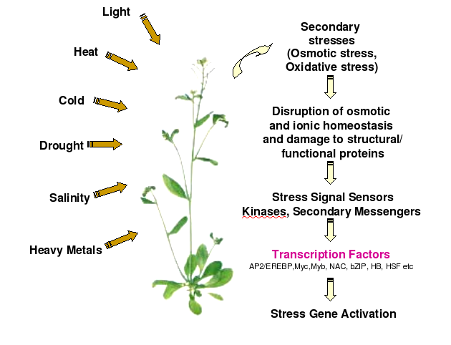
Reference
- Sakuma, Y., et al., Functional analysis of an Arabidopsis transcription factor, DREB2A, involved in drought-responsive gene expression. The Plant Cell, 2006. 18(5): p. 1292-1309.

- Nakano, T., et al., Genome-wide analysis of the ERF gene family in Arabidopsis and rice. Plant physiology, 2006. 140(2): p. 411-432.
- Riechmann, J.L., et al., Arabidopsis transcription factors: genome-wide comparative analysis among eukaryotes. Science, 2000. 290(5499): p. 2105-2110.
Biography
Shouhartha Choudhury has completed his B.Tech and M.Tech in Bioinformatics from India and now pursuing integrated pre-Ph.D. research program in School of Life Sciences, Department of Biotechnology, Assam University, Silchar-788011. He submitted four research reports entitled (a) Computational Genomics: AP2/ERF Family in plants, (b) Comparative Genomics: Novel: BCL-2 Family, (c) Genomics of OLIG Family of bHLH transcription factor and, (d) Genome-wide analysis of NeuroD Family of bHLH transcription factor in Assam University, for short communication

Author details


Full Name: Shouhartha Choudhury
Contact number: +91-9954411181
Twitter account: Shouhartha Choudhury
Linked In account: Shouhartha Choudhury
Session name/ number:
Category: (Oral and poster presentation)
Passport Number:

