Quantitative Trait Loci (QTL) Associated with Resistance to Fusarium oxysporum f. sp. cubense race 1 in bananas (Musa spp.)

Ivan Kabiita Arinaitwe^{1, 2, 4*}, Chee How Teo⁴, Fatimah Kayat³, Robooni Tumuhimbise², Brigitte Uwimana⁵, Jerome Kubiriba² Mustafa A.N. Alfayyadh.⁶, Jennifer Ann Harikrishna^{1, 4} and Rofina Yasmin Othman^{1,}

- Institute of Biological Sciences (Genetics), Faculty of Sciences, University of Malaya
- National Banana Research Program, National Agricultural Research Organization, P.O. Box 7065, Kampala, Uganda
- University Malaysia, Kelantan Jeli, Malaysia
- Centre for Research in Biotechnology for Agriculture (CEBAR), University of Malaya
- International Institute of Tropical Agriculture (IITA), Kampala, Uganda
- 6 Biotechnology department, Faculty of Science, Eskişehir Technic University, Turkey
*Corresponding author, Email: ivanarinaitwe@yahoo.co.uk ; Tel: +256 782828151

Musa spp., Fusarium wilt, Segregating population, Fusarium oxysporum f. sp. Cubense, Molecular markers, Quantitative trait loci,

Abstract
Fusarium oxysporum f. sp. cubense (Foc) is a disease that attacks bananas causing great economic losses to banana production worldwide. Conventional banana breeding to introgress resistance from wild relatives to susceptible cultivars is complicated and takes a long time. Markers assisted selection is a modern tool thought to over some barriers of banana breeding by increasing the breeding efficiency and shortening the breeding period. The aim of this study was to genotype two unrelated mapping populations developed Foc race 1 resistance and identify markers for analysis of Foc race 1 resistance QTL. Two F₁ mapping populations were developed for Foc race 1 resistance: First population of 140 hybrids, by crossing a resistant Monyet with a susceptible Kokopo and the second of 138 hybrids by crossing a susceptible Mshale with a resistant Calcutta 4. The parents contrasting for Foc race 1 resistance were screened using IRAP, ISSR, and SSR markers. IRAP primer GyLTRev had the highest polymorphism of 76.9% between Mshale and Calcutta 4 parents and 69.2% among their F₁ hybrids and 64.3 % between Monyet and Kokopo parents of and 42.9% their F₁ hybrids among all the primers. One major QTL associated with Foc race 1 in an F₁ population of Monyet x Kokopo was mapped at linkage groups 1 (LG1) with a LOD score of 4.0 using 32 polymorphic markers. Results in this study should be useful for further elucidating the mechanism of resistance to Fusarium wilt and in the development of molecular markers.

- Image
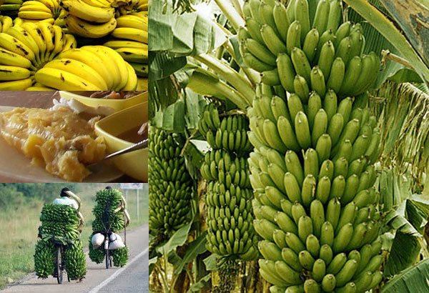

- Reference:

Brown, A., Tumuhimbise, R., Amah, D., Uwimana, B., Nyine, M., Mduma, H., … Swennen, R. (2017). Bananas and plantains (Musa spp.). In H. Campos & P. D. S. Caligari (Eds.), Genetic Improvement of Tropical Crops (pp. 219–240). Basel, Switzerland: Springer, Cham. https://doi.org/10.1007/978-3-319-59819-2_7
Heslop-Harrison, J. S., & Schwarzacher, T. (2007). Domestication, genomics and the future for banana. Annals of Botany, 100(5), 1073–1084. https://doi.org/10.1093/aob/mcm191
Lema, M. (2018). Marker Assisted Selection in Comparison to Conventional Plant Breeding : Review Article. Aricultural Research and Technolofy, 14(2), 1–10. https://doi.org/10.19080/ARTOAJ.2018.14.555914
Mbanjo, E. G. N., Tchoumbougnang, F., Mouelle, A. S., Oben, J. E., Nyine, M., Dochez, C., … Lorenzen, J. (2012). Molecular marker-based genetic linkage map of a diploid banana population (Musa acuminata Colla). Euphytica, 188(3), 369–386. https://doi.org/10.1007/s10681-012-0693-1
Pillay, M., Ashokkumar, K., Arun Siva Shunmugam, K., & Elayabalan, S. (2012). A Case for Molecular Breeding in Musa. In Genetics,Genomics and Breeding of Bananas (pp. 280–297). https://doi.org/10.13140/2.1.1246.7205

- Biography
Mr. Arinaitwe Ivan Kabiita is a banana breeder at the National Banana Research Programme of National Agricultural Research Organisation (NARO)-Uganda. Currently he is pursuing his Doctorate Degree in Genetics and Molecular Biology under Gates Foundation Scholarship and University (3rd yr) at the University of Malaya pursuing of Malaya, Malaysia. His topic of study is “Genetic Analysis of Resistance Against Fusarium oxysporum f. sp. cubense (Foc) in Selected Banana Populations Using Molecular Markers and Linkage Mapping Approaches”. Ivan undertakes the conventional part of research in Uganda and the molecular part of research at High Impact Research (HIR) at University of Malaya. Ivan holds a BSc. degree in Botany and Zoology from Makerere University-Uganda (2004-2007) and a Master of Science degree in Plant Breeding and seed Systems from Makerere University-Uganda (2012-2014) funded by the Alliance for the Green Revolution in Africa (AGRA) Scholarship in Collaboration with Bioversity International. Ivan worked as Laboratory technician at Agro-Genetic Technologies (AGT) banana tissue culture laboratory in between 2007-2008. Later, He worked with International Institute of Tropical Agriculture (IITA) - Uganda as Research Assistant, banana biotechnology department between 2008 and 2009. In 2009, Ivan joined National Banana Research programme under NARO-Uganda at National agricultural research laboratories (NARL) working as a banana breeder to date. The programme is mandated with improving banana mostly the East African Highland Bananas (EAHBs) and dessert bananas for farmer preferred traits such as yield and resistance to pests and diseases.

- Presenting author details



Full Name: Ivan Kabiita Arinaitwe
Contact number: +256 782 828151
Twitter account: @ArinaitweKIvan
Linked In account: Arinaitwe Ivan Kabiita
Session name/ number: Molecular plant breeding
Category: (Oral presentation)
Passport Number:B0835897

