Contrasting N-use efficient eggplants highlighted key morpho-physiological traits and differential expressed metabolites and genes related to N-metabolism

Antonio Mauceri¹, Laura Bassolino², Antonio Lupini¹, Franz Badeck³, Fulvia Rizza³, Massimo Schiavi², Laura Toppino², Maria R. Abenavoli¹, Giuseppe L. Rotino², Francesco Sunseri¹
¹ Dipartimento Agraria, Università degli Studi Mediterranea di Reggio Calabria, Loc. Feo di Vito snc, I-89124 Reggio Calabria – Italy
² CREA – Centro di ricerca Genomica e Bioinformatica – Via Paullese 28 – I-26836 Montanaso Lombardo (LO) – Italy
³ CREA – Centro di ricerca Genomica e Bioinformatica – Via San Protaso, 302 – I-29017 Fiorenzuola d’Arda (PC) – Italy

Keywords: Solanum melongena L., Nitrogen Use Efficiency (NUE), Root Architecture, Transcriptomics, Metabolomics

- Abstract
Eggplant (Solanum melongena L.) yield is highly sensitive to N fertilization, whose excessive use is responsible of environmental damages. Lowering N input together with the selection of improved Nitrogen-Use-Efficiency (NUE) genotypes, more able to uptake (NUpE), utilize (NUtE) and remobilize N available in soils, could be challenging to maintain high yields. The aim of this study was to explore the natural variation among 19 eggplant accessions in response to low and high NO₃⁻ supply to identify NUE-contrasting genotypes, in hydroponic and greenhouse experiments. AM222 and AM22 accessions were identified in both growing systems as N-use efficient and inefficient, respectively. Overall, the results indicated the key role of N-utilization component (NUtE) to confer high NUE. The higher N-content in AM222 fruits suggesting the efficient N-remobilization as a strategy to enhance NUtE, suggesting GS as a key enzyme.
To deeply understanding the mechanisms underlying NUE complex trait, AM222 and AM22 were employed for both transcriptomics and metabolomics approaches. Short- and long-term N-stress were adopted in the same experimental design for both -omics approaches. Metabolomics results highlighted that alanine, aspartate and glutamate metabolism was highly affected in AM222, while RNA-seq analysis underlined differential gene transcripts involved in processes of reactive oxygen species (ROS) rate‐limiting production that could be attributed to a higher antioxidant activity ability of N-use efficient genotype.
Overall, here we demonstrated the predominant role of NUtE to confer high NUE in eggplant. More interestingly, an integrated network of differential expressed genes and metabolites belong NUtE between AM222 and AM22 were discovered.

- Image:

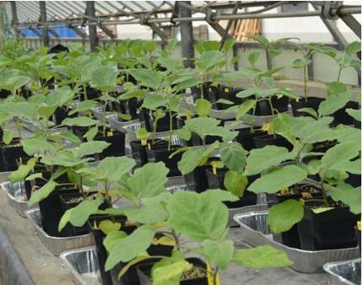

- Reference:
- Good A.G., Beatty P.H. (2011) Fertilizing Nature: A Tragedy of Excess in the Commons. PLOS Biology 9, e1001124.
- McAllister, C.H., Beatty, P.H., Good, A.G. (2012) Engineering nitrogen use efficient crop plants: the current status. Plant Biotechnology Journal. 10, 1011–1025.
- Xu, G., Fan, X., Miller, A.J. (2012) Plant nitrogen assimilation and use efficiency. Annual Review of Plant Biology. 63, 153-82.
- Mauceri, A. (2018). Molecular and physiological traits related to Nitrogen Use Efficiency (NUE) in eggplant (Solanum melongena L.). PhD Thesis, Università Mediterranea di Reggio Calabria.
- Mauceri, A, Bassolino L, Lupini A, Badeck F, Rizza F, Schiavi M, Toppino L, Abenavoli MR, Rotino GL, Sunseri F (2018) Genetic variation in eggplant (Solanum melongena L.) for Nitrogen Use Efficiency (NUE) under contrasting NO₃⁻ supply. J Integrative Plant Biology (submitted).
- Biography:
Associate Professor of Plant Genetics and Breeding at the Dipartimento Agraria, Università Mediterranea di Reggio Calabria, Italy. His research activity is focused on genetics and MAS on vegetable crops. Genomics and Transcriptomics, QTL analysis and cloning and plant abiotic stress with particular interest to Nitrogen Use Efficiency (NUE) are his interest. Associate Editor of BMC Plant Biology. Editor-in-Chief for the open access Journal of Genetics and Plant Breeding. Occasional reviewer for several scientific journals, he is author of about 60 scientific publications indexed in ISI and Scopus databases.

- Presenting author details


Full Name: SUNSERI Francesco
Contact number: +39 329 3178401
Session name: Plant Nutritional Genomics
Category: Oral presentation
Passport Number: AA5046235

