Abstract Template

Title: Unraveling the light-specific regulatory signatures and metabolic reprogramming in green leafy vegetables grown under different light quality and intensity conditions.

Mandar R. Godge¹, Kuppan R. Dinesh¹, Shabbir M. Moochhala¹, Anna Karen Carrasco Laserna², Sam Fong Yau Li²
¹School of Applied Science, Temasek Polytechnic, Singapore
² Department of Chemistry, National University of Singapore, Singapore

Keywords: Horticulture, leafy vegetables, LED lights, metabolomics, flavonoids, plant defence, plant productivity

- Abstract Body (up to 250 words)
Horticulture crop productivity and quality are seriously affected by various biotic and abiotic stresses which represent a severe threat to the agriculture production worldwide. In the present study, we have used Brassica rapa, var. chinensis, a green leafy vegetable, as a plant model to study the effects of LED lights on plant metabolome, plant defence signalling, nutritional status and overall yield parameters. Four types of monochromatic LEDs (blue, green, amber and red) and white (control) were used at low and high intensities (100 and 300 μmol·m⁻²·s⁻¹, respectively). As key molecular pathways underlying plant responses to a specific light quality and intensity remain poorly understood, we have used a multi-omics-based approach to evaluate the metabolic and transcriptional reprogramming (light signal mediated gene expression).

Our results show elevated contents of anthocyanin and flavonols which relates to the increase in gene expression levels of MYB12 (flavonol biosynthesis is regulated by MYB transcription factors). This demonstrates that LED lights can be used as an efficient tool for metabolic engineering of flavonoids biosynthetic pathway which could enhance the plants defence signalling. Based on previous studies and to fill in the gaps of our understanding for the effects of different light wavelengths on plant growth and development, we have investigated and demonstrated the influences of light quality and intensity on plant biomass, nutritional value and accumulation of chlorophylls, carotenoids and nitrates. These suggest that light quality can be strategically used as a modular system to enhance and maximize the economic efficiency of plant production, quality and nutrition potential of vegetables grown in controlled environment.

- Image:
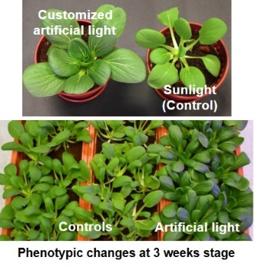
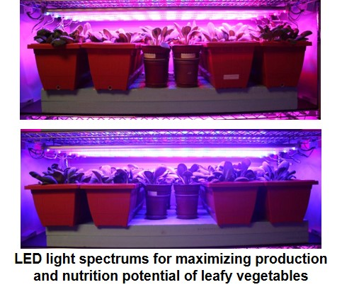

- Biography:
Mandar has completed his PhD at the age of 28 years and Postdoctoral Studies from National University of Singapore. He is the Lead Scientist for Plant Biotechnology in Temasek Polytechnic. He has been active in applied research and has 2 patents, presented more than 15 papers and has been serving as a reviewer for peer reviewed journals.

- Presenting author details


Full Name: Mandar R. Godge
Contact number: +65 94886075
Twitter account: NA
Linked In account: https://www.linkedin.com/in/mandar-godge-2172478/
Session name/ number: Plant Biotechnology / Session 8
Category: (Oral presentation)
Passport Number:

