Abstract Template

Setaria viridis: a model system for gene discovery and engineering in the grasses

BRUTNELL TP¹
¹Viridis Genomics Consulting, LLC, P.O. Box 430, Chesterfield, MO, USA

Keywords: grasses, model systems, C4 photosynthesis, genomics, trait development

- Abstract Body (up to 250 words)
Setaria viridis is rapidly emerging as the premier model system for studies of C₄ photosynthesis in the grasses (1). With a rapid life cycle of just 6 to 8 weeks, a short stature that is similar to A. thaliana and relatively simple growth requirements, S. viridis is an attractive system for conducting forward and reverse genetic screens to probe the genetic networks underlying the function and regulation of C₄ photosynthesis. To exploit Setaria as a model system, we have been developing a number of genetic and genomics tools, methods and resources for the community (2). Here I will present on methods we have developed to rapidly identify candidate genes underlying phenotypes of interest and to identify putative rate limiting steps in C₄ photosynthesis through cross-species selection scans (3). I will also discuss new methods and approaches to engineering synthetic circuits in plants and discuss how these methods could be applied to altering metabolic flux in a C₄ system as well as engineering C₄ traits into C₃ systems.

- Image:

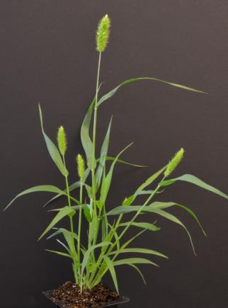

- Reference:
- Brutnell, T.P., Bennetzen, J.L. and J.P. Vogel, 2015. Brachypodium distachyon and Setaria viridis: Model genetic systems for the grasses. Annu. Rev. Plant Biol., 66; 465-485
- Huang P., Shyu C., Coelho C.P., Cao Y. and Brutnell TP, 2010. Setaria viridis as a model system to advance millet genetics and genomics. Front Plant Sci 7: 1781
- Huang, P., Studer, A.J., Schnable, J.C., Kellogg, E.A. and T.P. Brutnell, 2017. Cross species selection scans identify components of C4 photosynthesis in the grasses. J. Exp. Bot.., 68: 127-135
- Biography:
Dr. Brutnell is the founder and CEO of Viridis Genomics Consulting formed in 2018. He is the co-founder and former CSO of Benson Hill Biosystems and former Director of the Enterprise Rent-A-Car Institute for Renewable Fuels at the Donald Danforth Plant Science Center. Dr. Brutnell has published over 100 papers that have been cited over 10,000 times and is a Fellow of the American Association for the Advancement of Science (AAAS).
- Presenting author details

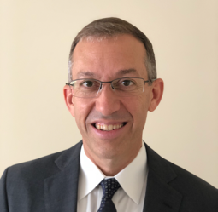
Full Name: Thomas P. Brutnell
Contact number: +1 607-229-0349
Linked In account:t www.linkedin.com/in/tom-brutnell-b62aa311
Session name/ number:
Category: (Oral presentation)
Passport Number:

