On the frequency function for stronger squeezing degree and the exact algebraic solution for the quantum harmonic oscillator with variable frequency

D. M. Tibaduiza¹, L. Pires¹, C. Farina¹, C. A. D. Zarro¹, D. Szilard² and A. L. C. Rego³
¹ Instituto de Física, Universidade Federal do Rio de Janeiro, 21941-972 Rio de Janeiro, RJ, Brazil.
² Centro Brasileiro de Pesquisas Físicas, 22290-180 Rio de Janeiro, RJ, Brazil.
³ Instituto de Aplicação Fernando Rodrigues da Silveira, Universidade do Estado do Rio de Janeiro, 20261-232 Rio de Janeiro, Rio de
Janeiro, Brazil.

Keywords: Rice lines, Salt stress, Microsatellite (SSR) marker, Protein analysis, Gene expression

- Abstract Body (up to 250 words)

We obtained an exact algebraic solution for the quantum harmonic oscillator with variable frequency in a closed form. This allows us to implement a numerical calculation to study the dynamics of the system. It is shown that for any frequency function, the instantaneous state of the system is a squeezed one of the initial Hamiltonian. Once the final state is found, is mandatory to analyse the models that maximize the squeezing degree. We present a discussion by comparison the Janszky-Adam scheme, where the frequency modulation accounts through sudden changes between two stable frequencies, and the parametric resonance model, where the frequency modulation accounts through a harmonic function. In such analyses new aspects of the problem are elucidated.

- Image:

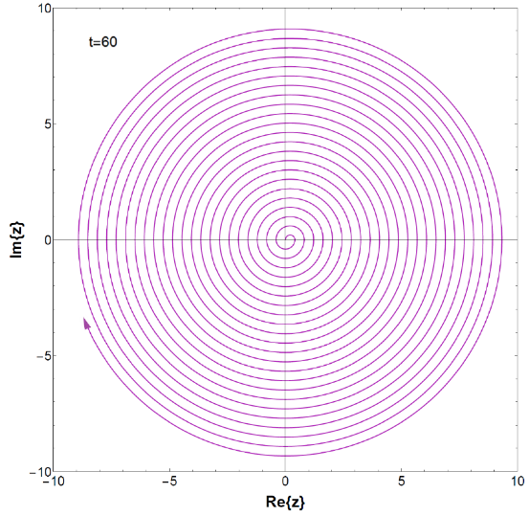
Squeezing state dynamics in the complex plane for the Janszky-Adam scheme.

- References:
1. MA, Xin; RHODES, William. Squeezing in harmonic oscillators with time-dependent frequencies. Physical Review A, v. 39, n. 4, p. 1941, 1989.
- KISS, T.; JANSZKY, J.; ADAM, P. Time evolution of harmonic oscillators with time-dependent parameters: A step-function approximation. Physical Review A, v. 49, n.6, p. 4935, 1994.

- FUJII, Toshiyuki et al. Quantum circuit analog of the dynamical Casimir effect. Physical Review B, v. 84, n. 17, p.174521, 2011.
- Biography:
D.M. Tibaduiza has completed his M.Sc. in theoretical physics with emphasis in colloidal stability at the age of 31 years and is a Ph.D. candidate in physics at the Federal University of Rio de Janeiro (UFRJ). Actually is researching in quantum electrodynamics and the dynamical Casimir effect. He is an expert in mathematical methods applied in physics and it computational implementation. He has Extensive experience in basic physics and mathematics education. He has two collaborations published in in reputed journals and two researches that will be sonly submitted.
- Presenting author details


Full name: Daniel Martínez Tibaduiza
Contact number: 55 21 969778873
Linked In account: http://buscatextual.cnpq.br/buscatextual/visualizacv.do?id=K8780921U8&idiomaExibicao=2
Session name/ number: Track 1- Quantum Mechanics and Field Theory
Category: Poster presentation
Passport Number: AO 085449

