Tunable Mie Resonances of Tin-based Iodide Perovskite Island-like Films with Enhanced Infrared Photoluminescence
Anastasiia V Sokolova, ITMO University, Russia
Elena V Ushakova, PhD, City University of Hong Kong, China
Shuai Chang, Beijing Institute of Technology, China
Aleksandr P. Litvin, PhD, ITMO University, Russia
Sergei A Cherevkov, PhD, ITMO University, Russia
Dmitry Gets, PhD, ITMO University, Russia
Alexander Berestennikov, PhD, ITMO University, Russia
Sergey Makarov, Prof. Dr., ITMO University, Russia
Tao Chen, Prof. Dr., University of Science and Technology of China, China
Andrey L Rogach, Prof. Dr., City University of Hong Kong, China
Hai-Zheng Zhong, Prof. Dr., Beijing Institute of Technology, China

Abstract

The optical response of the resonant dielectric nanoparticles can be modulated by their size, shape, and permittivity [1]. In particular, the increase in size leads to a redshift of Mie resonances [2]; variation in particle shape allows for independent control of diﬀerent modes [3], whereas free-charge carrier density plays an important role in determining the permittivity of dielectric materials, thus aﬀecting their optical properties. Organic−Inorganic metal halide perovskites have recently emerged as attractive semiconductor materials for various optoelectronic applications, ranging from photovoltaic devices to light-emitting diodes [4]. They can be easily processed from solution into diﬀerent kinds of nanostructures and devices for all-dielectric nanophotonics [5]. While the cited examples involved perovskites operating in the visible-to-NIR spectral range, to the best of our knowledge, resonant IR-emitting perovskite-based nanostructures whose Mie resonances are tunable via the control of free carrier density were not yet demonstrated. Moreover, there are obvious concerns about the presence of toxic lead as a component in most of the perovskite materials demonstrated above. Herein, we developed IR-active optical components based on lead-free MASnI3 (MA stands for CH3NH3) island-like structures that can support Mie-type resonances. By tuning the size of the perovskite islands in the ﬁlm, we can tune the position of the Mie resonances, while retaining the absorption and photoluminescence (PL) bandgap of the material. By aligning the Mie resonance with the maximum of the PL emission, an enhancement of the latter is achieved. We found that free holes generated via partial self-doping of Sn4+ into MASnI3 perovskite lattice modulate permittivity of the perovskite ﬁlms, which also contributes to the tunability of the Mie resonances.

Acknowledgements. This work was supported by the Russian Science Foundation (agreement 18-13-00200)

Image

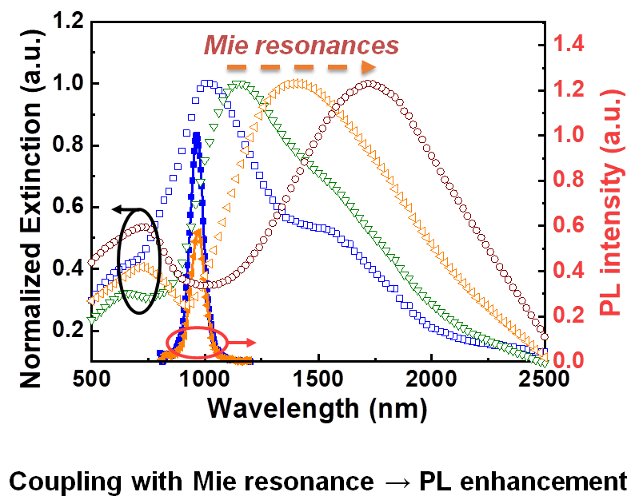
Recent Publications
- Makarov S. V. et al. (2017). Light‐Induced Tuning and Reconfiguration of Nanophotonic Structures. Laser & Photonics Reviews 11.5: 1700108.
- Kuznetsov, A., Miroshnichenko, A., Fu, Y. et al. (2012). Magnetic light. Scientific Reports 2: 492.
- Staude I. et al. (2013). Tailoring directional scattering through magnetic and electric resonances in subwavelength silicon nanodisks. ACS nano 7.9: 7824-7832.
- Zhao Y., Zhu K. (2016). Organic–inorganic hybrid lead halide perovskites for optoelectronic and electronic applications. Chemical Society Reviews 45. 3: 655-689.
- Zhang Y. et al. (2019). Photonics and optoelectronics using nano-structured hybrid perovskite media and their optical cavities. Physics Reports 795: 1-51.


Biography
Anastasiia V Sokolova is a student and lab assistant at Fedorov’s research group under the supervision of Dr. Cherevkov. She is ﬁnishing her BSc in Photonics at ITMO University, Saint Petersburg. Her research interest focuses on the synthesis and characterization of 2D nanocrystals, perovskives, ternary nanocrystals.
Email: physasv@yandex.ru

Notes/Comments:

