Luminescent composite material based on porous silica microspheres with embedded CsPbBr₃ perovskite nanocrystals
Sergei A Cherevkov, PhD, ITMO University, Russia
Elena V Ushakova, PhD, City University of Hong Kong, China
Anastasiia V Sokolova, ITMO University, Russia
Yanxiu Li, PhD, City University of Hong Kong, China
Ruslan R Azizov, ITMO University, Russia
Dmitry A Kurdyukov, PhD, Ioffe Institute, Russia
Ekaterina Yu Stovpiaga, PhD, Ioffe Institute, Russia
Valery G Golubev, Prof. Dr., Ioffe Institute, Russia
Andrey L Rogach, Prof. Dr., City University of Hong Kong, China
Alexander V Baranov, Prof. Dr., ITMO University, Russia

Abstract

Lead halide perovskite nanocrystals are attracting a lot of attention due to their superior optical properties, such as narrow emission bandwidths and high photoluminescence quantum yields [1]. This can be useful for the development of coherent light sources for the visualization in highly scattering media such as biological [2,3]. Still, they are far from utilization, since they can rather easily degrade under ambient conditions [4], in particular, at high humidity, temperature, and UV light exposure. This has triggered an on-going search for suitable protective host matrices [5]. We report a luminescent composite material based on porous silica microspheres (0.5 µm in diameter) with embedded CsPbBr₃ perovskite nanocrystals. This composite shows increased stability in terms of preserving photoluminescence of the CsPbBr₃ nanocrystals, while further encapsulation in polymer shells using sequential layer-by-layer (LbL) assembly of the oppositely charged polyelectrolytes poly(allylamine hydrochloride) and poly(sodium 4-styrenesulfonate) results in water-dispersible luminescent composite microparticles. The stability of their emission was evaluated and can be easily deposited onto both solid and flexible substrates and form thin, semitransparent films. Film samples were monitored for 3 months of storage at ambient conditions: the values of PL peak position, full width at half maximum, and integral intensity were estimated from Gaussian fitting. It has been shown that the PL peak position and width were almost unchanged and intensity kept 85% of the initial value during 7 days of storage in the ambient. The availability of such samples may expand the use of light-emitting perovskite nanocrystals in diverse biological applications, including imaging and sensing in highly scattering media.

Acknowledgements. This work was supported by the Russian Science Foundation (agreement 18-13-00200)

Image

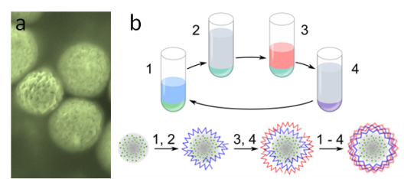

(a) Microimage of pNC@MS in artificial colors. (b) Scheme of the LbL fabrication of the pNC@MS-PAH/PSS sample: step 1 – deposition of PAH; steps 2 and 4 – washing with water, step 3 – deposition of PSS.
Recent Publications
- Li Y, et al. (2020) Advances in metal halide perovskite nanocrystals: Synthetic strategies, growth mechanisms, and optoelectronic applications. Materials Today 32: 204-221.
- Wei Y, et al. (2017) Enhancing the stability of perovskite quantum dots by encapsulation in crosslinked polystyrene beads via a swelling–shrinking strategy toward superior water resistance. Advanced Functional Materials 27.39: 1703535.
- Wang K, et al. (2019) Single‐Crystalline Perovskite Microlasers for High‐Contrast and Sub‐Diffraction Imaging. Advanced Functional Materials 29.39: 1904868.
- Huang, He, et al. (2017) Lead halide perovskite nanocrystals in the research spotlight: Stability and defect tolerance. ACS energy letters 2.9: 2071-2083.
- Ushakova, E. V., et. al. (2020). Stable luminescent composite microspheres based on porous silica with embedded CsPbBr₃ perovskite nanocrystals. ChemNanoMat 6.7: 1080-1085.

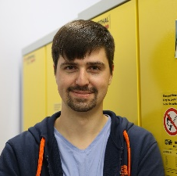
Biography
Sergei A. Cherevkov is a research fellow in ITMO University. He received his BSc in Laser Technology in 2008 and his MSc in Photonics in 2010, and his PhD degree in Raman Spectroscopy in 2013 from ITMO University, Saint-Petersburg. He is a member of Baranov’s research group. His research interests are primarily concerned with quantum conﬁned nanomaterials, particularly quantum dots and nanoplatelets, their synthesis, optical properties, self-assembly, and applications.
Email: s.cherevkov@gmail.com

Notes/Comments:

