Ultra-short pulses generation in a nonlinear fiber amplifier
Yanrong Song, Run Qin Xu, Jinrong Tian, College of Applied Sciences, Beijing University of Technology, Beijing 100124, China

Abstract (300 word limit)
Noise-like pulsed (NLP) laser was one kind of ultra-fast lasers, which shows a good application prospect in generating supercontinuum [1,2] and industrial micromachining[3]. A NLP is supposed as a wave packet that contains loads of sub-pulses with different amplitudes and phases, which was also called double-scale lumps[4]. As was illustrated in a recent study [5], the widths of the pedestal and the spike in the IAC trace are basically the width of the wave packet and the average pulse duration of the sub-pulses inside the packet respectively, whereas the ratio of the spike to the pedestal is related to the density of sub-pulses.
Here the NLP was generated in an Yb-doped nonlinear fiber amplifier, which is seeded by dissipative soliton (DSs) and is compressed by a grating pair. Fig. 1 is the schematic of the Yb-doped nonlinear fiber amplifier system. Part (a): NPR oscillator; part (b): fiber amplifier; part (c): compressor. The seed pulses were mode-locking by nonlinear polarization rotation (NPR) technique. The pulse duration of the seed pulse was 11.77 ps and the spectrum is about 15 nm. The output power was 120 mW and the repetition rate of the pulse train was 24.65MHz. The signal noise ratio was about 70 dB, which showed the stability of the laser was good. After amplified with a double cladding gain fiber and compressed with a grating pair, a noise-like pulse with 14.5 fs spike was generated in an Yb-doped nonlinear fiber amplifier, while the pedestal has a width of 3.70 ps. With an average output power of 5 W, the single pulse energy is approximately 200 nJ at a repetition rate of 24.65 MHz. Based on the coupled nonlinear Schrödinger equations, mathematic researches about the generation and the compressibility of the NLPs are carried out.

Image
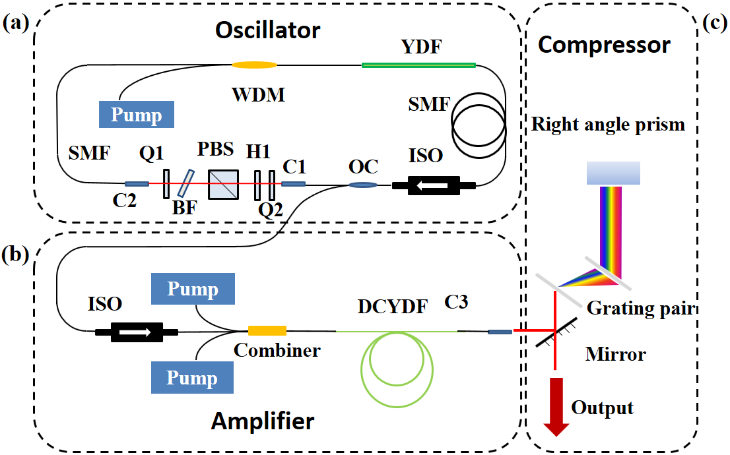
Fig. 1. Schematic of the Yb-doped nonlinear fiber amplifier system. Part (a): NPR oscillator; part (b): fiber amplifier; part (c): compressor.

Recent Publications
- H. Chen, X. F. Zhou, S. P. Chen, Z. F. Jiang, and J. Hou (2015) Ultra-compact Watt-level flat supercontinuum source pumped by noise-like pulse from an all-fiber oscillator. Opt Express 23: 32909.
- Chen, Y.W., S.C. Ruan, X. Wu (2017) Ultra-flat and Ultra-broadband Supercontinuum Generation in Photonic Crystal Fiber Pumped by Noise-like Pulses. Selected Papers from the 31st International Congress on High-Speed Imaging and Photonics: Imaging and Photonics. 10328.
- Xia, H.D., H.P. Li, G.L. Deng, J.F. Li, S.J. Zhang, Y. Liu (2015) Compact noise-like pulse fiber laser and its application for supercontinuum generation in highly nonlinear fiber. Applied Optics 54: 9379-9384
- Horowitz, M.,Y. Silberberg (1998) Control of noiselike pulse generation in erbium-doped fiber lasers. Ieee Photonics Technology Letters,.10: 1389-1391.
- Cheng, Z.C., H.H. Li, P. Wang (2015) Simulation of generation of dissipative soliton, dissipative soliton resonance and noise-like pulse in Yb-doped mode-locked fiber lasers. Optics Express 23: 5972-5981.


Biography
Yanrong Song has her expertise in ultra-fast pulse generation in fiber lasers and semiconductor lasers and nonlinear optics. She is in charge of some projects which came from the national foundation of China.
Email: yrsong@bjut.edu.cn

Notes/Comments:

