Design and modeling of optical filters based on S-shape structure
Mohammad Seifi Laleh, Dept. of Electrical Engineering, University of Kurdistan, Sanandaj, Iran.
Mohammad Razaghi, Dept. of Electrical Engineering, University of Kurdistan, Sanandaj, Iran.

Abstract
For the first time a new optical filter based on microring resonators (MRRs) has been introduced. This filter, being named as S-shape filter can split passband response of filters to n-desirable peaks and valleys. There are two general paths between input port and drop one. The number of main-loop MRRs determines the order of filter. The number of side-loop MRRs, being serially coupled to each other determines the number of cleavage in the passband of filter. By changing coupling coefficients between side-loop MRRs, the width of cleavages rather than center of passband are obtained. Also, by solving critical coupling coefficients just for MRRs, being coupled through main-loop parameters like shape factor (SF), quality factor (Q), cross talk and bandwidth of filter would be achieved. The simplicity, extensibility and compactness of this structure make it usable in wavelength division multiplexing (WDM) networks. To model this structure, signal flow graph method (SFG) based on Mason's rule is used. The modeling method is discussed in depth. Furthermore, the accuracy and applicability of the S-shape filter is verified through examples and comparison with other filter configurations.

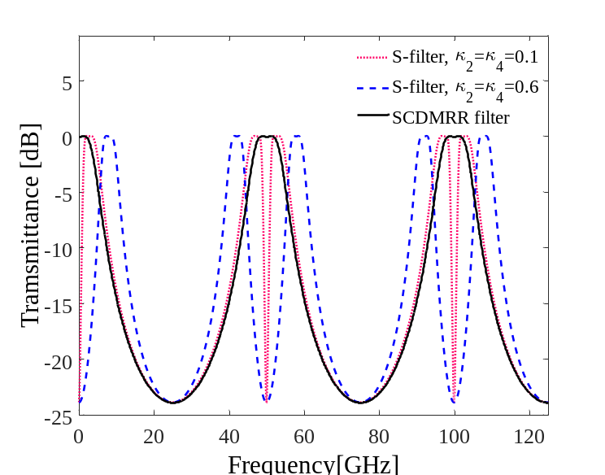
Fig.1 Comparison between a second order S-shape filter and serially coupled double microring resonator (SCDMRR) filter.
Recent Publications
- Razaghi. M, Seifi Laleh. M (2016), Design and modeling of flower like microring resonator”, Optics Communications, 36 (6), 370–381.
- Seifi Laleh. M, Razaghi. M, Jafari. O, Bevrani. H (2019), Performance optimization of an optical filter based on serially coupled microring resonators using a fuzzy logic system, Optical Engineering, 58 (2), 026115.
- Troia. B, De Leonardis. F, and Passaro. V. M (2011), Design of optical filters based on multiple ring resonators operating in C and L bands, Telecommunications Forum (TELFOR), 820-823.
- Jeong. S. H, Tanaka. Y, and Morito. K (2015), 1× 4 channel Si-nanowire microring-assisted multiple delay line based optical MUX/DEMUX, Journal of Lightwave Technology, 33 (17), 3736–3743.
- Y. D Yang. Y. D, Li, Huang. Y. Z, and Poon. A. W (2014), Silicon nitride three-mode division multiplexing and wavelength-division multiplexing using asymmetrical directional couplers and microring resonators, Optics express, 22 (18), 22172-22183.


Mohammad Seifi Laleh was born in Sanandaj, Kurdistan, Iran in 1987. He received the B.S. and M.S. degrees in electronics engineering from the University of Kurdistan, , in 2012 and the 2014. He has authored/coauthored 2 journals papers and 3 conference ones. He has taught some courses at University of Kurdistan (UOK). His current research interests include silicon photonic, optical communication, all-optical logic gate and ring resonator based structures. Mr. Seifi Laleh was a member of IEEE Photonics Society.

