Rogue waves in optics: Facts and fictions
Milivoj R Belić, Texas A&M University at Qatar, 23874 Doha, Qatar
Stanko N Nikolić, Institute of Physics Belgrade, Pregrevica 118, 10080 Zemun, Serbia

Abstract (300 word limit)

Rogue waves are giant nonlinear waves that suddenly appear and disappear in oceans and optics. We discuss the facts and fictions related to their strange nature, dynamic generation, ingrained instability, and potential applications. We propose the method of mode pruning for suppressing the modulation instability of rogue waves. We demonstrate how to produce Talbot carpets – ordered recurrent images of light and plasma waves – by rogue waves, for possible use in nanolithography.

Image
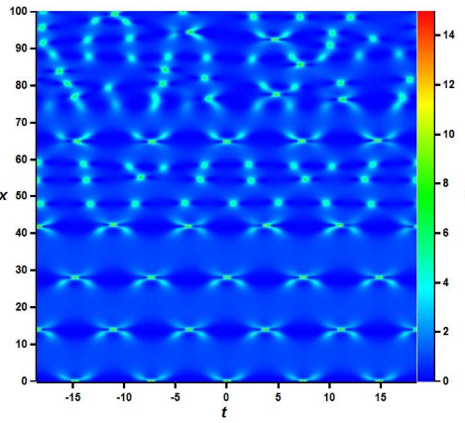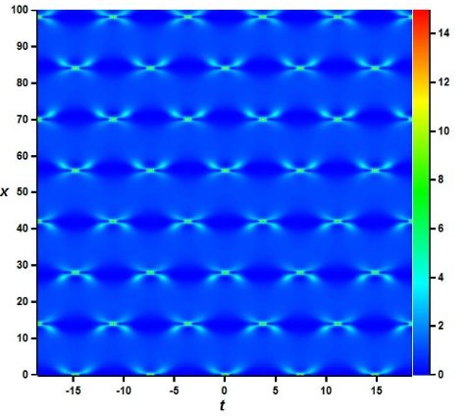
Recent Publications (minimum 5)
- N Akhmediev, B Kibler, F Baronio, M Belić, et al., ”Roadmap on optical rogue waves and extreme events.” J. Optics, 18 (6), 063001 (2016).
- SA Chin, OA Ashour, MR Belić, “Anatomy of the Akhmediev breather: Cascading instability, first formation time, and Fermi-Pasta-Ulam recurrence.” PHYSICAL REVIEW E 92, 0632025 (2015).
- SA Chin, OA Ashour, SN Nikolić, MR Belić, “Maximal intensity higher-order Akhmediev breathers of the nonlinear Schrödinger equation and their systematic generation.” Phys. Letters A 380, 3625 (2016).
- SA Chin, OA Ashour, SN Nikolić, MR Belić, “Peak-height formula for higher-order breathers of the nonlinear Schrodinger equation.¨ on nonuniform backgrounds.” PHYSICAL REVIEW E 95, 012211 (2017).
- SN Nikolić, OA Ashour, NB Aleksić, MR Belić, SA Chin, “Breathers, solitons and rogue waves of the quintic nonlinear Schrödinger equation on various backgrounds.” Nonlinear Dyn https://doi.org/10.1007/s11071-018-4726-8 (2019).

Figure 1: Unstable and stabilized Talbot carpets, made from second-
order rogue waves produced in the nonlinear Schrődinger equation.

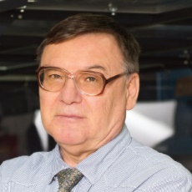 Biography (150 word limit)
Dr. Milivoj R. Belić was born in Yugoslavia in 1951. He finished the School of Mathematics in Belgrade in 1970, completed BS degree in physics at the University of Belgrade in 1974, and obtained PhD in physics at the City College of New York in 1980 (advisers Joel Gersten and Mel Lax). Since 1982 he is affiliated with the Institute of Physics Belgrade. Starting from 2004 Dr. Belić is professor in physics at the Texas A&M University at Qatar, Doha. His research areas include nonlinear optics and nonlinear dynamics. He is the author of 6 books and more than 500 papers. The recipient of numerous research awards, Dr. Belic received the Galileo Galilei Medal for 2004, from the International Commission for Optics. His research team was awarded twice as the best Research Team by the Qatar National Research Fund. Dr. Belić is a Senior Member of OSA.

Email: milivoj.belic@qatar.tamu.edu

