van der Waals epitaxy of nitrides material and Deep-UV Light-emitting Diodes

Zhiqiang Liu, Tongbo Wei, Yunyu Wang, Zhaolong Chen, Xiaoyan Yi, Junxi Wang, Peng Gao, Jinmin Li & Zhongfan liu

Abstract (300 word limit)
Recently, the van der Waals epitaxy (vdWE) growth of III-Ns films on graphene (or other two-dimensional materials) has been proposed to reduce the mismatch effect, and further alleviate the self-heating issue, or achieve transferable optoelectronics and electronics. However, the main challenge is that the dangling-bond-free feature of graphene suppresses the III-Ns nucleation, limiting the large-area single-crystalline growth. Here, we successfully grow high quality AlN film on graphene and fabricate DUV-LEDs with a low turn-on voltage, high output power and reliability. Graphene film is directly grown on sapphire substrate to avoid the tedious transfer process and treated in N2 plasma to increase nucleation sites for fast growth of AlN. With the presence of atomic thin graphene film, the substrate still has a weak interaction with the epilayers, insuring growth of large area single-crystalline film with low stress (0.11 GPa) and low dislocation density (1.96 ×108 cm-2), and therefore the as-fabricated LED devices show excellent performance.
What’s more, even though nitrides have been successfully grown on Si (111) and reported in many previous reports. Nitride materials grown on Si (100) are of more significant interest to be used in optoelectronic devices intergradation with silicon circuits, which are usually fabricated on Si (100), not (111). In this contribution, we also demonstrated the growth of AlGaN nanowires directly on SiO2/Si (100) substrate using graphene as a buffer layer.
This study brings revolutionary technologies for epitaxial growth of nitride film and paves a new pathway for scalable applications of graphene.

Image
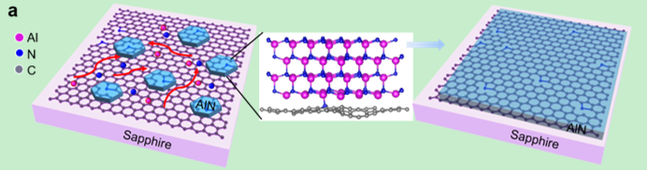
Figure1. Guided by the density functional theory, the nucleation of nitride on graphene was shown schematically.
Recent Publications (minimum 5)
- Zhaolong Chen, Zhiqiang Liu et al., Improved Epitaxy of AlN Film for Deep-ultraviolet Light-emitting Diodes Enabled by Graphene, Advanced Materials. 2019 ***** (accepted) co-first author.
- Haina Ci, Hongliang Chang, et al., Enhancement of Heat Dissipation for Violet Light-Emitting Diodes by a Vertically-Oriented Graphene Nanowalls Buffer Layer, Advanced Materials. 2019 ***** (accepted) co-corresponding author.
- Yue Qi; Yunyu Wang, et al.， Fast Growth of Strain-Free AlN on Graphene-Buffered Sapphire， Journal of the American Chemical Society, 2018.9.3, 140(38): 11935~11941. Co- author.
- Chen Zhaolong; Zhang Xiang，et al. High-Brightness Blue Light-Emitting Diodes Enabled by a Directly Grown Graphene Buffer Layer，Advanced Materials, 2018.7.8, 30(30): 0~1801608。 Co- author.
- zhiqiang liu, et al. Impurity resonant state p-doping layer for high-efficiency nitride-based light-emitting diodes. Semiconductor Science and Technology, 2018.10.11, 33(11): 0~114004 . first author.

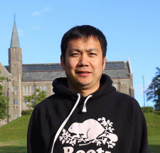
Biography (150 word limit)
Zhiqiang liu, full professor:
currently based Institute of Semiconductors, Chinese Academy of Sciences (IOS, CAS). the director of fabrication department at State key lab of solid state lighting.. My research expertise is in building interdisciplinary teams to use compound semiconductor materials and devices for applications in the areas of nitride materials and Light Emitting devices. This research was supported through competitive research grants and contracts through government, industry and others totaling about $4M us as a lead investigator in academia and industry. I have had active collaborations in the US, Europe, and Asia, which has resulted in more than 100 papers, including papers in AM and JACS, APL, Nanoscale,.
Email: lzq@semi.ac.cn

Notes/Comments:

