PRISMS Applied Physics and Photonics Laboratory:
An optical materials test facility that will send you the test results,
along with the high school students that made the measurements

Gregory S. Herman, Ph.D., PRISMS, Princeton, NJ 08540

Abstract
Photonics is on the rise, in both academic research and commercial enterprises. This is evident in the increase in undergraduate programs that are tailored to photonics, such as those at the University of Arizona’s College of Optical Sciences, the University of Rochester’s Institute of Optics and The University of Central Florida’s Center for Research in Electro-Optics and Lasers (CREOL). These undergraduate schools are direct evidence of an industry wide need for education in photonics. So where do these programs get their students?
At the Princeton International School for Mathematics and Science (PRISMS), we have an Applied Physics and Photonics Laboratory that is equipped with optical tables and associated lasers and components, a high vacuum evaporation chamber, a chemical vapor deposition unit, and an Atomic Force Microscope. In addition, at Princeton University’s Imaging Analysis Center, we have available to us very precise research tools, including ellipsometers, sputterers, SEMs, and TEMS.
The students at PRISMS have won numerous awards in the 5 year lifespan of the school. Our graduates have won gold medals at the International Math Olympiad (later a Putnam award winner), and the International Chemistry Olympiad. In addition, PRISMS’ ZERO ROBOTICS team was the 2017 champion of the international NASA-MIT competition that is held on board the International Space Station.
PRISMS has collaborated with Dr. Xi-Cheng Zhang of the Institute of Optics regarding 3-D printed materials for Terahertz photonics. PRISMS invites industry and academia to collaborate with us to test new materials. In addition, the facility will train students for the new undergraduate photonics programs. Let us test your materials, and we will send you the test results, along the students who made them!

Image
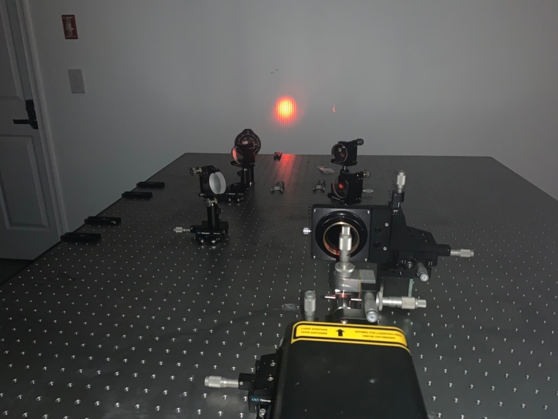
A Mach-Zehnder Interferometer used to study
Quantum Mechanical “Which Way” Experiments
Recent Publications
- Herman, Gregory, S., (2013), Terahertz Local Oscillator via Difference Frequency Generation in III – V Semiconductors using Frequency Stabilized Lasers, University of Arizona Dissertation.
- M. Bahoura, G. S. Herman, N. P. Barnes, C.. L. Bonner, and . P. Higgins, (2000), Proceedings of the SPIE, 3928 , 132.
- G. Herman, (1999), Proceedings of the IEEE: LEOS ’99, 2, 574.
- G. Herman, N. Barnes and N. Peyghambarian, (1999), Proceedings of the SPIE, 3617.
- Herman, Gregory S., Norman Barnes, and S.P. Sandford, (1998) Investigations of GaP for Terahertz wave generation using Quasi-phase-matched difference frequency mixing, Proceedings of the IEEE, Nonlinear Optics ’98: Materials, Fundamentals and Applications Topical Meeting, 30.
- US Patent 6,144,679, (1999).

 Biography
Dr. Gregory Herman is the Director of the Applied Physics and Photonics Laboratory at the Princeton International School of Mathematics and Science (PRISMS). Prior to PRISMS, Dr. Herman worked on site at NASA Langley Research Center, where he engineered LIDAR and DIAL systems, frequency-stabilized lasers using the Pound-Drever-Hall technique, and utilized frequency stabilized lasers in optical parametric amplifiers to produce narrowband, coherent Terahertz sources.
Dr. Herman is the inventor of the first collinear perfect phase matching technique applicable to isotropic crystals.

Email : gherman@alum.mit.edu

