Method of white light interference in thin film for analysis morphology of red blood cells
¹A.A. Paiziev, ²A.A. Dyachenko, ²V.P. Ryabukho, ²L.I.Malinova.

¹NewMaxTechnology, Tashkent, Uzbekistan
²Saratov State University, Saratov, Russia

Abstract
Statement of the Problem: To get color image of morphological structure of blood smears are usually using staining of living blood smears by dyes. But this method leads to disruption of sample caused by the specimen preparation and viewing conditions [1]. Other ways to get color contrast based on visualization of phase gradients within unstaining specimens, as realized by phase contrast [2] and differential interference contrast [3] microscopy. Usually conventional bright-field microscopy let us to see black and white image of separate morphological elements of blood smears only (Figure 1a). The purpose of this study is to present the new method of optical interference microscopy to image Red Blood cells (RBC) in their natural colors without staining, by using a specially designed substrate for deposition of blood smears. Methodology: Low-coherence full-field interferometry method is proposed to investigate inner structure of transparent layered biological objects. Visualization program and algorithm of optical and physical property measurements were worked out. Method based on light interference reflected from sample surface and substrate (Au, Mo, W, Si). Measurements has been performed for human blood cells collected from finger of health persons and deposited on ordinary microscopy slide (fig.1a) and on the special no transparence substrate (fig.1b). Findings: It has been shown that color interference image of blood cells is a result of two coherent rays interaction reflected from cell surface (reference signal) and interface cell-substrate (object signal). The method of interference color analysis of thin film to further measurement its optical thickness is developed. Results of simulation of interference pattern of thin film are presented. The dependence of interference color versus optical thickness is presented. The application of this method for the study of the morphological features of red blood cells is examined. Conclusion: Developed new technique for fast in real time regime to get color image of human blood cells without any chemical treatment. This method let us to determine chemical compounds of blood cells by comparison this color image with calibrate color map..

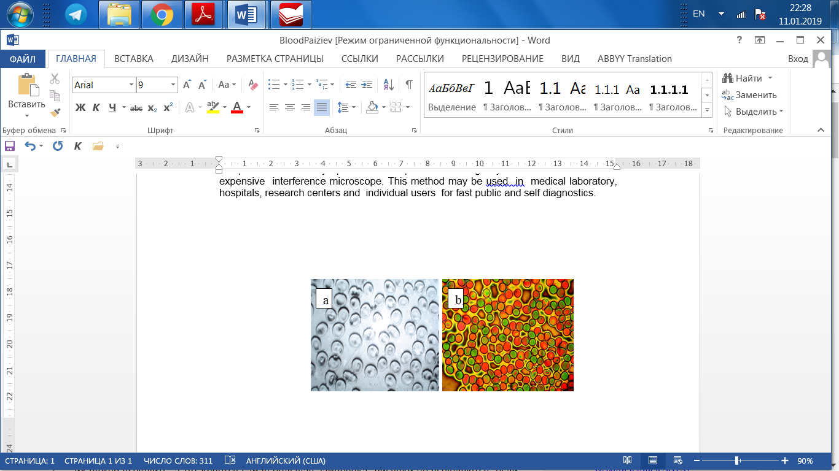

Publications
- Kozlovskaya L.V., Nikolaev A.Yu. Textbook on Clinical Laboratory Methods of Investigations. Moscow. Medicine. 1984. 288p.
- Zernike F. Phase contrast: A new method for the observation of transparent objects. Physica 1942; 9: 686-693.
- Nomarski G. Microinterferometric differential a on des palarisees. J. Phys. Radium. 1955; 16; S9.
- Lychagov V.V., Ryabukho V.P., Kalyanov A.L., Smirnov I.V. (2010). Low-coherence interferometry of .stratified structures using polychromatic light and digital recording and processing of interferograms. Computer Optics, V.34, №1б pp. 90-100.
- A.A. Dyachenko, A.A. Paiziev, V.P. Ryabukho, L.I. Malinova (2015). Method of white light interference in thin film for analysis morphology of red blood cells. Bulletin of High School (Physics), №1, pp. 1-4.


Biography
Adkham Paiziev have experience in positron material science, light microscopy and its application to life science (morphology plant and animal cells). Last 10 years his interest has been connected with elaboration the new physical methods in medical diagnostics. In particular he in first offers the new kind of light microscope to reveal cancer cells membrane lesions, to see in color red blood cells without chemical treatment. Dr. Paiziev 2 years ago have organized the new Lab. Of Biophotonics aimed to use visible and IR light for human treatment and diagnostics. In this area his research interest has been connected with application elaborated physical methods in cardiovascular science, emergency medicine, neurology, neonatology and muscle physiology.
Email: adkhampaiziev@gmail.com

Notes/Comments:

