Key Words: Withania coagulens, phytoconstituents, Soxhlet, Tannins, Flavonoids, Medicinal plants.
Abstract
Medicinal plants are those plants that contains properties or compounds that can be use for therapeutic purposes, or those that synthesize metabolites to produce useful drugs.(WHO 2002) Phytochemicals are biologically active naturally occurring chemical compounds found in plants, which provides health benefits for human. The present study was performed to study the phytoconstituents of alcoholic & aqueous fruit extract of Withania coagulens. This plants shows free radical scavenging, cardiovascular hypoglycemic, central nervous system depresent anti-inflammatory, antitumor, wound healing effect.(Gupta & Keshari 2013). Qualitative phytochemical screening showed the presence of carbohydrate, Alkaloids, glycosides, saponins, Flavonoids, tannins, sterol & proteins. From the research we conclude that aqueous is the best solvent for extraction of phytoconstituents. The presence of tannins & flavonoids justifies the use of the plant in the Indian traditional systems of medicine. The proposed plant contains a wide variety of the chemical constituents which are very beneficial to the mankind. Thus the extraction of the essential oils from The Phytochemical analysis, both qualitative and quantitative, has shown the significant presence of large number of important phytochemical in the fruits of Withania coagulans L. Dunal plant. Withanolide are the major biologically active group of compounds in W. coagulans, showing a wide range of therapeutic and antioxidant effects which can used in treatment of Diabetes.
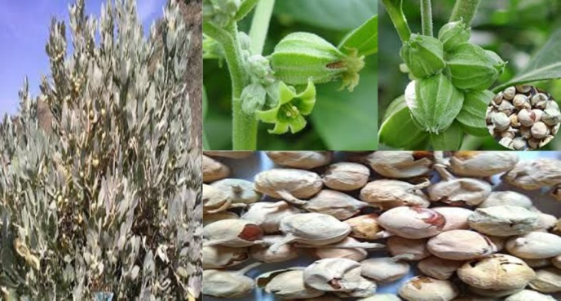
Withania coagulens L.
Reference:
- Gupta, P.C. (2012). Withania coagulans Dunal an overview, International Journal of Pharmaceutical Sciences Review and Research.,1:32-39.
- Harborne, J.B. (1998). Phytochemical method, A guide to modern technique of plant. Analysis, 3rd Edition Chapman and Hall. New York
- WHO. (2002). Traditional Medicine Growing Needs and Potential- WHO Policy Perspectives on Medicines, No. 002, May, World Health Organization, Geneva, Switzerland.
Biography
Dr. Renu Mishra has completed her Ph.D.at the age of 25 from Barkatullah University, Bhopal, (India). She has published more than 60 papers in reputed journals and guiding more than 10 students for Doctoral work.
Presenting author details

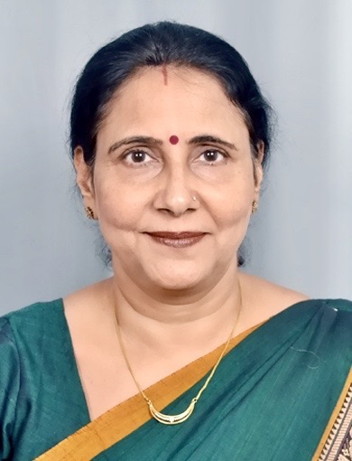
Full Name: Dr. Renu Mishra
Contact number: 919425014870
Linked In account: renumishra21@gmail.com
Session name: Pharmacovigilance for Herbal Medicines
Session number: 6
Category: Oral presentation
Passport Number: K5639120

