Loranthus Europaeus is a Nano Alternative Medicine in Treatment of side effect of Chemotherapy of Breast Cancer.
¹ Ali Awad Hamoud Aljeboory & ² Nazhat Mahmood Abdlkareem Al-zubaidi
1 Pharmacology and Pharmacognosy Dept. Pharmacy College, Uruk
University Iraq.
2 Oral and Maxillofacial surgery Dept. Dentistry College, Mustansiriyah , Baghdad
Abstract
Cancer is responsible for one in eight deaths worldwide more than AIDS, tuberculosis, and malaria together. Natural product still continue to be important as source of novel drugs because these dugs does not need sophisticated instrument, cheep resources, less toxic, no resistance to them by bacteria compared with the synthetic drugs. However the natural product will continue to be important in addition in three areas of discovery, they are a target for production by biotechnology, as source of new lead compounds of novel chemical structure and as the active ingredients of useful treatments divided from traditional systems of folkloric medicine(1) . The herb Loranthus Europaeus leaves and fruits was used in Iraq traditional medicine for treatment of inflammation, tumor and antimicrobial infection (2). For these reasons we tried to use the phytochemical and pharmacological studies to approache to their bioactive products as a new source for medicine. The extraction of active constituent of loranthus Europaeus (flavonoids terpenoids and alkaloids) by using chromatography method using a thimble of suxlet with different organic solvents. The ethylacetate extract contain flavonoid which contain qurcitin and quercitrin. The active ingredient mixture of LE leaves extract have used as mouth wash for 10 ladies different age have breast cancer and under treatment with chemotherapy. We found that the bioactive martial extracted from LE used as mouth wash cause cure of the inflammation of the mouth of those ladies. In addition that 10 humans of different sexes complaining of cyst attached to one of their tooth treated with different types of antibiotic there was no response but when have given an antibiotic with bioactive agents of this LE there was complete cure of the cyst and there was no need for operation which give the possibility of presence of one or more of these (qurcitin and quercitrin) active agents act as positive nano carrier of the antibiotic to the cyst directly and cure it. In the following medicinal plant as Haloxylon, Loranthus European, Salvia, Artemesia, Ocimum sanctum microemulsion, polymeric nano particles act as drug delivery barrier for alkaloids so which act directly on cancer cell without side effect So we can have cheap cancer drugs therapy which available from Cheap resources and safe effective cancer therapy.

Image

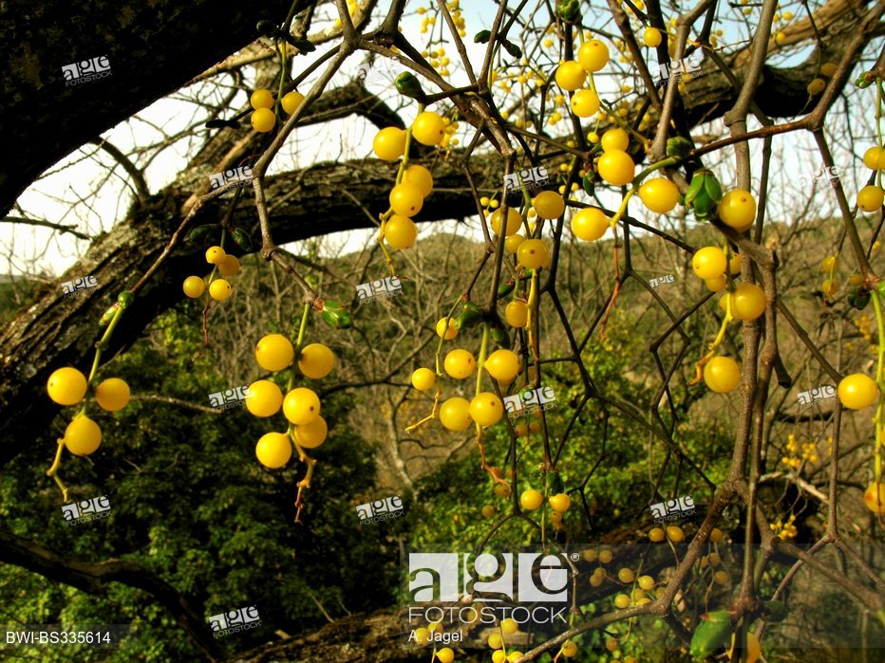

Figure 1: This figure shows typical picture of Loranthus europeas

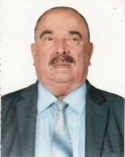
Biography
Ali Awad Hamoud Al-jeboory has completed PhD at the age of 30 years from strathclyed University. He is the professor of Uruk Pharmacy College , Uruk Private University. Ali Awad Aljeboory has published 50 papers and have had 5 discoveries of new drugs from natural products antihypertensive and heart tonic. In addition serving as an editorial board member of Al-mustanseriah college of medicine journal. Also supervised 20 PhD graduated students in pharmacology, published two books in natural pharmacology and pharmacy . He was the director of Kufa college of medicine , head of the department of pharmacology ,pharmacognosy in scientific research center , Head of the department of pharmacology and therapeutics department college of medicine Baghdad university. Head of department of pharmacology and Pharmacognosy Pharmacy College just now
Presenting author details
Full name : Ali Awad Hamoud Al-jeboory
Contact Number :07702645748
Category : ( oral presentation)
Email: ali_aljeboory@yahoo.com
References
(1) Arman,Z.9 Zarshenas,M.m and Aliasghar,k.(2013) Management of stroke as Described by Ibn Sina ( Avicinna) in Canon medicine, International journal of cardiology 5, 233-237
(2) Harvvey A.L. Drugs from natural products, England : Ellis Horwood,1993,p 450
(3) Ali Awad Aljeboory. “Haloxylon F Salsoloidpae as an Alternative Nanoscince Medicine in Treatment of Cancer”.Acta Scientific Pharmaceutical Sciences 3.1 (2019):23-28.

