Amelioration of neuroadverse effect of doxorubicin with vitamin E and coenzyme Q10 in rats: role of apoptosis

MANAL ABDULKHALIQ IBRAHIM^{1*,} NADA NAJI AL-SHAWI²
¹Department of Pharmacology and Toxicology, College of Pharmacy, University of Basra, Basra, Iraq. ²Department of Pharmacology and Toxicology, College of Pharmacy, University of Baghdad, Baghdad, Iraq. Email: manal.ph2008@yahoo.com
Keywords: Vitamin E, Coenzyme Q10, Doxorubicin, Neuroadverse, TUNEL-assay, caspase-3.

I.ABSTRACT
Objective: This work was designed to investigate the effect of Vitamin E and the coenzyme Q10(CoQ10) supplementation on neuroadverse effect by doxorubicin (Dox) in rats. Methods: Forty-nine adult Albino rats of both sexes were utilized in this study; animals were randomly enrolled into seven groups of seven animals each. Group I: Control (rats administered corn oil); Group II: Vitamin E at a dose of 100 mg/kg/day for 3 weeks; Group III: CoQ10 at a dose of 50 mg/kg/day for 3 weeks; Group IV: DOX (2.5 mg/kg) intraperitoneally (IP) injected every other day for 2 weeks; Group V: Vitamin E (100 mg/kg/day) orally administered for 3 weeks prior to a DOX 2.5 mg/kg IP injected every other day for 2 weeks; Group VI: Co Q10 (50mg/kg/day) for 3 weeks orally-administered prior to a IP dose of Dox 2.5 mg/kg every other day for 2 weeks. Group VII: Co Q10 (50mg/kg/day), Vitamin E (100mg/kg) for 3 weeks orally-administered prior to a IP dose of Dox 2.5 mg/kg every other day for 2 weeks. Twenty-four hour after the end of the treatment duration, brain of each animal was excised and part of it to be utilized to prepare homogenate for the estimation of caspase-3 (CASP-3), and the remaining part is used for immunohistochemistry examination and to estimate the percent of apoptotic index by terminal deoxynucleotidyl transferase-mediated deoxyuridine triphosphate nick end labeling (TUNEL) assay.
Results: Vitamin E and CoQ10 significantly (p<0.05) reduced CASP-3, reduced the percent apoptotic index of TUNEL-assay, and there was an improvement in the immunohistochemistry of rats’ brain in Groups V, Group VI, and group VII by reducing number of apoptotic cells compared to Group IV.
Conclusion: Both Vitamin E and CoQ10 may have a protective effect against Dox-induced neuroadverse effect in rats.
II. References
1. Sener SF, Grey N. The global burden of cancer. J Surg Oncol 2005;92:1-3.
2. Parkin DM, Bray F, Ferlay J, Pisani P. Global cancer statistics, 2002. CA Cancer J Clin 2005;55:74-108.
3. Urruticoechea A, Alemany R, Balart J, Villanueva A, Viñals F, Capellá G, et al. Recent advances in cancer therapy: An overview. Curr Pharm Des 2010;16:3-10.
4. Kerbel RS, Kamen BA. The anti-angiogenic basis of metronomic chemotherapy. Nat Rev Cancer 2004;4:423-36.
5. Maria A. Mitry, John G. Doxorubicin induced heart failure: Phenotype and molecular mechanisms.IJC Heart Vasc 2016;10:17-24.
6. Cutts SM, Swift LP, Rephaeli A, Nudelman A, Phillips DR. Sequence specificity of adriamycin-DNA adducts in human tumor cells. Mol Cancer Ther 2003;2:661-70.
7. Jansen CE, Dodd MJ, Miaskowski CA, Dowling GA, Kramer J. Preliminary results of a longitudinal study of changes in cognitive function in breast cancer patients undergoing chemotherapy with doxorubicin and cyclophosphamide. Psychooncology 2008;17:1189-95.
8. Merzoug S, Toumi ML, Boukhris N, Baudin B, Tahraoui A. Adriamycinrelated anxiety-like behavior, brain oxidative stress and myelotoxicity in male wistar rats. Pharmacol Biochem Behav 2011;99:639-47.
9. Banks WA, Erickson MA. The blood-brain barrier and immune function and dysfunction. Neurobiol Dis 2010;37:26-32.
10. Kipnis J, Derecki NC, Yang C, Scrable H. Immunity and cognition: What do age-related dementia, HIV-dementia and “chemo-brain” have in common? Trends Immunol 2008;29:455-63.
11. Schlatter MC, Cameron LD. Emotional suppression tendencies as predictors of symptoms, mood, and coping appraisals during AC chemotherapy for breast cancer treatment. Ann Behav Med 2010;40:15-29.
12. Packer L, Weber SU, Rimbach G. Molecular aspects of alpha-tocotrienol antioxidant action and cell signalling. J Nutr 2001;131:369S-73S.
13. Imounan F, Bouslam N, Aasfara J, Alaoui KE, Regragui W, Haddou EA, et al Vitamin E in ataxia and neurodegenerative diseases: A review. World J Neurosci 2012;2:217-22.
14. Crane FL. Biochemical functions of coenzyme Q10. J Am Coll Nutr 2001;20:591-8.
15. Overvad K, Diamant B, Holm L, Holmer G, Mortensen SA, Stender S, et al. Coenzyme Q10 in health and disease. Eur J Clin Nutr 1999;53:764-70.
16. Chapidze G, Kapanadze S, Dolidze N, Bachutashvili Z, Latsabidze N. Prevention of coronary atherosclerosis by the use of combination therapy with antioxidant coenzyme Q10 and statins. Georgian Med News 2005;118:20-5.
17. Rosenfeldt F, Hilton D, Pepe S, Krum H. Systematic review of effect of coenzyme Q10 in physical exercise, hypertension and heart failure. Biofactors 2003;18:91-100.
18. Sarter B. Coenzyme Q10 and cardiovascular disease: A review. J Cardiovasc Nurs 2002;16:9-20.
19. Galal MK, Khalaf AA, Ogaly HA, Ibrahim MA. Vitamin E attenuates neurotoxicity induced by deltamethrin in rats. BMC Complement Altern Med 2014;14:458.
20. Kandhare A, Ghosh P, Ghule A, Bodhankar S. Elucidation ofmolecular mechanism involved in neuroprotective effect of coenzyme Q10 in alcohol-induced neuropathic pain. Fundam Clin Pharmacol 2013;27:603-22.
21. Mohamed RH, Karam RA, Amer MG. Epicatechin attenuates doxorubicin-induced brain toxicity: Critical role of TNF-α, iNOS and NF-κB. Brain Res Bull 2011;86:22-8.
22. Kreisel T, Frank MG, Licht T, Reshef R, Ben-Menachem-Zidon O, Baratta MV, et al. Dynamic microglial alterations underlie stressinduced depressive-like behavior and suppressed neurogenesis. Mol Psychiatry 2014;19:699-709.
23. Post A, Rücker M, Ohl F, Uhr M, Holsboer F, Almeida OF, et al. Mechanisms underlying the protective potential of alphatocopherol (vitamin E) against haloperidol-associated neurotoxicity. Neuropsychopharmacology 2002;26:397-407.
24. Haendeler J, Zeiher AM, Dimmeler S. Vitamin C and E prevent lipopolysaccharide-induced apoptosis in human endothelial cells by modulation of bcl-2 and bax. Eur J Pharmacol 1996;317:407-11.
25. Siler-Marsiglio KI, Shaw G, Heaton MB. Pycnogenol and vitamin E inhibit ethanol-induced apoptosis in rat cerebellar granule cells. J Neurobiol 2004;59:261-71.
26. Tawfik MK. Coenzyme Q10 enhances the anticonvulsant effect of phenytoin in pilocarpine-induced seizures in rats and ameliorates phenytoin-induced cognitive impairment and oxidative stress. Epilepsy Behav 2011;22:671-7.
27. Li H, Chen G, Ma W, Li PA. Water-soluble coenzyme q10 inhibits nuclear translocation of apoptosis inducing factor and cell death caused by mitochondrial complex I inhibition. Int J Mol Sci 2014;15:13388-400.
28. Hwang JY, Min SW, Jeon YT, Hwang JW, Park SH, Kim JH, et al. Effect of coenzyme Q10 on spinal cord ischemia-reperfusion injury. J Neurosurg Spine 2015;22:432-8.

III. Images
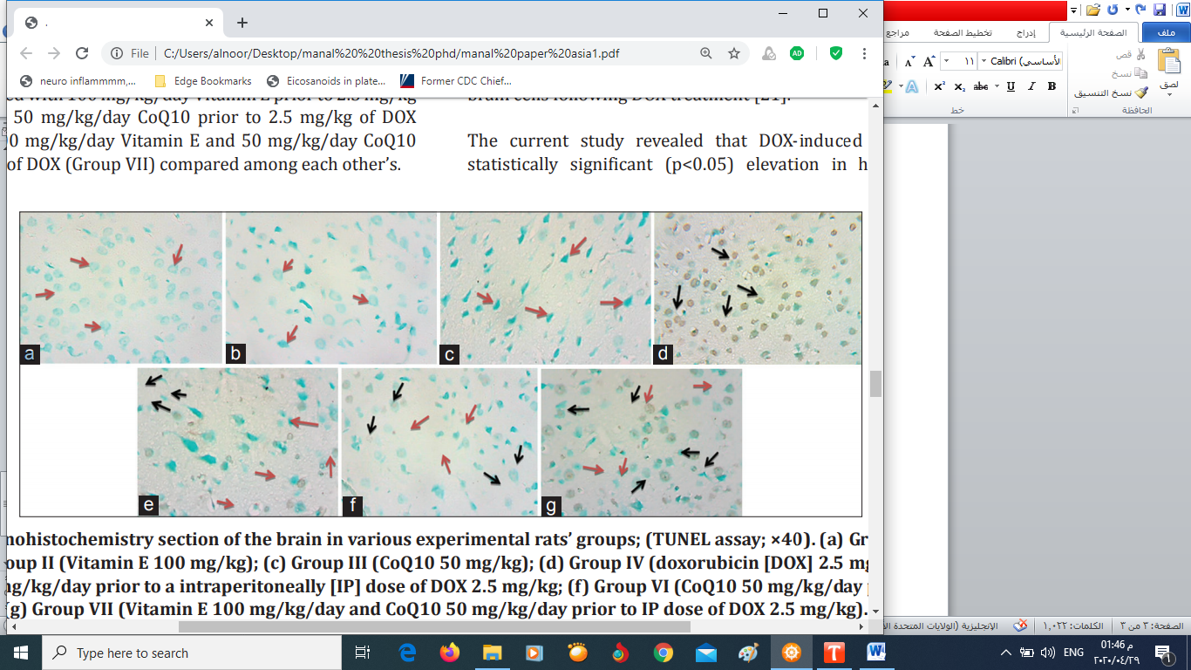
Fig. 1: Immunohistochemistry section of the brain in various experimental rats’ groups; (TUNEL assay; ×40). (a) Group I (control (corn oil); (b) Group II (Vitamin E 100 mg/kg); (c) Group III (CoQ10 50 mg/kg); (d) Group IV (doxorubicin [DOX] 2.5 mg/kg); (e) Group V (Vitamin E 100 mg/kg/day prior to a intraperitoneally [IP] dose of DOX 2.5 mg/kg; (f) Group VI (CoQ10 50 mg/kg/day prior to IP dose of DOX 2.5 mg/kg); (g) Group VII (Vitamin E 100 mg/kg/day and CoQ10 50 mg/kg/day prior to IP dose of DOX 2.5 mg/kg). Normal neurocyte cells had green color referred by red arrow and apoptotic cells had brown color referred by black arrow.
IV.Biography:
Manal has completed his PhD at the age of 35 years from Baghdad University, College of pharmacy .She is the sub- Director of department of pharmacology and toxicology ,college of pharmacy ,basra university . She academic member in department of pharmacology and toxicology ,college of pharmacy ,basra university She has published more than 5 papers in reputed journals and has been serving as a reviewer for article and participate in several conferences.

V.Presenting author details



Full Name: Manal Abdulkhaliq Ibrahim
Contact number:07801451991
Category: (Oral presentation)
Passport Number:

