Proteases produced by micromycetes of genus Aspergillus with promising activity for diagnosing and treating the hemostasis system dysfunction diseases
Timorshina S.N.*, Rakova A.I.*, Popova E.A.*, Zvonareva E.S.*, Orechova A.V.*, Osmolovskiy A.A.*
*Biological faculty of Lomonosov Moscow State University, Russia

Abstract
Statement of the Problem: In diagnosing and treating the hemostasis system dysfunction diseases preparations based on proteases of animal origin are used since they have a higher specificity compared to bacteria-synthesized enzymes; yet, their disadvantage comes at high cost. Therefore, searching for protease-producers active against the proteins of human hemostasis system and revealing their properties is challenging for modern biomedicine. Methodology & Theoretical Orientation: Here micromycetes of the genus Aspergillus were screened for ability to synthesize extracellular proteases with promising activity for designing anti-thrombotic preparations. For isolation, purification and study of physicochemical properties of proteases, standard methods were used (salting out, electrophoresis, isoelectrofocusing). Enzyme activity was measured spectrophotometrically using native proteins (fibrin, fibrinogen) and chromogenic peptide substrates
(HD-Val-Leu-Lys-pNA, pGlu-Pro-Arg-pNA). Findings: As a result of the screening, 3 active producers were selected: Aspergillus alliaceus 7dN1, A. ustus 1, A. terreus 2. The studied extracellular proteases, produced by these micromycetes, had a molecular weight of 30, 33, 34 kDa and isoelectric point of 8.21, 5.10, 4.71, respectively. The protease of micromycete A. ustus 1 showed the greatest fibrinolytic activity
(134.4 μm Tyr/ml*min), and the enzyme produced by A. alliaceus 7dN1 has the maximum fibrinogenolytic activity (184.0 μm Tyr/ml*min). The extracellular protease of A. terreus 2 possessed the highest plasmin-like activity (54.1 nmol pNA/ml*min), but the activity against native proteins was relatively low: fibrinolytic - 25.2 μm Tyr/ml*min, fibrinogenolytic - 85.9 μm Tyr/ml*min. However, the ability of A. terreus 2 protease to activate the key factor of human anticoagulant hemostasis system — protein C (39.8 nmol pNA/ml*min) was shown. Conclusion & Significance: Thus, the proteases of micromycetes of the genus Aspergillus as components for enzyme anti-thrombotic preparations are promising. They were demonstrated to have a broad substrate specificity of extracellular proteases produced by various micromycetes, combined with economic advantage of cultivating these producers.

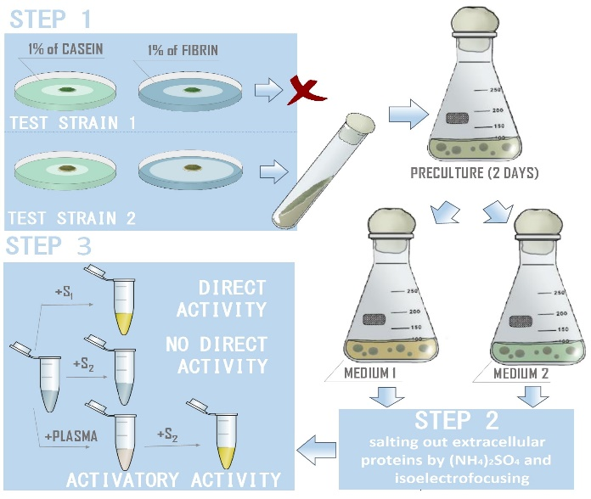
Figure. An experimental scheme on the evaluation of direct and hemostasis proteins-related activating activities of extracellular proteases
Recent Publications
- Popova E.A. et al. (2019) Production by Aspergillus ustus Strain of proteinases highly active against fibrillar proteins. Mikologia I Fitopotologiya 53 (4): 229-235
- Osmolovskiy A.A. et al. (2018) Combined microbiological approach to screening of producers of proteases with hemostasis system proteins activity among micromycetes. Biotechnology Reports 19: e00265
- Zvonareva E.A. et al. (2018) Production of proteinase with plasmin-like and prekallikrein activating activity by the micromycete Aspergillus terreus. Applied Biochemistry and Microbiology 54 (2): 206–210
- Osmolovskiy A.A. et al. (2018) Secretion of proteinases with fibrinolytic activity by micromycetes of the genus Aspergillus. Moscow University Biological Sciences Bulletin 73 (1): 39–42
- Osmolovskiy A.A. et al. (2017) Micromycetes from the genus Aspergillus as perspective producers of proteases effecting on human haemostasis proteins. Journal of Biotechnology 256 (S): S94–S94

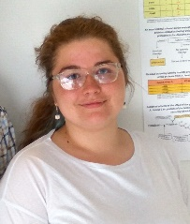Biography
Svetlana Timorshina learned a wide range of microbiological and biochemical methods for studying proteolytic enzymes and working with their producers. In her research, she has used a multi-stage scheme for the isolation of protease producers active against the target proteins. This approach was developed by employees of N.S. Egorov Research Group (Department of Microbiology, Biological Faculty, Lomonosov Moscow State University). Personally, Svetlana Timorshina participates in research on the micromycetes-synthesized proteases active against the proteins of human hemostasis system and against fibrillar proteins, especially, keratin.
Email: timorshina.svetlana@mail.ru

Notes/Comment

