Silver nanoparticles testicular toxicity in rat
Eman E. El-Sharkawy ¹, Mahmoud. Abd El-Nasser¹, Heba F. Kamaly¹
1Department of Forensic Medicine and Toxicology, Faculty of Veterinary Medicine, Assiut University, Egypt.

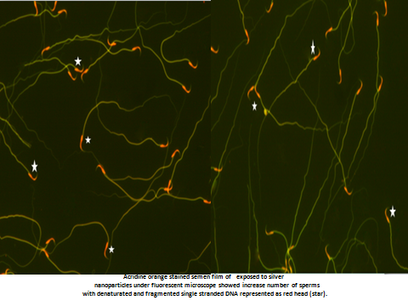 | Abstract  To evaluate the potential testicular toxicity induced by silver nanoparticles (AgNPs) in Sprague Dawley rate. The protocol study was designed as follows: G1: 30 adult male rats were kept as control. G2: 30 adult male rats were administered 5.36 mg/kg of AgNPs orally, twice weekly for six months. G3: 30 adult male rats were administered 13.4mg/kg of AgNPs orally, twice weekly for six months. The results of hormonal assay revealed that a significant decrease in testosterone level while a significant increase in LH level was obtained. The testicular homogenate showed a significant decrease in SOD activity accompanied by a significant increase in MDA level in both G2 and G3 in comparison with the control in a dose-response relationship. Sperm viability indicates a significant decrease in rats in G2 and G3 groups. A significant decrease in DNA chromatin integrity % was obtained in rats of G3 in comparison with G2 and control. The semithin and TEM sections of the testis of G2 and G3 groups showed Sertoli cells have vacuolations with a disturbance in the arrangement and the staining affinity of spermatogenic cells. The spermatogonia appeared with a moderate electron density of the nucleus and cytoplasm. The acrosome and its cap become oval and light electron dens of spermatid cells.
Recent Publications
- Baki, M.E.; Miresmaili, S.M.; Pourentezari, M.; Amraii, C.E.; Yousefi, V. and Spenani, H.R. et al. (2014): Effects of silver nano-particles on sperm parameters number of Leydig cells and sex hormones in rats, Iran.J. Reprod. Med. 12; 139-144.
- Duran, N.; Guterres, S.S. and Oswaldo Alves, L. (2014): Nanotoxicology: materials, methodologies, and assessments. New York: Springer.
- Ema, M.; Gamo, M. and Honda, K. (2016): Developmental toxicity of engineered nanomaterials in rodents. Toxicol. Appl. Pharmacol. 299; 47-52.
- Han, J.W.; Jeong, J.K.; Gurunathan, S.; Choi, Y.J.; Das, D.N. and Kwon et al. (2016): male and female-derived somatic and germ cell-specific toxicity of silver nanoparticles in mouse, Nanotoxicology 10(2016)361-373.
- Ema, M.; Okuda, H.; Gamo, M. and Honda K. (2017): a review of reproductive and development toxicity of silver nanoparticles in lab animals. Reprod. Toxicol. 67:149-164.



My name is Eman Ezz El-dawela Gaber ElSharkawy. I'm a Professor of forensic medicine and toxicology, Faculty of Veterinary Medicine, Assiut University, Egypt. I have Master and Ph.D. degree in forensic medicine and toxicology and I have many international publications in this discipline. And also, I'm an academic researcher and University lecturer for fourth and fifth levels student in my faculty as well as course coordinator to the substance specialization related to the forensic medicine and toxicology.
Email: medicine1971@yahoo.com

