Nimbolide abrogates cerulein-induced chronic pancreatitis by modulating Wnt/β-catenin/Smad in a Sirtuin 1-dependent way
Sapana P. Bansod, MS. Pharm, NIPER, Hyderabad, India
Dr. Chandraiah Godugu*, PhD, Assistant Professor, NIPER, Hyderabad, India

Abstract
Background and purpose: Chronic pancreatitis (CP) is characterized by pancreatic inflammation and fibrosis, which leads to impairment of pancreas function. The present study was designed to investigate the possible mechanisms of chronic pancreatitis and the anti-inflammatory, antioxidant and anti-fibrotic effect of nimbolide (NB), active constituent of neem tree Azadirachta indica in cerulein-induced CP. Experimental approach and Key results: Effect of nimbolide was investigated on cerulein 50 μg.kg⁻¹.hr⁻¹*6 exposures^{.-1}day 3 days a week for 3 weeks induced CP model in Swiss albino mice. Nimbolide (0.3 and 1 mg/kg) and sirtuin 1 (Sirt1) inhibitor, nicotinamide (200 mg/kg), were given intraperitoneally daily for 21 days. Pancreatic function was assessed by biochemical evaluation including amylase and lipase levels. The deposition of collagen in pancreatic tissue was measured by using hydroxyproline assay, Picrosirius red and Masson’s trichrome staining. The expression of collagen I, α-smooth muscle actin (SMA) and β-catenin in the pancreas tissue was evaluated using immunohistochemistry and immunofluroscence. NB treatment significantly reduced cerulein-induced CP by inhibiting Wnt/β-catenin signaling pathway including β-catenin, MMP7 and GSK3β. NB treatment remarkably decreased α-SMA, TGF-β1, MMP-2, fibronectin, p-smad-2/3 expression and collagen deposition in pancreatic tissue. However, the therapeutic effects of nimbolide against cerulein-induced CP were impaired by nicotinamide treatment. The levels of pro-inflammatory and pro-fibrotic cytokines such as TNF-α, IL-1β, IL-6 and TGF-β1 were elevated by cerulein treatment; further, they were decreased by NB treatment. Additionally, NB was found to increase the expression of

Sirt1 protein, which ultimately decreased the expressions of Smad2/3 and β-catenin signalling pathway proteins to attenuate cerulein-induced CP. Conclusion and implications: Nimbolide attenuated cerulein-induced CP by activating Sirt1, which regulates Smad/β-catenin signaling pathways and it could be the novel therapeutic strategy for the treatment of CP associated fibrosis.

Image

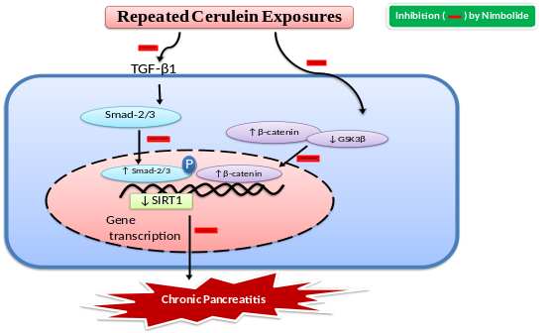
Figure 1: The proposed hypothesis of the intervention of NB against cerulein-induced CP. The activating Sirt1 regulates Wnt/β-catenin and TGF-β1/Smad signaling pathways in the pancreatic tissue and the promising protective effect of nimbolide in cerulein-induced CP model in mice.
Publication

S. Bansod, A. Khurana, C. Godugu, “Cerulein-induced chronic pancreatitis in Swiss albino mice: An improved short-term model for pharmacological screening” Journal of Pharmacological and Toxicological Methods, (Under revision).

Biography
Sapana Bansod is a PhD student in the Department of Pharmacology and Toxicology at NIPER Hyderabad, India’s Pioneer Pharmaceutical Research Institute. She holds MS. Pharm in Pharmacology and Toxicology from NIPER Mohali under the supervision of Dr. GB Jena. She has Proficient knowledge and expertise in acute and chronic pancreatitis, liver fibrosis, genotoxicity and molecular biology. Her current research includes exploration of novel pharmacological interventions in cerulein-induced pancreatitis. She has first time developed and standardized the short-term chronic pancreatitis model in swiss mice. She is highly motivated, enthusiastic experimental pharmacologist.

Email:bansodsapana@gmail.com

