New Insights into PI3K Inhibitor Design using X-ray Structures of PI3Kα Complexed with a Potent Lead Compound
Xiuyan Yang, Qiufen Zhang, Jian Zhang, China .

Abstract (300 word limit)
Statement of the Problem: Phosphatidylinositol 3-kinases (PI3Ks) are lipid kinases that play pivotal roles in a multitude of fundamental biological processes, including proliferation, survival, differentiation, and metabolism. Recent reports have shown that the PI3K/AKT/mTOR pathway is crucial in T cell activation and function6. PI3Ks are currently divided into classes IA, IB, II, and III7. The class IA family consists of three isoforms, α, β, and δ8. The class IB family consists of only the γ subtype. Among the different PI3K subfamily proteins, PI3Kα is the most important isoform in cell proliferation in response to growth factor-tyrosine kinase pathway activation. PI3Kα is a heterodimer that contains a p110α catalytic subunit and p85α regulatory subunit. The gene encoding the p110α subunit, PIK3CA, is mutated at a rate of nearly 30% in human cancers, including colorectal cancer, glioblastoma, and gastric cancer. Importantly, hyper-activation of PI3Kα directly correlates with resistance to current therapeutic agents and poor prognosis in most human cancers. Therefore, PI3Kα is a potential target for anti-cancer drug development. The design of new potent PI3Kα inhibitors with drug-like properties is still a major challenge because of the highly conserved lipid kinase ATP binding sites and the similarity between their three-dimensional structures. Currently, X-ray crystallography is one of the most useful experimental methods employed in structure-assisted drug design. Co-crystal structures of the protein of interest and ligands provide accurate structural insights into binding sites. Several complex structures of PI3Kα and its ligands have been reported; however, limited useful information can be extracted from the existing structures. Methodology & Theoretical Orientation: PI3Kα and its inhibitor were co-crystallized. In vitro PI3-Kinase Assays were performed. Findings: We determined the crystal structure of PI3Kα in complex with the potential inhibitor YXY-4F. Conclusion & Significance: The description of the new crystal structure provides further insights into the potent and selective design of PI3Kα inhibitors.
Image
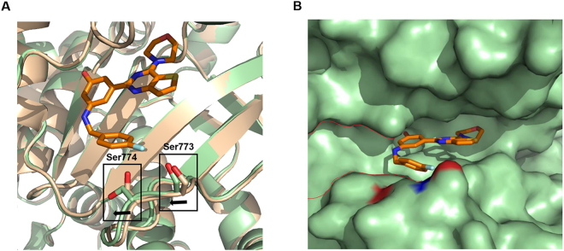

Figure 1: Comparison of apo p110α and YXY-4F-p110α complexes. (A) Overlay apo p110α and YXY-4F-p110α complexes. Apo p110α is colored in wheat and YXY-4F-p110α is colored in palegreen. (B) Interface between YXY-4F.

Recent Publications (minimum 5)
- 1. Arcaro A, Guerreiro AS. The phosphoinositide 3-kinase pathway in human cancer: Genetic alterations and therapeutic implications. Curr Genomics. 2007;8:271–306.
- Chen P, et al. The phosphoinositide 3-kinase/Akt-signal pathway mediates proliferation and secretory function of hepatic sinusoidal endothelial cells in rats after partial hepatectomy. Biochem Biophys Res Commun. 2006;342:887–893.
- Chen P, et al. The phosphoinositide 3-kinase/Akt-signal pathway mediates proliferation and secretory function of hepatic sinusoidal endothelial cells in rats after partial hepatectomy. Biochem Biophys Res Commun. 2006;342:887–893.
- Amur S, Frueh FW, Lesko LJ, Huang SM. Integration and use of biomarkers in drug development, regulation and clinical practice: a US regulatory perspective. Biomark Med. 2008;2:305–311.
- Denny WA. Phosphoinositide 3-kinase alpha inhibitors: a patent review. Expert Opin Ther Pat. 2013;23:789–799.

 Biography (150 word limit)
Qiufen Zhang has her expertise in natural products drug discovery for anti-cancer with extensive knowledge on pharmacology, molecular biology, structural biology and medicinal chemistry. Her compound library based on molecular designing creates new structurally untapped resource for improving healthcare. Based on this library, she has discovered some promising lead compounds targeted to enzymes.
Email: autumn.sky@163.com
Phone: +86-158-0171-6624

Notes/Comment

